Lesson 22
Objective: Represent two-digit sums and differences involving length by using the ruler as a number line.

Suggested Lesson Structure
 Fluency Practice (10 minutes)
 Application Problem (5 minutes)
 Concept Development (35 minutes)
 Student Debrief (10 minutes)
Total Time (60 minutes)
Fluency Practice (10 minutes)
- Compensation 2.NBT.5, 2.NBT.7 (5 minutes)
- Grade 2 Core Fluency Differentiated Practice Sets 2.OA.2 (5 minutes)
Compensation (5 minutes)
Note: This fluency drill reviews the mental math strategy of compensation. By making a multiple of 100, students solve a much simpler addition problem. Draw a number bond for the first problem on the board to help students visualize the decomposition.
T: (Write 420 + 190 = _____.) Let’s use a mental math strategy to add. How much more does 190 need to make the next hundred?
S: 10 more.
T: Where can 190 get 10 more from?
S: From the 420.
T: Take 10 from 420 and give it to 190. Say the new number sentence, with the answer.
S: 410 + 200 = 610.
T: 370 + 190.
S: 360 + 200 = 560.
Continue with the following possible sequence: 290 + 230, 380 + 190, 320 + 190, 240 + 180, and 340 + 180.

Grade 2 Core Fluency Differentiated Practice Sets (5 minutes)
Materials: (S) Core Fluency Practice Sets (Lesson 1 Core Fluency Practice Sets)
Note: During Topic E and for the remainder of the year, each day’s Fluency Practice includes an opportunity for review and mastery of the sums and differences with totals through 20 by means of the Core Fluency Practice Sets or Sprints. The process is detailed and Practice Sets are provided in Lesson 1.
Application Problem (5 minutes)
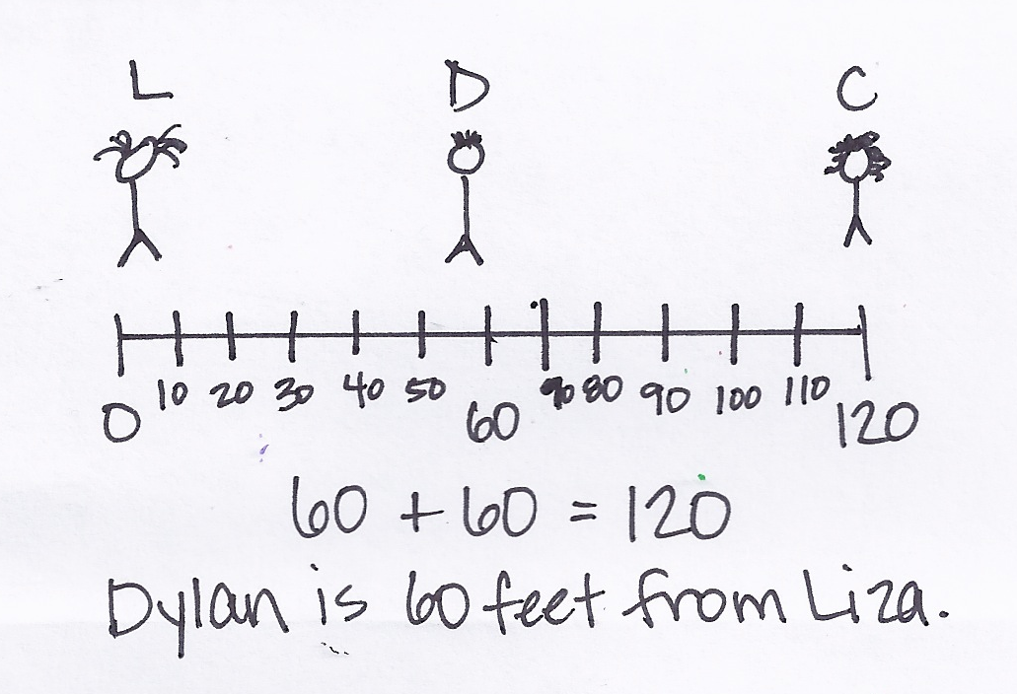
Liza, Cecilia, and Dylan are playing soccer. Liza and Cecilia are 120 feet apart. Dylan is in between them. If Dylan is standing the same distance from both girls, how many feet is Dylan from Liza?
Note: In this problem, students synthesize their understanding of length by finding the middle point on a number line and realizing that the length from 0 to 60 feet is equal to the length from 60 to 120 feet. For example, students might draw a number line and count by tens and then estimate or use trial and error to find the midpoint. They might also simply think of 120 as 12 tens, so 6 tens is the middle point.
Concept Development (35 minutes)
Materials: (S) Number lines A and B (Template), personal white board, 1 new pencil
Draw a large number line segment on the board (as shown below). Distribute the number line Template for use in Parts 1 and 2. Instruct students to slide the Template into their personal white boards.

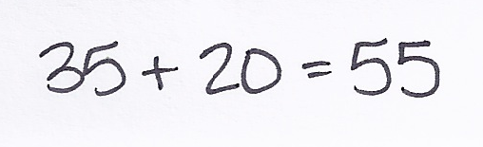
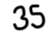
Problem 1: Relate more length on the number line to addition.
T: How can we use the number line to show 20 yards more than 35 yards? Talk to your partner.
S: We can label the left endpoint 35 and then slide 20 more yards counting by fives. We could count by tens, too.
T: For now, let’s say that each unit has a length of 5 yards.
T: Student A, come up and label the endpoint and show us how you slide 20 more yards when each hash mark is a length of 5 yards. Everyone else, use the number line in your personal white boards to do the same. (Allow students time to work.)

NOTES ON
MULTIPLE MEANS
OF ACTION AND EXPRESSION:
Support English language learners by pointing to the number line segment on the board while speaking. While asking what the distance is between each labeled interval, sweep a finger from 0 to 10, 10 to 20, 20 to 30, etc. Do the same for the smaller intervals.
T: So, did we end up at 20 yards?
S: No, because we went more than 35 yards. No, we counted up 20 more than 35. Twenty yards was the distance we traveled.
T: Hmm. Let’s put a dot where we ended to show 20 more than 35 yards. What do we need to do to figure out the value of that point?
S: We can skip-count by fives starting at 35, but stop counting when we get to the mark we made, so we only go 20 more yards. We can add 20 yards to 35 yards.
T: That’s a good idea. Write an addition sentence on your personal white board that matches 20 more than 35 on the number line.
S: (Write 35 + 20 = 55.) We are at 55 yards.
T: Label the number line.
Continue giving examples with different units and endpoints (on the left) until students readily write an addition sentence corresponding to more length. Consider using the following suggestions:
- Show 15 more than 45.
- Show 50 more than 60 using units of 10.
- Show 30 more than 85 using units of 5.
Problem 2: Relate less length on the number line to subtraction.
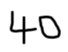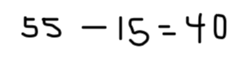

T: How can we use the number line to show 15 feet less than 55 feet? Talk to your partner.
S: We can label the right endpoint 55 and then slide 15 less feet going back. We could label the left endpoint 55 and then count back as we slide to the right.
MP.6
T: Both methods are fine, but we just did addition moving to the right. (Demonstrate.) So, now let’s do the opposite and move to the left to show subtraction.
T: Work on your personal white boards to show 15 less than 55. (Allow students time to work.)
T: Where did you end up?
S: At 40.
MP.6
T: Label the number line, and write a subtraction sentence on your board that matches 15 less than 55 on the number line.
Continue giving examples with different units and endpoints (on the right) until students readily write a subtraction sentence corresponding to less length. Consider using the following suggestions:
- Show 15 less than 45.
- Show 20 less than 90 using units of 10.
- Show 30 less than 115 using units of 5.
Problem 3: Relate the length of an object on the number line to subtraction. Use compensation to simplify calculation.
T: Look at number line B (Template). This was part of a whole meter strip, but it got cut at 49 and 66. These are our endpoints.
49 50 51 52 53 54 55 56 57 58 59 60 61 62 63 64 65 66

T: Place the end of your pencil at the endpoint of the number line where it says 49.

NOTES ON
MULTIPLE MEANS
OF REPRESENTATION:
Help students who are performing below grade level by demonstrating, one step at a time, how to understand 62 – 49 = 63 – 50 by having them solve each side of the equation. Have students express what 62 – 49 is, and then ask them what 63 – 50 is. Have students write the difference after each step and rewrite the whole equation (13 = 13). Ask them to express in their own words what they think the equal sign meant in the original equation.
T: How can we figure out the length of the pencil?
S: We can count the units from the beginning of the pencil to the end. We can write a subtraction sentence to find the difference.
T: Let’s mark the endpoints of our pencil on the number line. Mark the point on the left A and the point on the right B.
S: (Work.)
T: The length from A to B is the same as the length of the…?
S: Pencil.
T: How can we find the length of the pencil?
S: We can count up from A to B. We can subtract.
T: On your personal white boards, under the number line, write and solve a subtraction sentence that will tell us the length of the pencil. Don’t solve yet. Just leave a blank for the unknown length of the pencil.
S: (Write 62 – 49 = ___.)
T: Hmm. Will the pencil length change if I move it on the number line?
S: No!
T: Could I move the pencil on the number line so that I can write a subtraction sentence that is simpler to solve?
S: Yes! If you move the pencil 1 unit to the right so that the end of the pencil is at the 50 hash mark, your number sentence would be 63 – 50 = ____.
T: Move your pencil and write the new number sentence. Solve both equations. Count the length units to check and see if the length of the pencil is the same as the answers to your equations.
50 63

S: Both equations equaled 13. When I counted the length units, there were 13. That means the pencil is 13 units long.
T: (Write 62 – 49 = 63 – 50 on the board.) Talk to your partner about what I wrote on the board. Is this true? Why or why not?
T: Great job. Let’s practice some more problems like the ones we have done today on our Problem Set.
Problem Set (10 minutes)
Students should do their personal best to complete the Problem Set within the allotted 10 minutes. For some classes, it may be appropriate to modify the assignment by specifying which problems they work on first. Some problems do not specify a method for solving. Students should solve these problems using the RDW approach used for Application Problems.

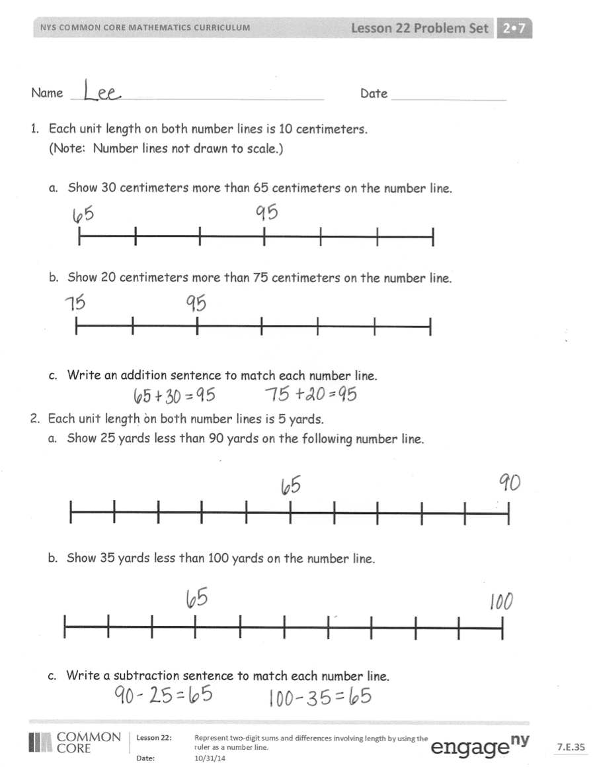
Student Debrief (10 minutes)
Lesson Objective: Represent two-digit sums and differences involving length by using the ruler as a number line.
The Student Debrief is intended to invite reflection and active processing of the total lesson experience.
Invite students to review their solutions for the Problem Set. They should check work by comparing answers with a partner before going over answers as a class. Look for misconceptions or misunderstandings that can be addressed in the Debrief. Guide students in a conversation to debrief the Problem Set and process the lesson.
Any combination of the questions below may be used to lead the discussion.
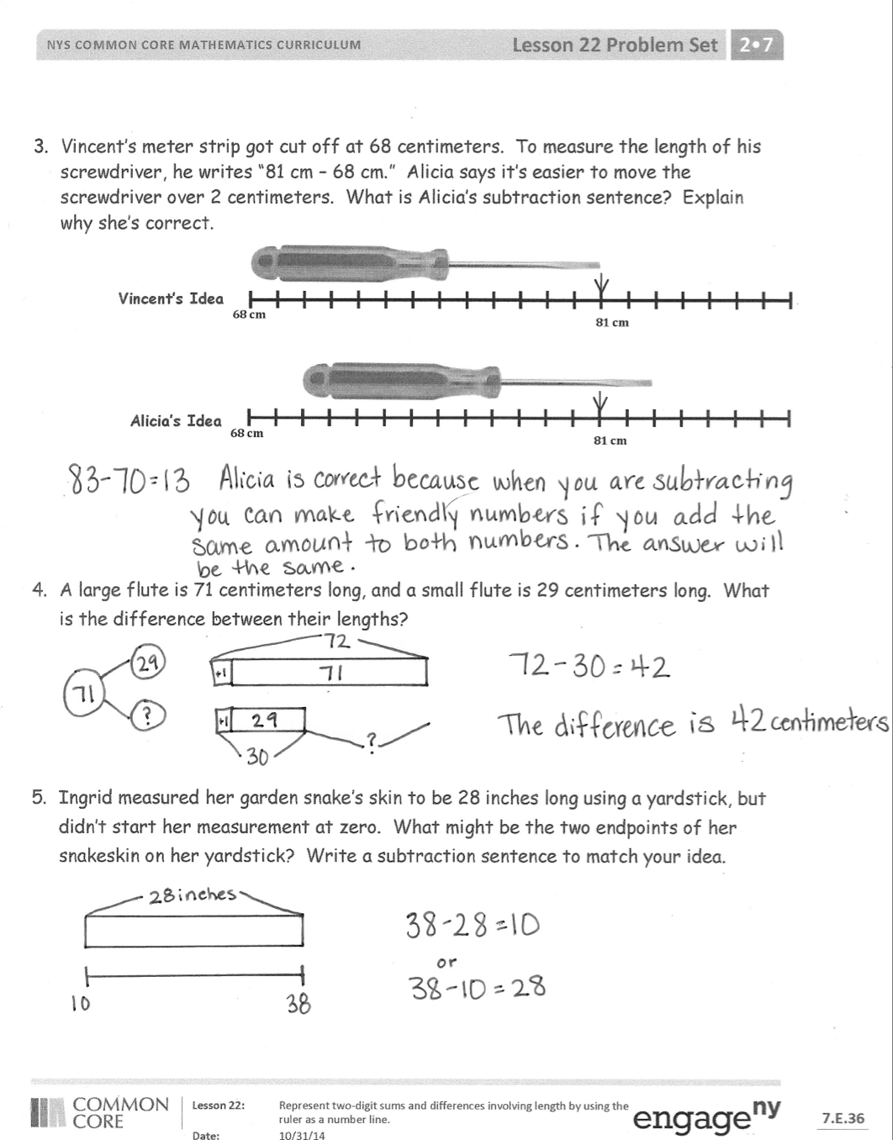
- Look at Problem 1 on your Problem Set. Using your finger and skip-counting, show your partner how you represented 30 more than 65 centimeters on the number line.
- Talk to your partner about how Problem 3 on your Problem Set can help you solve Problem 4.
(I know the length of each flute will stay the same if I move each flute 1 centimeter to the right, and in doing so, I make a much easier subtraction problem for me to solve. Instead of 71 – 29, I can think 72 – 30.)
- Sometimes we count the units on a ruler or number line to figure out the length of an object. What are some things we have to think about when we use this strategy? (We have to be aware of the length of each unit so we can skip-count if necessary, and we have to be careful to count the jumps and not the hash marks.)
- If you knew the endpoints of an object, could you figure out the length of the object without using a number line or ruler? How?
Exit Ticket (3 minutes)
After the Student Debrief, instruct students to complete the Exit Ticket. A review of their work will help with assessing students’ understanding of the concepts that were presented in today’s lesson and planning more effectively for future lessons. The questions may be read aloud to the students.
Name Date
- Each unit length on both number lines is 10 centimeters.
(Note: Number lines not drawn to scale.)
  - Show 30 centimeters more than 65 centimeters on the number line.

  - Show 20 centimeters more than 75 centimeters on the number line.

  - Write an addition sentence to match each number line.

- Each unit length on both number lines is 5 yards.
  - Show 25 yards less than 90 yards on the following number line.

  - Show 35 yards less than 100 yards on the number line.

  - Write a subtraction sentence to match each number line.
- Vincent’s meter strip got cut off at 68 centimeters. To measure the length of his screwdriver, he writes “81 cm – 68 cm.” Alicia says it’s easier to move the screwdriver over 2 centimeters. What is Alicia’s subtraction sentence? Explain why she’s correct.
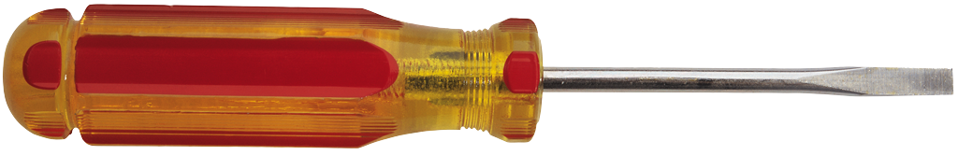
68 cm
81 cm
Vincent’s Idea
Alicia’s Idea
68 cm
81 cm

- A large flute is 71 centimeters long, and a small flute is 29 centimeters long. What is the difference between their lengths?

- Ingrid measured her garden snake’s skin to be 28 inches long using a yardstick but didn’t start her measurement at zero. What might be the two endpoints of her snakeskin on her yardstick? Write a subtraction sentence to match your idea.

Name Date
Each unit length on both number lines is 20 centimeters.
(Note: Number lines not drawn to scale.)

- Show 20 centimeters more than 25 centimeters on the number line.

- Show 40 centimeters less than 45 centimeters on the number line.

- Write an addition or subtraction sentence to match each number line.

Name Date
- Each unit length on both number lines is 10 centimeters.
(Note: Number lines not drawn to scale.)
  - Show 20 centimeters more than 35 centimeters on the number line.

  - Show 30 centimeters more than 65 centimeters on the number line.

  - Write an addition sentence to match each number line.

- Each unit length on both number lines is 5 yards.
  - Show 35 yards less than 80 yards on the following number line.

  - Show 25 yards less than 100 yards on the number line.

  - Write a subtraction sentence to match each number line.

- Laura’s meter strip got cut off at 37 centimeters. To measure the length of her screwdriver, she writes “51 cm – 37 cm.” Tam says it’s easier to move the screwdriver over 3 centimeters. What is Tam’s subtraction sentence? Explain why she’s correct.
37 cm
Laura’s Idea
51 cm

Tam’s Idea
37 cm
51 cm

- Alice measured her belt to be 22 inches long using a yardstick, but she didn’t start her measurement at zero. What might be the two endpoints of her belt on her yardstick? Write a subtraction sentence to match your idea.

- Isaiah ran 100 meters on a 200-meter track. He started running at the 19-meter mark. On what mark did he finish his run?
Number Line A

Number Line B
49 50 51 52 53 54 55 56 57 58 59 60 61 62 63 64 65 66

number lines A and B

