Lesson 21
Objective: Identify unknown numbers on a number line diagram by using the distance between numbers and reference points.

Suggested Lesson Structure
 Fluency Practice (10 minutes)
 Application Problem (7 minutes)
 Concept Development (33 minutes)
 Student Debrief (10 minutes)
Total Time (60 minutes)
Fluency Practice (10 minutes)
- Roll and Follow the Rule 2.OA.2 (5 minutes)
- Grade 2 Core Fluency Differentiated Practice Sets 2.OA.2 (5 minutes)
Roll and Follow the Rule (5 minutes)
Materials: (S) 1 die per student or pair, math journal or notebook
Note: Give students a base number such as 9. They roll their die to find the “rule.” For example, if they roll a 5, they add 5 repeatedly, 9 + 5 = 14, 14 + 5 = 19, 19 + 5 = 24, etc. Students track their number sentences in their notebooks and count the total of number sentences they have written after 30 seconds. Continue the process with a different base number and/or operation.
Base numbers for addition: 38, 156, 291. Base numbers for subtraction: 40, 100.
Grade 2 Core Fluency Differentiated Practice Sets (5 minutes)
Materials: (S) Core Fluency Practice Sets (Lesson 1 Core Fluency Practice Sets)
Note: During Topic E and for the remainder of the year, each day’s Fluency Practice includes an opportunity for review and mastery of the sums and differences with totals through 20 by means of the Core Fluency Practice Sets or Sprints. The process is detailed and Practice Sets are provided in Lesson 1.

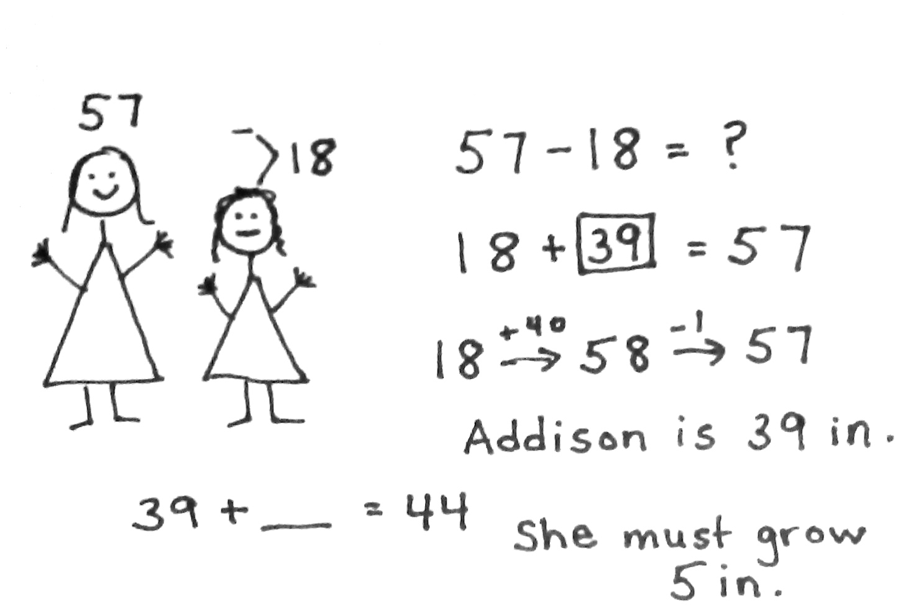
Application Problem (7 minutes)
To ride the Mega Mountain roller coaster, riders must be at least 44 inches tall. Caroline is 57 inches tall. She is 18 inches taller than Addison. How tall is Addison? How many more inches must Addison grow to ride the roller coaster?
Note: This two-step word problem involving length bridges the work done in the previous lesson with the number line work to follow. Encourage students to use the RDW process to solve and to write equations to represent the problem.
Concept Development (33 minutes)
Materials: (T) Meter strip (Template), ruler (S) Meter strip (Template), ruler, personal white board
Distribute the meter strip Template and ruler to students.

NOTES ON
MULTIPLE MEANS
OF ENGAGEMENT:
Students who are struggling can continue to use measuring tape for support, marking the intervals with additional paper clips or sliding their finger along the tape while skip-counting. The continued use of the measuring tape will help students to focus more on the conceptual understanding of the activity.
Problem 1: Identify missing points on a number line with endpoints 30 and 50 and units of 5.
T: What are the endpoints of your meter strip?
S: Zero and 1 meter!
T: 1 meter is how many centimeters?
S: 100 centimeters!
T: Let’s change the endpoints. Partner A, put your finger on 30 centimeters. Partner B, put your finger on 50 centimeters.
T: Let’s draw a number line to represent this part of the meter strip.
T: Use your meter strip as a ruler to make hash marks at 30 and 50 centimeters on your personal white boards.
S: (Draw hash marks.)
T: Now, take away your meter strip and use your ruler to connect your hash marks with a line.
S: (Draw.)
T: Label the hash mark on the left 30 and the hash mark on the right 50.
T: We have used our meter strip to draw part of a number line. What are the endpoints of our number line? Let’s just work with the numbers rather than continue to call the numbers centimeters.
S: 30 and 50.
T: Our left endpoint is often 0. Turn and talk: Where has 0 gone?
S: It didn’t disappear; we just aren’t using that part of the number line. If I put my meter strip back, it’s about over here.
T: It’s like zooming in on a piece of the number line; the numbers to the left and right are not written down, but we could extend this out and see them if we needed or wanted to.
T: Watch as I draw a hash mark in the middle, equal distances from both endpoints. (Draw the hash mark.) The length between hash marks is a unit. Let’s count the units together. (Use your finger to slide on the number line to show two equal units.)
30 50

NOTES ON
MULTIPLE MEANS
OF REPRESENTATION:
Support English language learners by posting the words thirty, forty, and fifty with their corresponding numerals. English language learners can easily confuse thirty, forty, and fifty with the pronunciation of thirteen, fourteen, and fifteen. Posting and referring to the visual will clarify any confusion that might arise.
S: (Chorally count.) 1, 2.
T: What number comes right in the middle of 30 and 50?
S: 40.
T: Label the middle hash mark 40 on your number line.
T: Watch as I make more equal units on my number line by drawing hash marks in the middle between 30 and 40 and between 40 and 50. (Draw two more hash marks. Label them A and B as shown below.) Make more equal units on your number line. (Allow students time to work.)
T: How many hash marks are on our number line?
S: Five!
T: How many units do we have on our number line now?
S: Four! Five!
T: The units are the lengths. Put your finger on 30, and let’s slide straight from 30 to the next hash mark to count the units. We say “one” after we have gone the length from 30 to the next hash mark.
S: (Count the slides with their fingers.) There are 4 units!
T: Good. Turn and talk: What are the values of Point A and Point B? How do you know? Label them.
30 A 40 B 50 30

MP.2
S: If the distance from 30 to 40 is 10, then Point A has to be 35 because it’s in the middle. I figured out that the distance from one hash mark to the next one is 5, so I counted by fives: 30, 35, 40, 45, 50. Since 40 to 50 has a length of 10, Point B cuts the length in half, so each smaller distance has to be 5.
T: What is the length of each unit?
S: 5.
MP.2
T: What happens when we add the lengths of the units together on this part of the meter strip?
S: We get the total distance from 30 to 50. 5 + 5 + 5 + 5 = 20, which is the total length.
I counted up: 5, 10, 15, 20.
Problem 2: Use the unit length to count up or down to figure out endpoints.
100 E

T: (Draw the number line above on the board.) Look at this number line. How many units are there?
S: Four!
T: If you know each equal unit length is 10, can you figure out the other endpoint, E?
S: Yes. Since we know the beginning endpoint is 100, we can count by tens until we get to E.
T: Good! What is the value of E?
S: 140.
T: Yes, let me label that on my number line. What is the difference in length between endpoints? Tell your partner how you can figure this out.
S: The difference is 40. I counted up by tens for 4 units. The difference is 40. I subtracted the shorter endpoint from the longer endpoint, 140 – 100 = 40.
T: Good. I’m going to write the difference between endpoints on the side of my number line. (Don’t erase from the board because it will be needed to compare with the next number line.)
Problem 3: Vary the position of the unknown on the number line.
T: Now, draw a number line that is just the same as your other one on your personal white board with 4 units (5 hash marks) and a right endpoint of 95. Label the left endpoint with an A. Look at the number line on the board if you need help.
A 95

T: (As students draw, assist as necessary.)
T: If each equal unit length is 10, figure out the starting point, A.
S: (Count backward from 95 by tens to determine the value of A.)
T: What did you label Point A?
S: 55.
T: Good. Now that we know both endpoints, use one of the strategies we just talked about to find the difference in length between the endpoints on your number line, and then tell your partner.
T: What was the difference on this number line?
S: 40.
T: Now, look at your number line and the one that’s on the board. Talk to your partner about what is the same and what is different.
S: The endpoints are different. Each number line has the same number of units. Each unit was 10 on both number lines. The difference between endpoints was the same.
Continue the work using a sequence of problems such as the following to prepare students for the Problem Set:
- Find the value of Point B on the number line.
45 B 85

- Find the value of Point C on the number line. What is the difference between the two endpoints?
C 100 115

- Find the value of Point D on the number line. Each hash mark represents a value of 10. What is the distance between the two endpoints?
D 65

Problem Set (10 minutes)
Students should do their personal best to complete the Problem Set within the allotted 10 minutes. For some classes, it may be appropriate to modify the assignment by specifying which problems they work on first. Some problems do not specify a method for solving. Students should solve these problems using the RDW approach used for Application Problems.

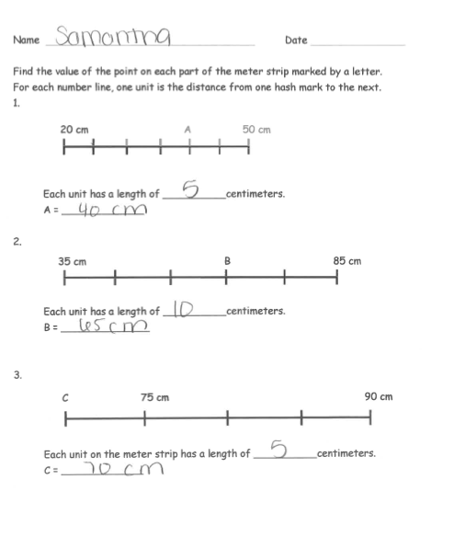
Student Debrief (10 minutes)
Lesson Objective: Identify unknown numbers on a number line diagram by using the distance between numbers and reference points.
The Student Debrief is intended to invite reflection and active processing of the total lesson experience.
Invite students to review their solutions for the Problem Set. They should check work by comparing answers with a partner before going over answers as a class. Look for misconceptions or misunderstandings that can be addressed in the Debrief. Guide students in a conversation to debrief the Problem Set and process the lesson.
Any combination of the questions below may be used to lead the discussion.
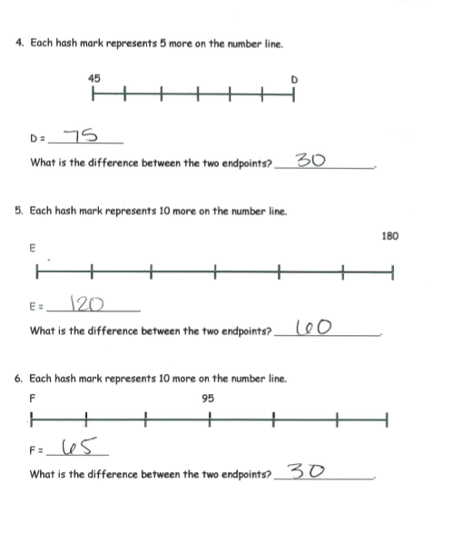
- Look at the first number line on your Problem Set. Count the hash marks. (7.) Count the units. (6.) What do you notice? Look at the second number line and compare how many hash marks to how many units. What do you notice?
- What do we count when we are counting units? (The spaces between the hash marks.) What do the hash marks do on a number line? (Separate the units and tell us where to write the reference points.)
- If you know the value of one unit on a number line, do you know the value of all of them?
- Look at the second number line on your Problem Set. Explain to your partner the strategy you used to find the value of each unit.
- Look at Problem 4 on your Problem Set. Explain to your partner how you found the difference between endpoints.
- On a yardstick, can you find two different sections that have the same difference between endpoints?

Exit Ticket (3 minutes)
After the Student Debrief, instruct students to complete the Exit Ticket. A review of their work will help with assessing students’ understanding of the concepts that were presented in today’s lesson and planning more effectively for future lessons. The questions may be read aloud to the students.
Name Date
Find the value of the point on each part of the meter strip marked by a letter.
For each number line, one unit is the distance from one hash mark to the next.
20 cm A 50 cm

Each unit has a length of __________ centimeters.
A = _____________

35 cm B 85 cm
Each unit has a length of __________ centimeters.
B = _____________

C 75 cm 90 cm

Each unit on the meter strip has a length of __________ centimeters.
C = _____________

- Each hash mark represents 5 more on the number line.
45 D

D = _____________
What is the difference between the two endpoints? _________________.

- Each hash mark represents 10 more on the number line.
180
E

E = _____________
What is the difference between the two endpoints? _________________.

- Each hash mark represents 10 more on the number line.
95
F

F = _____________
What is the difference between the two endpoints? _________________.

Name Date
Find the value of the point on each number line marked by a letter.

1. Each unit has a length of __________ centimeters.
50 A 110

A = _____________

23 B 73
2. What is the difference between the two endpoints? _____________.
B = ______________

Name Date
Find the value of the point on each part of the meter strip marked by a letter.
For each number line, one unit is the distance from one hash mark to the next.

10 cm A 40 cm

Each unit has a length of __________ centimeters.
A = _____________

55 B 105

Each unit has a length of __________ centimeters.
B = _____________

C 210 240

Each unit has a length of __________ centimeters.
C = _____________
- Each hash mark represents 5 more on the number line.
400 D E

What is the difference between D and E? ________________.
D = ____________
E = ____________

- Each hash mark represents 10 more on the number line.
115
F

What is the difference between the two endpoints? _________________.
F = ____________

- Each hash mark represents 10 more on the number line.
G
650

What is the difference between the two endpoints? ________________.
G = ____________

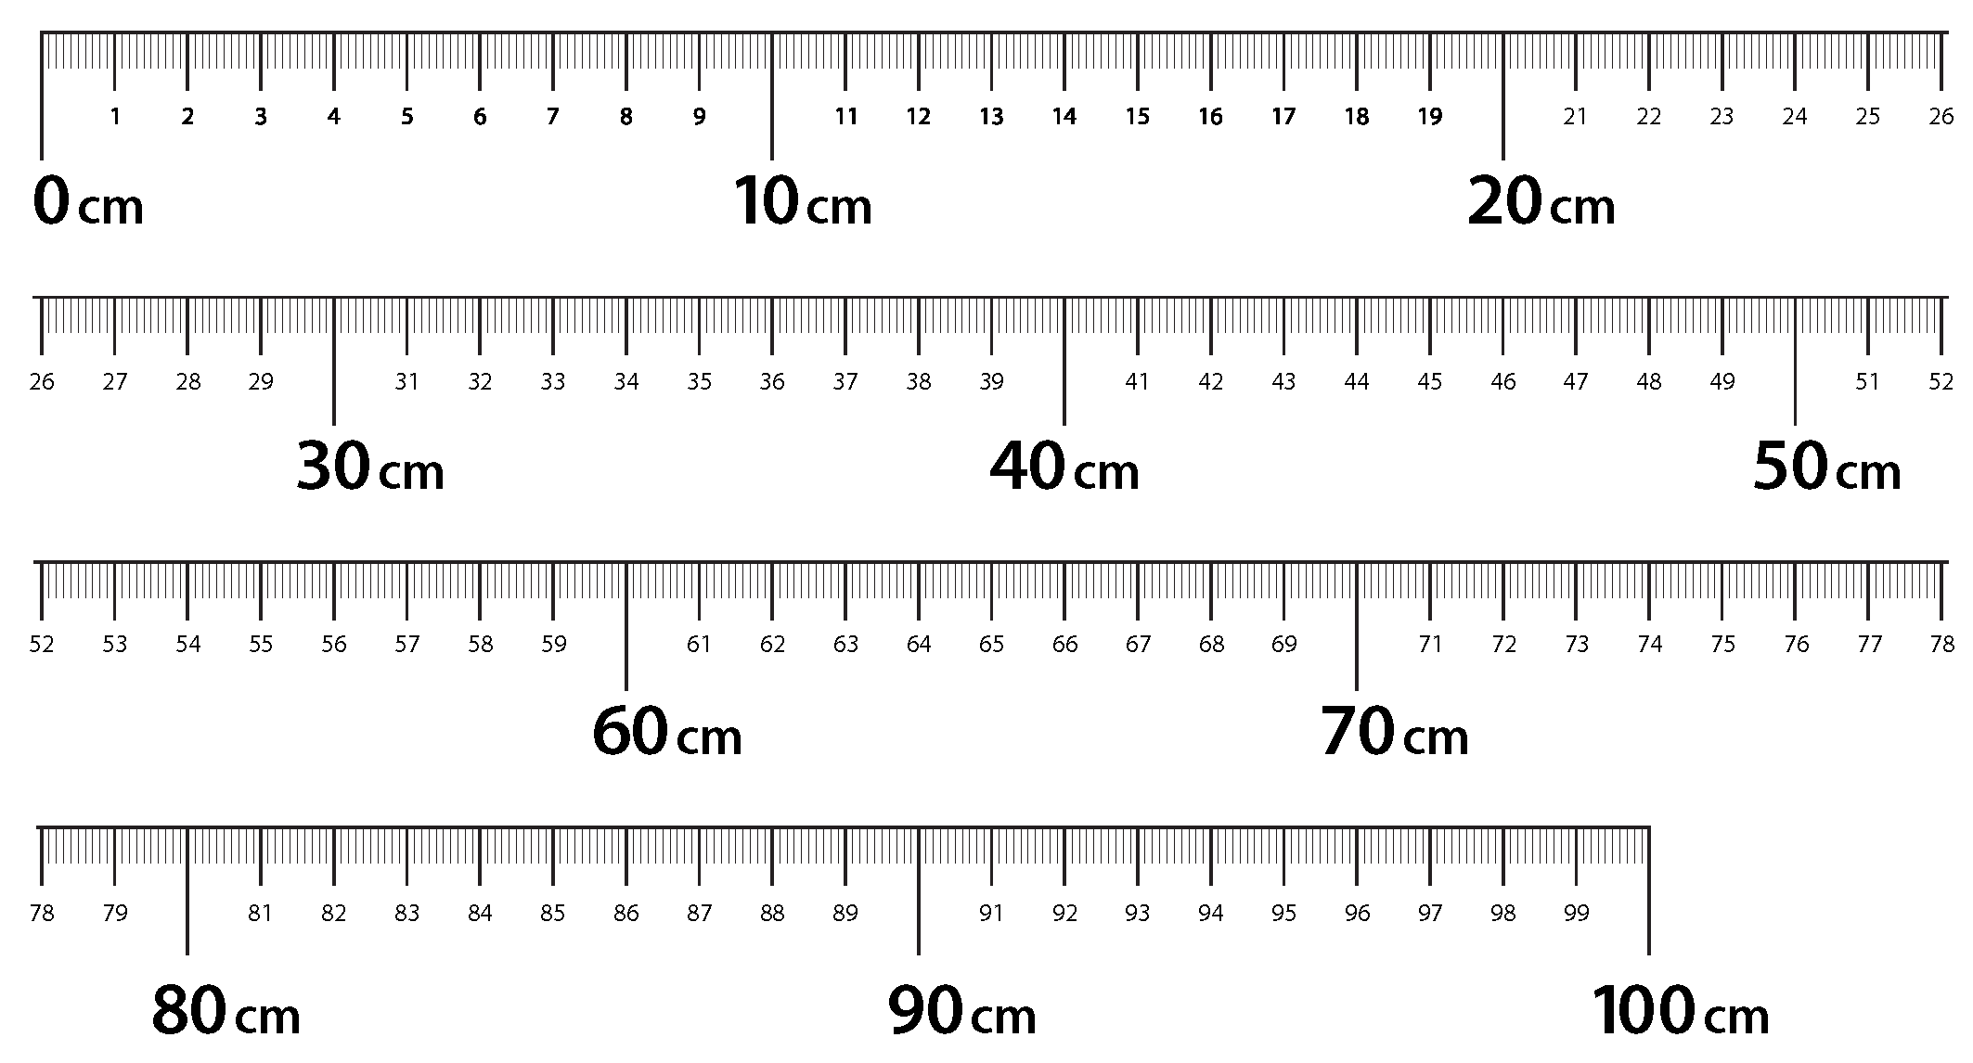

meter strip

