Lesson 19
Objective: Measure to compare the differences in lengths using inches, feet, and yards.

Suggested Lesson Structure
 Fluency Practice (11 minutes)
 Concept Development (24 minutes)
 Application Problem (15 minutes)
 Student Debrief (10 minutes)
Total Time (60 minutes)
Fluency Practice (11 minutes)
- Subtraction from Tens 2.NBT.5 (2 minutes)
- Sprint: Subtraction Patterns 2.OA.2, 2.NBT.5 (9 minutes)
Subtraction from Tens (2 minutes)
Note: This fluency activity reviews mental math strategies within 100 and subtraction of 9 or 8 from any number.
T: When I say a basic fact, you add 10 to the whole and continue until I say to stop. So, after 11 – 9, you would solve 21 – 9, then…?
S: 31 – 9, 41 – 9, 51 – 9.
T: Yes. Solve as many as you can on your personal white board before I give the signal to stop. Let’s begin. 11 – 9.
When every student has completed at least two problems, stop the class and give the next expression.
Continue with the following possible sequence: 12 – 8, 11 – 8, and 13 – 9.
Sprint: Subtraction Patterns (9 minutes)
Materials: (S) Subtraction Patterns Sprint
Note: Students practice subtraction to gain mastery of the sums and differences within 20 and see relationships with higher numbers.

Concept Development (24 minutes)
Materials: (T) Piece of butcher paper (30 inches × 18 inches), 1 student desk (18 inches × 24 inches),
12-inch ruler, yardstick, piece of string (7 feet long) (S) Personal white board
Note: The dialogue below uses hypothetical measurements. The length of the string should be about 10 to 15 feet shorter than the length of the classroom wall. The Application Problem should be completed before sending students off to work on the Problem Set. (The Problem Set time has been added to the Application Problem.)
T: I want to cover this desk in paper. I need to know if the paper is long enough. I need a few extra inches on each side to tape it down. Let’s figure out if I have enough paper.
T: What do we need to do to see if the paper is the right size?
S: Measure both the desktop and the paper. Put the paper on the desk to make sure the paper is longer than the desk. Use a ruler or a yardstick to measure both lengths.
T: Good ideas! Let’s measure the desktop and the paper. (Call a student volunteer to measure the paper and another to measure the table.)
T: What measurement tool do you think they should use to measure the paper and the desk? Why? Talk to your partner.
MP.5

NOTES ON
MULTIPLE MEANS
OF ENGAGEMENT:
Support the oral practice of English language learners by providing them with sentence frames to help in turn-and-talk with partners: “The ____ is ________longer/shorter than the ______because _________.” Post the sentence starters so that they can easily refer to them.
S: A yardstick because I can see that the paper and the desk are both longer than a 12-inch ruler. We won’t have to measure and advance so many times if we use a yardstick. We can use the yardstick, but use inches to actually measure.
T: If we use the yardstick, why don’t we have to measure in yards? Talk to your partner.
S: We can choose inches, feet, or yards. We can do what we want. It just depends on what we are measuring. The yardstick can be used to measure yards, but we only need inches for the desk.
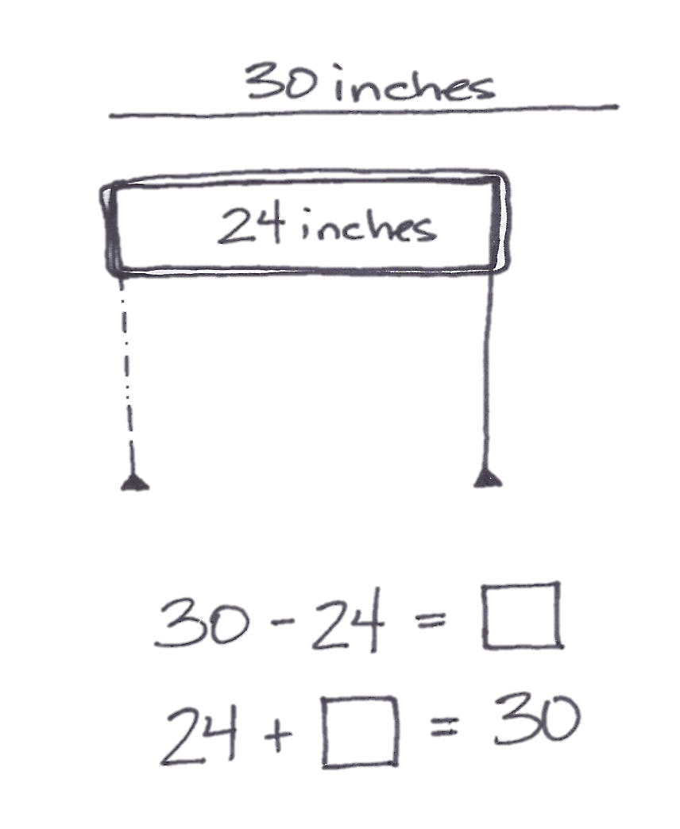
S: (Volunteers measure the paper and the desktop with a yardstick.)
T: How long is the desktop?
S: 24 inches.
T: (Record measurement.) How long is the paper?
S: 30 inches.
T: (Record measurement.) Which is longer?
S: The paper!
T: Turn and talk. How much longer is the paper, and how do you know?
S: The paper is 6 inches longer because 30 – 24 is 6. It’s 6 inches longer because 24 + 6 = 30.
T: (Record the difference in the two lengths as a number sentence.) Do we have enough paper to cover the desktop?
S: Yes!
Invite students to measure and compare the lengths of the following objects: journal and pencil, crayon and pink eraser, and marker and scissors. Have them record each length and the difference in lengths as they go. Each time, they should compare the two lengths and describe the difference using a number sentence.
T: Can you help me with one more thing? I would like to use this string to hang our work along the wall. How can we figure out if we have enough string?
S: Measure the string and the wall.
T: Which measurement tool should we use?
S: The yardstick!
T: We know we don’t have to measure in yards. What unit should we use this time?
S: Inches! Feet! Yards!
T: First, let’s measure both lengths in feet so we can be more precise than we could be using yards. The number of inches would be too much! Let’s say there is a measurement between 4 and 5 feet. Do you remember what to do if our measurement falls in between the foot hash marks?
S: If it is more than halfway, we say it is about 5 feet. If it is less than halfway, we say it is about 4 feet.
T: Good! (Call on a few student volunteers to measure the length of the wall and the length of the string.) While these students are measuring silently, it is everyone’s job to tally the number of feet as they go.
T: (Allow students time to measure the string.) How long is the string?
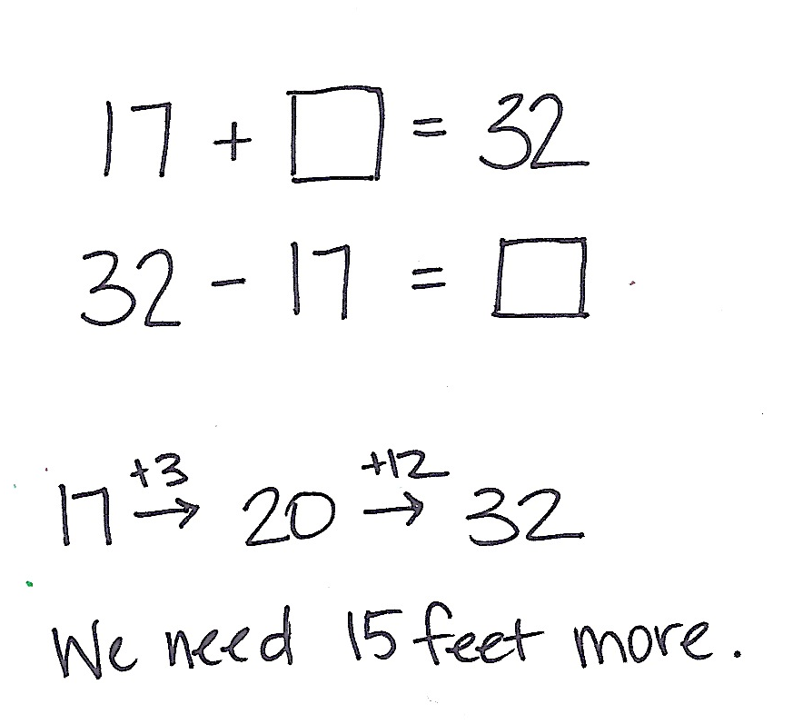
S: 17 feet.
T: (Record measurement.)
T: (Allow students time to measure the wall.) How long is the wall?
S: 32 feet.
T: (Record measurement.)
T: Uh, oh. We need more string. Turn and talk: How can we figure out how much more string we need?
S: Subtract! Add on from 17 to get to 32.
T: (Write the number sentences on the board as shown to the right.)
T: Count on from 17 to figure out how much more string we need.
S: Seventeen plus 3 is 20, plus 12 more is 32. We need 15 more feet.
Repeat this activity, this time measuring the string and the wall using yards. Students should again compare the two lengths and describe the difference using a number sentence.
T: What was the difference between the length of the string and the length of the wall when we measured in feet?
S: 15 feet.
T: What was the difference between the length of the string and the length of the wall when we measured in yards?
S: 5 yards.
T: Did the length of the string or the wall change? Why are the differences so different?
S: No! Feet and yards are different. We used a different unit each time. Feet are smaller than yards, so we need more of them to cover the same distance.
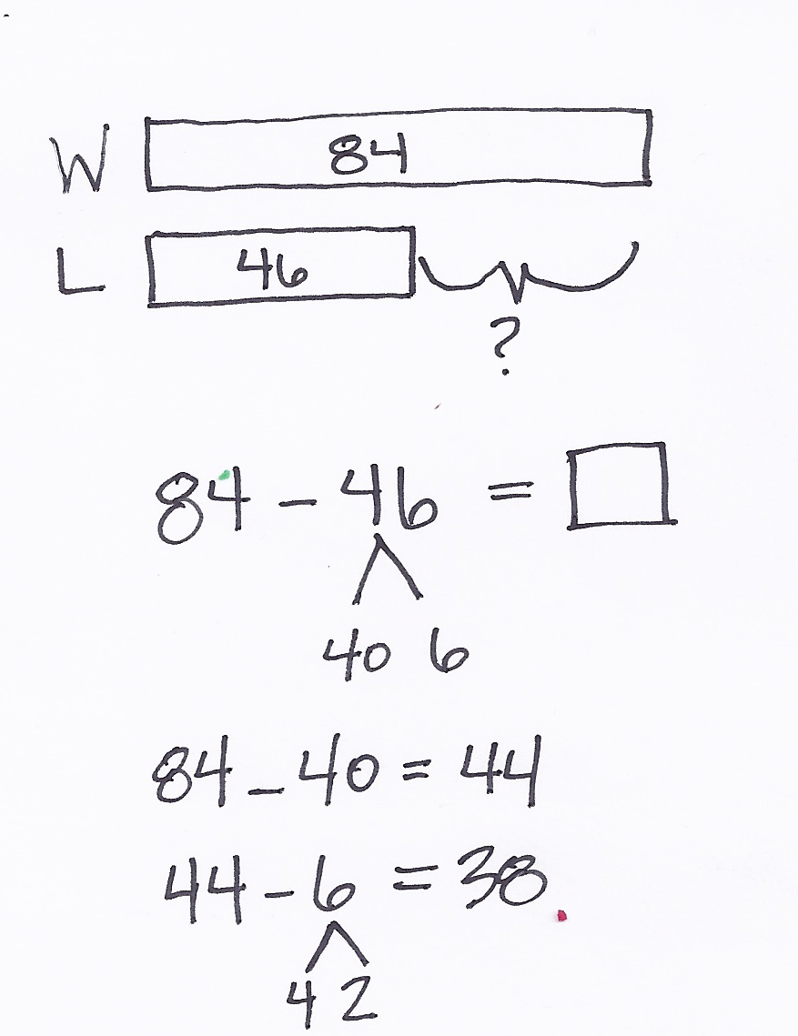
Application Problem (15 minutes)
Katia is hanging decorative lights. The strand of lights is 46 feet long. The building wall is 84 feet long. How many more feet of lights does Katia need to buy to equal the length of the wall?
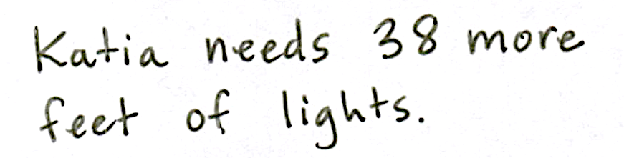
Note: This Application Problem provides practice with comparing the difference between measurements without making the measurement. When students finish, invite them to share their reasoning with either the whole group or with partners.
Problem Set (10 minutes)
Students should do their personal best to complete the Problem Set within the allotted 10 minutes. For some classes, it may be appropriate to modify the assignment by specifying which problems they work on first. Some problems do not specify a method for solving. Students should solve these problems using the RDW approach used for Application Problems.

NOTES ON
MULTIPLE MEANS
OF ENGAGEMENT:
Challenge students working above grade level by asking them what would happen if Katia is asked to hang two strings of lights on the building wall. How many more yards of lights will she have to buy? Ask students to explain what strategies they used to find the answer.
Student Debrief (10 minutes)
Lesson Objective: Measure to compare the differences in lengths using inches, feet, and yards.
The Student Debrief is intended to invite reflection and active processing of the total lesson experience.
Invite students to review their solutions for the Problem Set. They should check work by comparing answers with a partner before going over answers as a class. Look for misconceptions or misunderstandings that can be addressed in the Debrief. Guide students in a conversation to debrief the Problem Set and process the lesson.
Any combination of the questions below may be used to lead the discussion.
- When you measured the lines on your Problem Set, did the endpoint fall exactly on an inch
hash mark? Talk to your partner about what you did if the endpoints of the lines fell between inch hash marks.

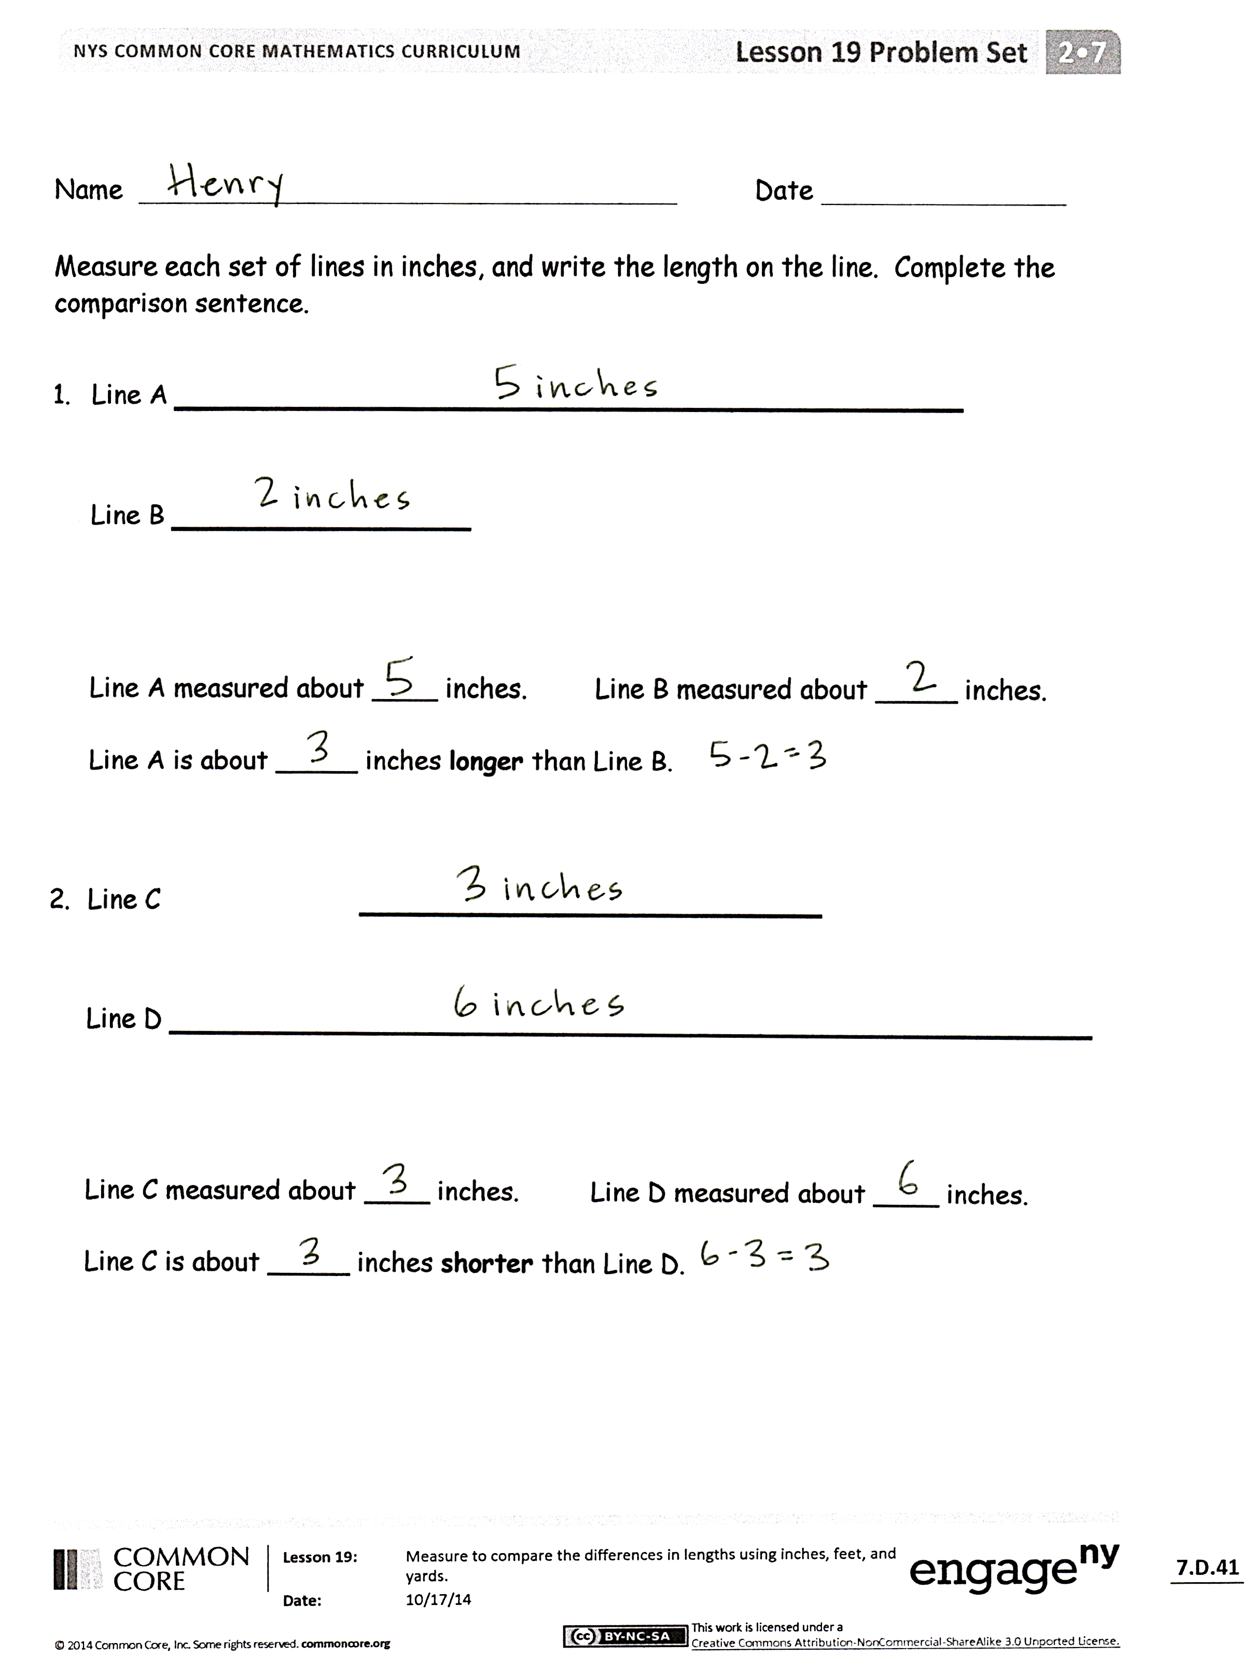
- Look at Problem 4 on your Problem Set. Tell your partner how long Martha’s fence is. Did anyone have a measurement smaller than 54 yards? Without doing any calculations, how do you know that this is incorrect?
- Today in the lesson when we were measuring and comparing lengths, how did you decide which tool to use? Talk to your partner about when and why you would choose a 12-inch ruler instead of a yardstick, or a yardstick instead of a 12-inch ruler.
- Sometimes we choose to measure in yards, other times in feet, yet others in inches or centimeters. Talk to your partner about when you might measure using each of these units. (Yards for a football field, feet for a wall, inches for a book, centimeters for a bean.)
- What strategies did you use to solve the Application Problem? How many more yards of lights does Katia need?
Exit Ticket (3 minutes)
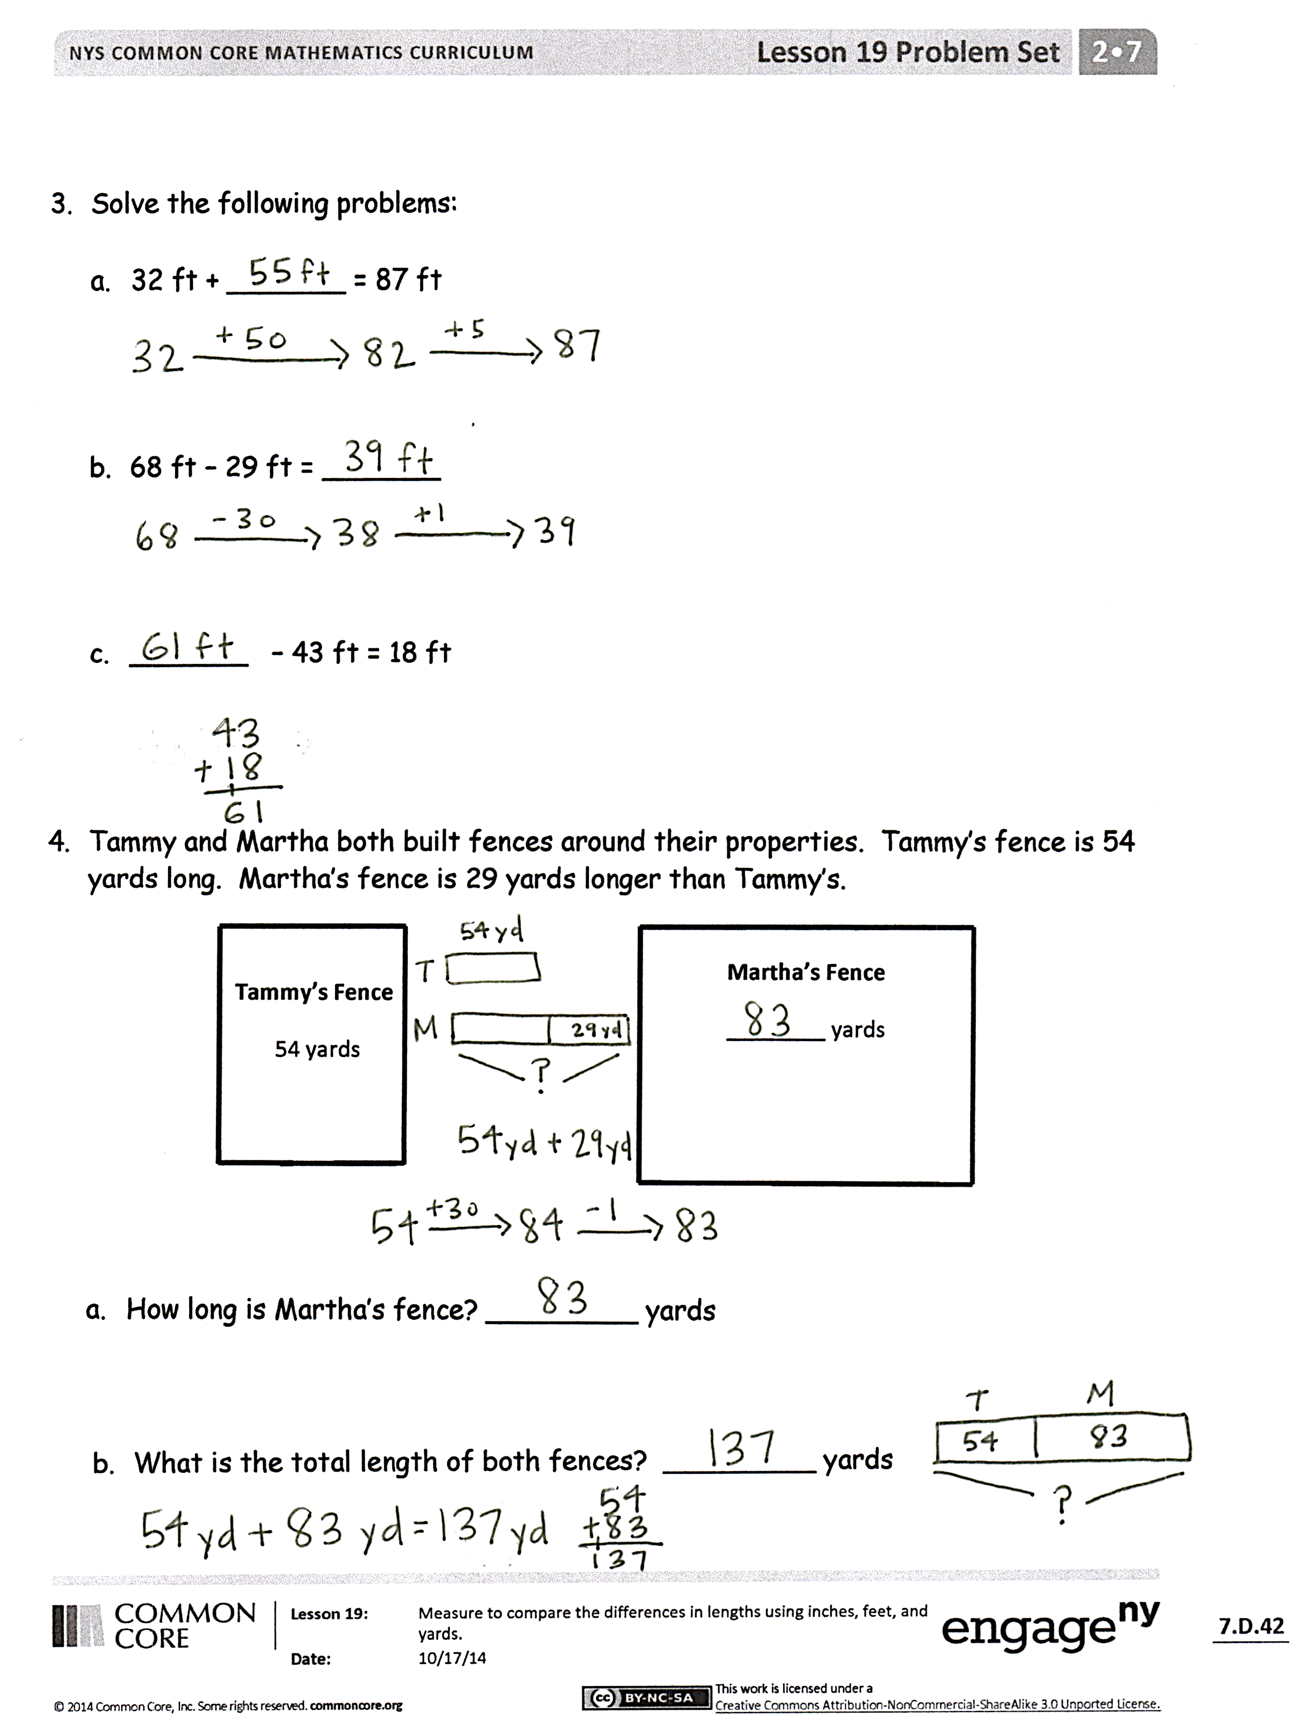
After the Student Debrief, instruct students to complete the Exit Ticket. A review of their work will help with assessing students’ understanding of the concepts that were presented in today’s lesson and planning more effectively for future lessons. The questions may be read aloud to the students.

Number Correct: _______
A
Subtraction Patterns
 | 10 – 1 = |  |  |  | 21 – 6 =
 | 10 – 2 = |  |  |  | 91 – 6 =
 | 20 – 2 = |  |  |  | 10 – 7 =
 | 40 – 2 = |  |  |  | 11 – 7 =
 | 10 – 2 = |  |  |  | 31 – 7 =
 | 11 – 2 = |  |  |  | 10 – 8 =
 | 21 – 2 = |  |  |  | 11 – 8 =
 | 51 – 2 = |  |  |  | 41 – 8 =
 | 10 – 3 = |  |  |  | 10 – 9 =
 | 11 – 3 = |  |  |  | 11 – 9 =
 | 21 – 3 = |  |  |  | 51 – 9 =
 | 61 – 3 = |  |  |  | 12 – 3 =
 | 10 – 4 = |  |  |  | 82 – 3 =
 | 11 – 4 = |  |  |  | 13 – 5 =
 | 21 – 4 = |  |  |  | 73 – 5 =
 | 71 – 4 = |  |  |  | 14 – 6 =
 | 10 – 5 = |  |  |  | 84 – 6 =
 | 11 – 5 = |  |  |  | 15 – 8 =
 | 21 – 5 = |  |  |  | 95 – 8 =
 | 81 – 5 = |  |  |  | 16 – 7 =
 | 10 – 6 = |  |  |  | 46 – 7 =
 | 11 – 6 = |  |  |  | 68 – 9 =
Number Correct: _______
Improvement: _______
B
[KEY]

Subtraction Patterns
 | 10 – 2 = |  |  |  | 21 – 6 =
 | 20 – 2 = |  |  |  | 41 – 6 =
 | 30 – 2 = |  |  |  | 10 – 7 =
 | 50 – 2 = |  |  |  | 11 – 7 =
 | 10 – 2 = |  |  |  | 51 – 7 =
 | 11 – 2 = |  |  |  | 10 – 8 =
 | 21 – 2 = |  |  |  | 11 – 8 =
 | 61 – 2 = |  |  |  | 61 – 8 =
 | 10 – 3 = |  |  |  | 10 – 9 =
 | 11 – 3 = |  |  |  | 11 – 9 =
 | 21 – 3 = |  |  |  | 31 – 9 =
 | 71 – 3 = |  |  |  | 12 – 3 =
 | 10 – 4 = |  |  |  | 92 – 3 =
 | 11 – 4 = |  |  |  | 13 – 5 =
 | 21 – 4 = |  |  |  | 43 – 5 =
 | 81 – 4 = |  |  |  | 14 – 6 =
 | 10 – 5 = |  |  |  | 64 – 6 =
 | 11 – 5 = |  |  |  | 15 – 8 =
 | 21 – 5 = |  |  |  | 85 – 8 =
 | 91 – 5 = |  |  |  | 16 – 7 =
 | 10 – 6 = |  |  |  | 76 – 7 =
 | 11 – 6 = |  |  |  | 58 – 9 =

Name Date
Measure each set of lines in inches, and write the length on the line. Complete the comparison sentence.
- Line A _____________________________
Line B ___________

Line A measured about ____ inches. Line B measured about _____ inches.
Line A is about _____ inches longer than Line B.

- Line C _________________
Line D __________________________________

Line C measured about ____ inches. Line D measured about ____ inches.
Line C is about _____ inches shorter than Line D.

- Solve the following problems:
- 32 ft + _______ = 87 ft

- 68 ft – 29 ft = _______

- _______ – 43 ft = 18 ft

- Tammy and Martha both built fences around their properties. Tammy’s fence is 54 yards long. Martha’s fence is 29 yards longer than Tammy’s.

Martha’s Fence
________ yards

Tammy’s Fence
54 yards

- How long is Martha’s fence? _________ yards

- What is the total length of both fences? _________ yards

Name Date
Measure the set of lines in inches and write the length on the line. Complete the comparison sentence.
Line A _____________________________
Line B ___________________________________

Line A measured about ____ inches. Line B measured about ____ inches.

Line A is about _____ inches longer/shorter than Line B.

Name Date
Measure each set of lines in inches and write the length on the line. Complete the comparison sentence.
- Line A _____________________________
Line B _________________
Line A measured about ____ inches. Line B measured about _____ inches.
Line A is about _____ inches longer than Line B.

- Line C _______________________
Line D _________________
Line C measured about ____ inches. Line D measured about ____ inches.
Line D is about _____ inches shorter than Line C.

- Solve. Check your answers with a related addition or subtraction sentence.

- 8 inches – 5 inches = inches

inches + 5 inches = 8 inches

- 8 centimeters + _______ centimeters = 19 centimeters

- 17 centimeters – 8 centimeters = _______ centimeters

- _______ centimeters + 6 centimeters = 18 centimeters

- 2 inches + ______ inches = 7 inches

- 12 inches - _______ = 8 inches

