Lesson 17
Objective: Develop estimation strategies by applying prior knowledge of length and using mental benchmarks.

Suggested Lesson Structure
 Fluency Practice (10 minutes)
 Application Problem (5 minutes)
 Concept Development (35 minutes)
 Student Debrief (10 minutes)
Total Time (60 minutes)
Fluency Practice (10 minutes)
- Subtraction Fact Flash Cards 2.OA.2 (5 minutes)
- Grade 2 Core Fluency Differentiated Practice Sets 2.OA.2 (5 minutes)
Subtraction Fact Flash Cards (5 minutes)
Materials: (T) Subtraction fact flash cards set 2 (Lesson 14 Fluency Template)
Note: This is a teacher-directed, whole-class activity. By practicing subtraction facts, students gain mastery of differences within 20 through regular, motivating practice.
Grade 2 Core Fluency Differentiated Practice Sets (5 minutes)
Materials: (S) Core Fluency Practice Sets from (Lesson 1 Core Fluency Practice Sets)
Note: During Topic D and for the remainder of the year, each day’s Fluency Practice includes an opportunity for review and mastery of the sums and differences with totals through 20 by means of the Core Fluency Practice Sets or Sprints. The process is detailed and Practice Sets are provided in Lesson 1.
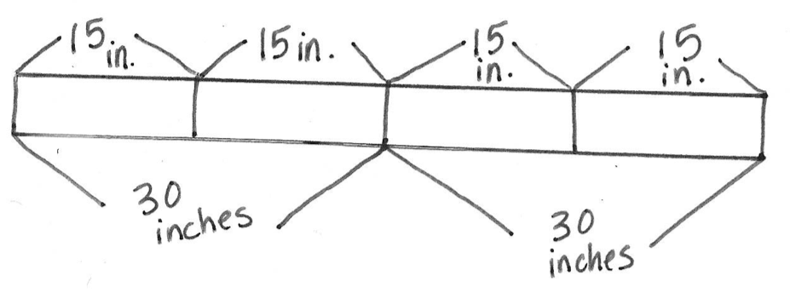
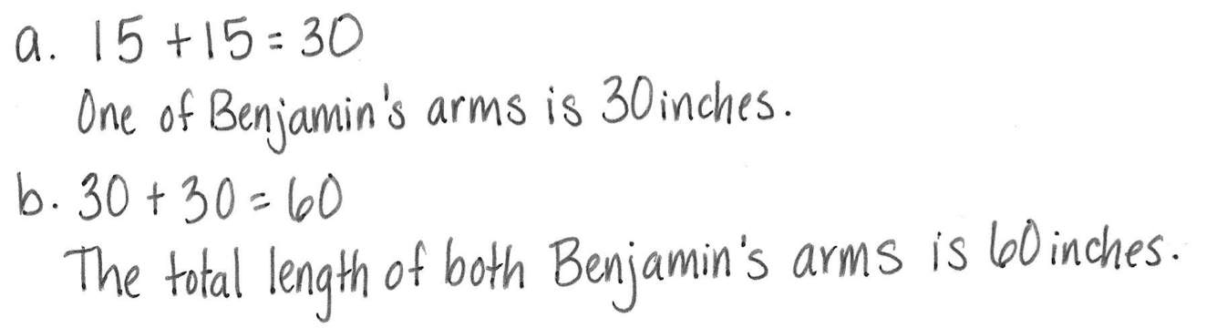
Application Problem (5 minutes)
Benjamin measures his forearm and records the length as 15 inches. Then, he measures his upper arm and realizes it’s the same!
- How long is one of Benjamin’s arms?
- What is the total length of both of Benjamin’s arms together?
Note: This Application Problem provides practice of the previous day’s concepts. Provide support when needed, but encourage students to solve independently as much as possible.
Concept Development (35 minutes)
Materials: (T) 2 charts (pictured below), new unused pink eraser (S) Lesson 16 Recording Sheets
The beginning of this Concept Development provides a structure for students to develop a class list of mental benchmarks. Choose a mental benchmark for each length unit that is meaningful for each individual class.
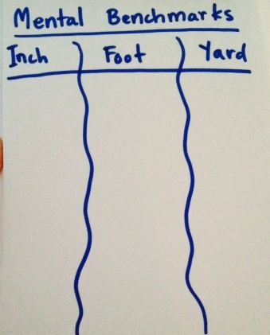
Part 1: Identify mental benchmarks.
T: Look back at your Recording Sheets from yesterday’s centers. Let’s make a list of things we measured that were about the size of a foot. (Record ideas on the chart as students say them.)
S: My math journal was about a foot. It was just a little bit shorter. The construction paper was exactly a foot.
The homework sheet was a little less than a foot long.
T: What on our list could remind us about the length of a foot?
S: The paper!
T: The length of the paper or the 12-inch ruler can be a mental benchmark for the length of a foot or 12 inches.
T: How about a mental benchmark for a yard?
(Chart as students share.)
S: My arms are a yard when I hold them open like this. I measured my brother’s bike at home, and it was
3 feet, which is a yard! The width of our classroom door was exactly a yard!

NOTES ON
MULTIPLE MEANS
OF REPRESENTATION:
Explain the idea of a mental benchmark by showing a few examples. For instance, demonstrate that the width of a paper clip is about a centimeter. Explain that having the mental benchmark helps in estimating the length of objects.
T: Which item on our list should be our class benchmark for the yard?
S: The width of the door!
T: Look at your recording sheet. Did anyone find something that could be our mental benchmark for an inch?
S: The middle part of my finger is an inch! I measured a quarter, and it was an inch long.
T: Which one should be our benchmark for an inch?
S: The quarter!
T: Talk to your partner about how it is helpful to understand mental benchmarks when people say things such as, “Your new teacher is about 6 feet tall,” “Draw a line about 6 inches long,” or “The room is about 10 yards long.”
S: Then, you will know better who might be your new teacher. Then, you will know about how long to draw the line. Then, you can understand the size of the room. If you understand benchmarks, you can understand what people are talking about better.
Part 2: Use mental benchmarks to estimate lengths and check estimations with measurement tools.
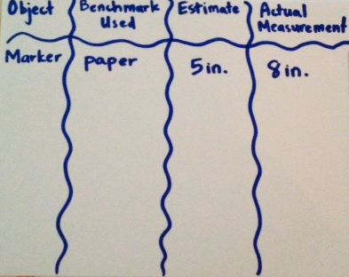
T: The width of a quarter is a benchmark for…?
S: An inch.
T: The length of a paper is a benchmark for…?
S: A foot.
T: The width of a door is a benchmark for…?
S: A yard!
T: Let’s use mental benchmarks to estimate measurements.
T: Step 1: Use a mental benchmark to think how long something is. Look at this dry erase marker. Turn and talk: How long do you think it is?
S: Shorter than the paper. Maybe 7 inches? It’s longer than a quarter, maybe 5 inches or so.
T: (Record estimates.)
T: Step 2: Let’s measure and see how close our estimates are! Which unit should we use?
S: Inches!
T: (Have a student measure and record the length on the chart.)
S: The actual length of the marker is 8 inches.
MP.6
T: Were our estimates close to the actual length?

NOTES ON
MULTIPLE MEANS
OF ACTION AND EXPRESSION:
Before this lesson, find some time to practice estimating and measuring different objects with students working below grade level. This practice will allow them to participate in the lesson in a more meaningful way and perhaps take the lead in group discussions.
S: Yes! Mine wasn’t that close. Some were.
T: What strategies can we use so that our estimates are close to the actual length?
S: Think about which benchmark is closest in length to what we are measuring and compare. Is it a little more or a little less, a lot more or a lot less? Visualize how many times a benchmark makes the same length as the thing you’re measuring.
T: Step 1 is…?
S: Choose a mental benchmark and estimate.
T: Step 2 is…?
S: Measure to see how close we are.
Repeat the above process with two or three more objects around the room before moving on to the Problem Set.
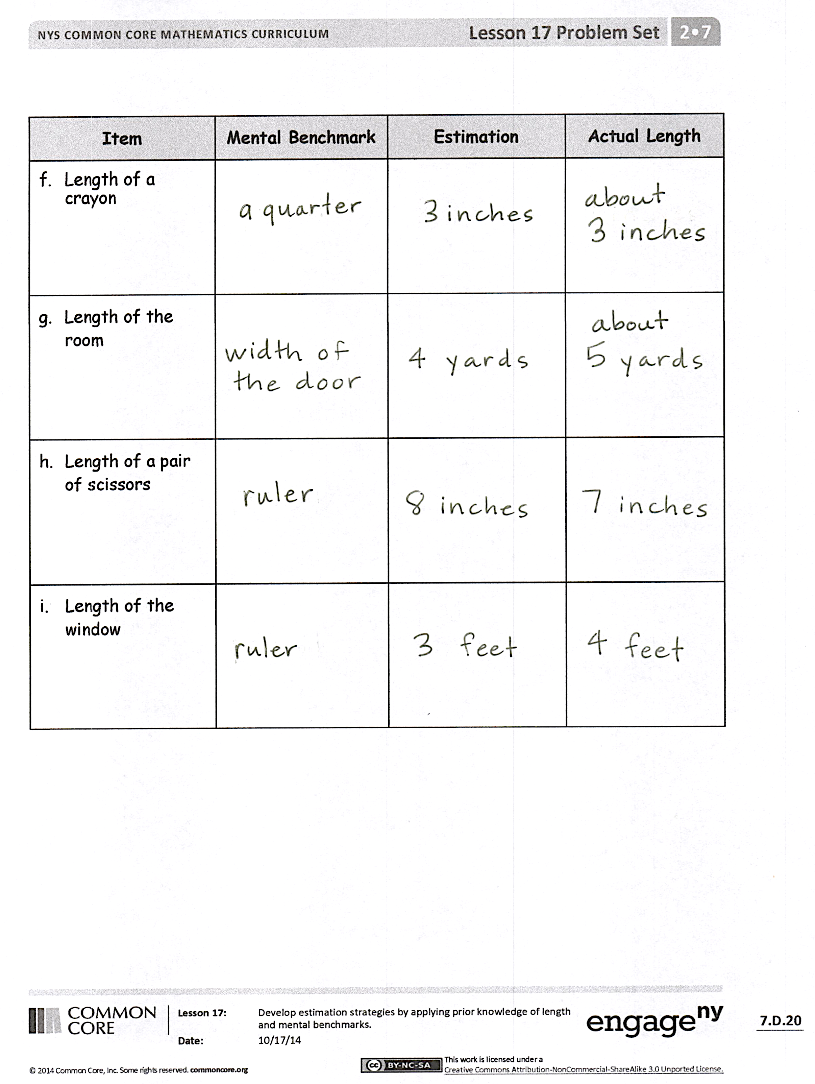
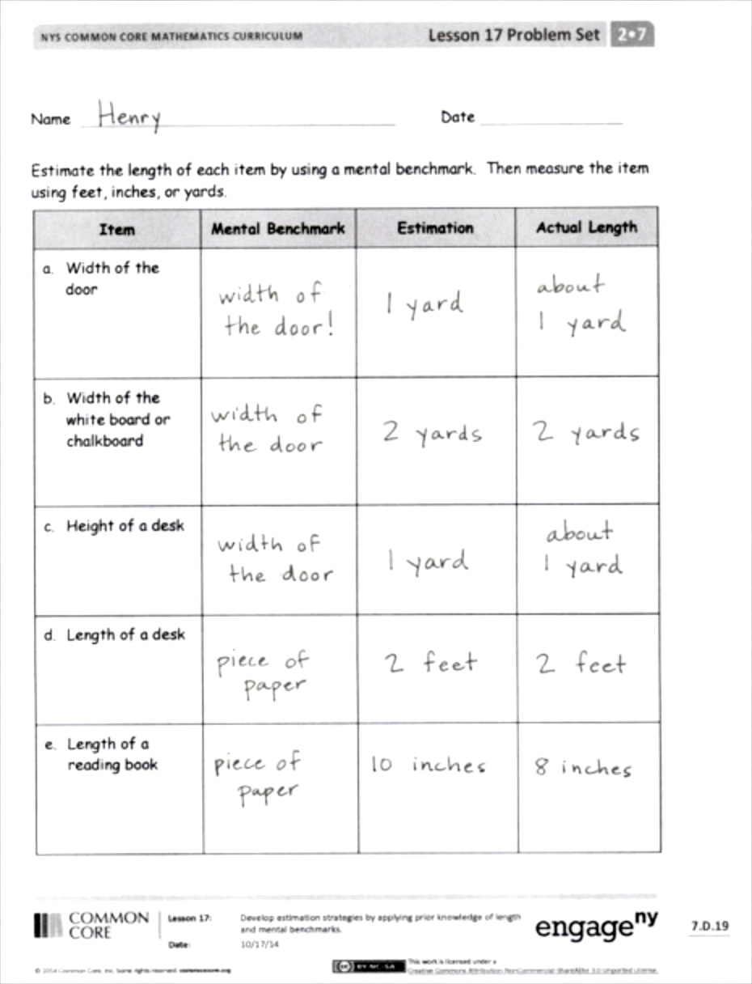
Problem Set (10 minutes)
Students should do their personal best to complete the Problem Set within the allotted 10 minutes. For some classes, it may be appropriate to modify the assignment by specifying which problems they work on first. Some problems do not specify a method for solving. Students should solve these problems using the RDW approach used for Application Problems.
Student Debrief (10 minutes)
Lesson Objective: Develop estimation strategies by applying prior knowledge of length and using mental benchmarks.
The Student Debrief is intended to invite reflection and active processing of the total lesson experience.
Invite students to review their solutions for the Problem Set. They should check work by comparing answers with a partner before going over answers as a class. Look for misconceptions or misunderstandings that can be addressed in the Debrief. Guide students in a conversation to debrief the Problem Set and process the lesson. Any combination of the questions below may be used to lead the discussion.
- Look at your Problem Set. With a partner, figure out the difference between your estimate of the height of a desk and the actual measure of the height of a desk. Did you include the unit?
- Look at your Problem Set. Were there some estimates and actual length measures that were exactly the same? Why do you think that you were able to guess the right measurement for some items?
- How do mental benchmarks, objects that are about the same length as standard forms of measure like the 12-inch ruler, help when we are comparing length?
- Talk to your partner about why getting good at estimating length could be helpful.
- Sometimes when we measure things, they are not exactly a foot or a yard long. How do we record things that are a foot and a little bit more or a yard and a foot more?
Exit Ticket (3 minutes)
After the Student Debrief, instruct students to complete the Exit Ticket. A review of their work will help with assessing students’ understanding of the concepts that were presented in today’s lesson and planning more effectively for future lessons. The questions may be read aloud to the students.

Name Date
Estimate the length of each item by using a mental benchmark. Then, measure the item using feet, inches, or yards.
Item | Mental Benchmark | Estimation | Actual Length
- Width of the door

- Width of the white board or chalkboard

- Height of a desk

- Length of a desk

- Length of a reading book

Item | Mental Benchmark | Estimation | Actual Length
- Length of a crayon

- Length of the room

- Length of a pair of scissors

- Length of the window

Name Date
Estimate the length of each item by using a mental benchmark. Then, measure the item using feet, inches, or yards.
Item | Mental Benchmark | Estimation | Actual Length
- Length of an eraser

- Width of this paper

Name Date
Estimate the length of each item by using a mental benchmark. Then, measure the item using feet, inches, or yards.
Item | Mental Benchmark | Estimation | Actual Length
- Length of a bed

- Width of a bed

- Height of a table

- Length of a table

- Length of a book

Item | Mental Benchmark | Estimation | Actual Length
- Length of your pencil

- Length of a refrigerator

- Height of a refrigerator

- Length of a sofa

