Lesson 15
Objective: Apply concepts to create inch rulers; measure lengths using inch rulers.

Suggested Lesson Structure
 Fluency Practice (11 minutes)
 Application Problem (5 minutes)
 Concept Development (34 minutes)
 Student Debrief (10 minutes)
Total Time (60 minutes)
Fluency Practice (11 minutes)
- Sprint: Adding and Subtracting by 2 2.OA.2 (9 minutes)
- Subtraction Fact Flash Cards 2.OA.2 (2 minutes)
Sprint: Adding and Subtracting by 2 (9 minutes)
Materials: (S) Adding and Subtracting by 2 Sprint
Note: Students practice adding and subtracting by 2 to gain mastery of the sums and differences within 20.
Subtraction Fact Flash Cards (2 minutes)
Materials: (T) Subtraction fact flash cards set 2 (Lesson 14 Fluency Template)
Note: By practicing subtraction facts, students gain mastery of differences within 20.
This can be a teacher-directed, whole-class activity or an opportunity for students to work in pairs. The teacher can hold the cards and use choral response or distribute the cards and have students pair up to question each other.
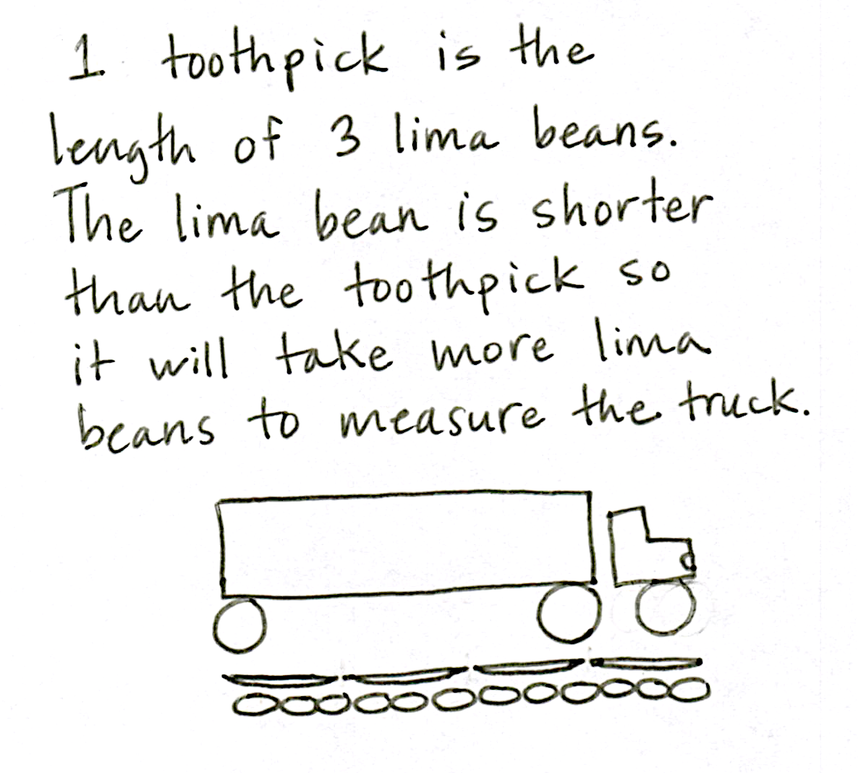
Application Problem (5 minutes)
Materials: (S) Small object approximately 6 inches long or less,
9 lima beans, 3 toothpicks per pair
Edwin and Tina have the same toy truck. Edwin says his is 4 toothpicks long. Tina says hers is 12 lima beans long. How can they both be right?
Work with a partner to measure your object. Partner A, measure with lima beans. Partner B, measure with toothpicks. Use words or pictures to explain how Edwin and Tina can both be right.
Note: This problem gives students a hands-on opportunity to reason through the relationship between the size and number of length units: the smaller the length unit, the larger the number of units, and the larger the length unit, the smaller the number of units. This anticipates the comparison between centimeters and inches that students explore in Lesson 18.
Concept Development (34 minutes)

NOTES ON
MULTIPLE MEANS
OF ACTION AND REPRESENTATION:
Glue a toothpick or Wikki Stix to represent each of the hash marks for blind or visually impaired students, enabling them to feel the length units on their ruler.
Materials: (S) 12-inch long × 2-inch wide strip of tag board or sentence strip, paper or math journal, 1 inch tile,
2-inch paper clip, 3 × 5 index card
Pass out tag board and inch tiles.
T: Yesterday, we used a 1-inch tile to measure the length of various objects. Today, we’re going to create a tool that will help us measure inches in a more efficient way.
T: Remember how we made centimeter rulers earlier in the year? Let’s make an inch ruler today!
T: Watch how I make the first hash mark on my ruler. (Demonstrate placing the tile at the left end of the tag board, drawing the line, and writing 1 above it.)

NOTES ON
MULTIPLE MEANS
OF ENGAGEMENT:
Some students will have a deeper understanding of concepts of measurement. Give them the opportunity to explain to their peers, using words, drawings, or actions, their understanding of notions such as why there can be no gaps or overlaps when creating their rulers.
T: Now, you do the same.
Circulate to ensure that all students are marking the hash marks correctly on the tag board.
T: What does the number 1 mean?
S: It’s one length unit. It’s where the length unit ends. It’s the space you have measured so far.
T: Yes. And what do we call this length unit that we’re using?
S: An inch!
T: Yes. And where should 0 go on our rulers?
S: At the very beginning of the ruler. Before the number 1.
T: Let’s write 0 at the left edge of the ruler. (Model as students do the same.)
T: What does the 0 mean?
S: It means you haven’t measured anything yet. It’s where you start to measure.
T: So, when we put our tile at the edge of the ruler and then marked the end of the tile with the hash mark, we actually measured 1 inch.
T: You’re going to finish making your rulers now. Each time you move your tile forward, be sure to put it down right on top of the line. Why is it important not to have any gaps between the tiles?
S: Our measurements would all be different. The length units have to be equal.
T: Correct! Remember to write each number directly above the hash marks as you go.
Support students who need assistance, and allow those who show mastery to complete their rulers independently. Early finishers can explore measuring objects around the room. When all students have finished, distribute the paper, paper clips, and index cards.
T: What is the last number on your ruler?
S: 12.
T: So, this ruler measures 12 what?
S: 12 inches!
T: Yes! And 12 inches make a larger unit called a foot.
T: Everyone say this with me: 12 inches equals 1 foot.
S: (Repeat.)
T: Show your partner how to measure your paper clip with the ruler. (Watch for misconceptions.)
T: How long is the paper clip?
S: 2 inches.
T: So, the number 2 means the number of inches so far. The end of this paper clip is where 2 length units, in this case, inches, end.
T: Now, on your paper, use your ruler to draw a line that is 2 inches long. (Pause.)
T: Lay your paper clip along the line you drew. What do you notice?
S: They’re the same length!
T: Tell your partner: How many more inches would we need to add to make a foot? How do you know?
S: Two inches plus 10 inches equals 12 inches, and 12 inches equals 1 foot.
T: Now, measure the length of the index card. Check your answer with a partner. (Allow students time to check answers.)
MP.2
T: How long is the index card?
S: 5 inches.

T: So, the card is the same length as the space between 0 and 5 on your ruler. It is the same length as 5 inches.
T: Use your ruler to draw a line that is 5 inches long. Then, lay your index card along the line and compare the two lengths.
MP.2
S: They’re both 5 inches long. They’re the same length.
T: 5 inches plus how many inches equal 1 foot?
S: 7 inches!
T: So, a foot is composed of 12 inches, just as a unit of ten is composed of 10…?
S: Ones!
T: And a unit of one hundred is composed of 10…?
S: Tens!
T: A dollar is composed of 100…?
S: Cents!
T: How many inches equal one foot? Give me a complete sentence.
S: 12 inches equal 1 foot!
T: Why is it more efficient to use a ruler than to measure using inch tiles?
S: You can measure all at once instead of going 1 plus 1 plus 1. Everybody has rulers, but I only see inch tiles in school. It takes a lot longer to mark and move forward than to just use a ruler.
On the ruler, the inches all stay together in the same place, so it’s like all the inch tiles are connected, which is easier to use.
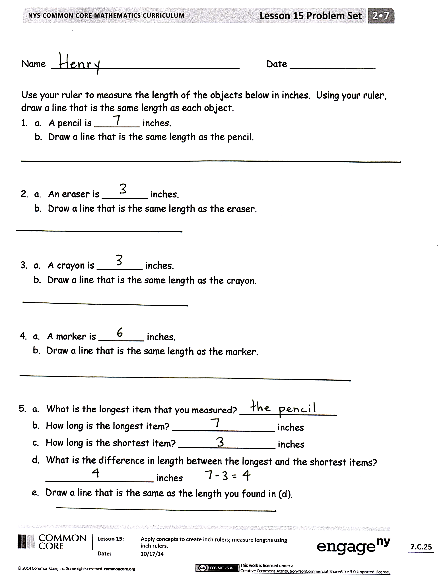
T: That’s a great way to think of the ruler! And I’d much rather measure my desk with a ruler than with a single inch tile!
If students need more support measuring or drawing lines of equal length, repeat the procedure to measure the width of the index card and draw a line of equal length. Otherwise, as students demonstrate proficiency using the ruler to measure and draw lines of equal lengths, allow them to move on to the Problem Set.
Problem Set (10 minutes)
Students should do their personal best to complete the Problem Set within the allotted 10 minutes. For some classes, it may be appropriate to modify the assignment by specifying which problems they work on first. Some problems do not specify a method for solving. Students should solve these problems using the RDW approach used for Application Problems.

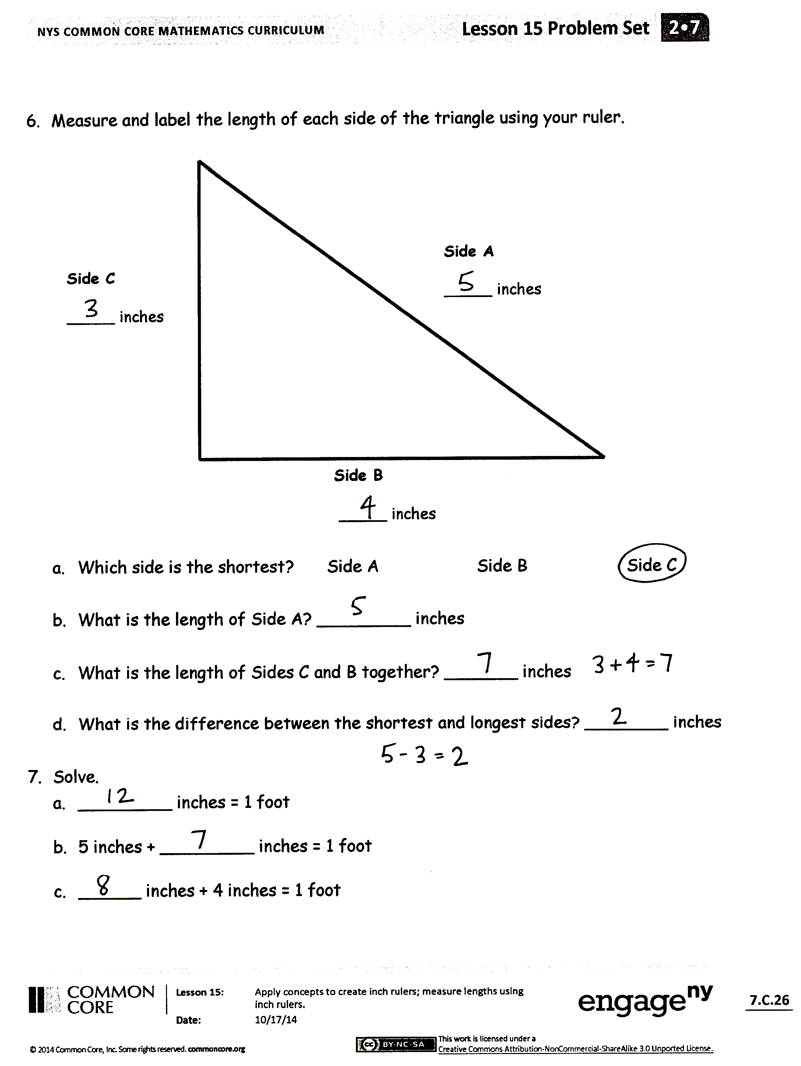
Student Debrief (10 minutes)
Lesson Objective: Apply concepts to create inch rulers; measure lengths using inch rulers.
The Student Debrief is intended to invite reflection and active processing of the total lesson experience.
Invite students to review their solutions for the Problem Set. They should check work by comparing answers with a partner before going over answers as a class. Look for misconceptions or misunderstandings that can be addressed in the Debrief. Guide students in a conversation to debrief the Problem Set and process the lesson.
Any combination of the questions below may be used to lead the discussion.
- Look at the things you measured on your Problem Set. Did you have to round to the nearest inch on any of the items? Was it easier to measure objects or the lines on the triangle? Why? (Lines, because there is a definite starting
and ending point. Objects are three-dimensional. The triangle was harder because I had to keep turning my ruler.)
- When you compared the length of two objects on your Problem Set, did you use an equation? What operation did you use in your equation?
- When we add 5 and 7, many of us make ten and add two more. What about if we add 9 inches and 6 inches? Would we make ten? How many does 9 need to make a foot? How many extra inches would there be? So, 9 + 6 = 1 ten 5 ones, and 9 inches + 6 inches = 1 foot 3 inches. Explain to your partner how you might add 8 inches and 7 inches, making a foot first.
- There are many different types of units. Most of the time, there are units within units. For example, within a foot there are inches, and within a dollar there are cents. What units are within a hundred? A ten? A meter? How does having smaller units and larger units help us?
- Think about when we were making our inch rulers today. Tell your partner exactly what the length unit was on our rulers. Will length units always be an inch?
Exit Ticket (3 minutes)
After the Student Debrief, instruct students to complete the Exit Ticket. A review of their work will help with assessing students’ understanding of the concepts that were presented in today’s lesson and planning more effectively for future lessons. The questions may be read aloud to the students.

Number Correct: _______
A
Adding and Subtracting by 2
 | 0 + 2 = |  |  |  | 2 + 4 =
 | 2 + 2 = |  |  |  | 2 + 6 =
 | 4 + 2 = |  |  |  | 2 + 8 =
 | 6 + 2 = |  |  |  | 2 + 10 =
 | 8 + 2 = |  |  |  | 2 + 12 =
 | 10 + 2 = |  |  |  | 2 + 14 =
 | 12 + 2 = |  |  |  | 2 + 16 =
 | 14 + 2 = |  |  |  | 2 + 18 =
 | 16 + 2 = |  |  |  | 0 + 22 =
 | 18 + 2 = |  |  |  | 22 + 22 =
 | 20 – 2 = |  |  |  | 44 + 22 =
 | 18 – 2 = |  |  |  | 66 + 22 =
 | 16 – 2 = |  |  |  | 88 – 22 =
 | 14 – 2 = |  |  |  | 66 – 22 =
 | 12 – 2 = |  |  |  | 44 – 22 =
 | 10 – 2 = |  |  |  | 22 – 22 =
 | 8 – 2 = |  |  |  | 22 + 0 =
 | 6 – 2 = |  |  |  | 22 + 22 =
 | 4 – 2 = |  |  |  | 22 + 44 =
 | 2 – 2 = |  |  |  | 66 + 22 =
 | 2 + 0 = |  |  |  | 888 – 222 =
 | 2 + 2 = |  |  |  | 666 – 222 =
B
[KEY]

Number Correct: _______
Improvement: _______
Adding and Subtracting by 2
 | 2 + 0 = |  |  |  | 4 + 2 =
 | 2 + 2 = |  |  |  | 6 + 2 =
 | 2 + 4 = |  |  |  | 8 + 2 =
 | 2 + 6 = |  |  |  | 10 + 2 =
 | 2 + 8 = |  |  |  | 12 + 2 =
 | 2 + 10 = |  |  |  | 14 + 2 =
 | 2 + 12 = |  |  |  | 16 + 2 =
 | 2 + 14 = |  |  |  | 18 + 2 =
 | 2 + 16 = |  |  |  | 0 + 22 =
 | 2 + 18 = |  |  |  | 22 + 22 =
 | 20 – 2 = |  |  |  | 22 + 44 =
 | 18 – 2 = |  |  |  | 66 + 22 =
 | 16 – 2 = |  |  |  | 88 – 22 =
 | 14 – 2 = |  |  |  | 66 – 22 =
 | 12 – 2 = |  |  |  | 44 – 22 =
 | 10 – 2 = |  |  |  | 22 – 22 =
 | 8 – 2 = |  |  |  | 22 + 0 =
 | 6 – 2 = |  |  |  | 22 + 22 =
 | 4 – 2 = |  |  |  | 22 + 44 =
 | 2 – 2 = |  |  |  | 66 + 22 =
 | 0 + 2 = |  |  |  | 666 – 222 =
 | 2 + 2 = |  |  |  | 888 – 222 =

Name Date
Use your ruler to measure the length of the objects below in inches. Using your ruler, draw a line that is the same length as each object.
- a. A pencil is ________ inches.
- Draw a line that is the same length as the pencil.

- a. An eraser is ________ inches.
- Draw a line that is the same length as the eraser.

- a. A crayon is ________ inches.
- Draw a line that is the same length as the crayon.

- a. A marker is ________ inches.
- Draw a line that is the same length as the marker.

- a. What is the longest item that you measured? _________________
- How long is the longest item? __________________ inches
- How long is the shortest item? _________________ inches
- What is the difference in length between the longest and the shortest items?
___________________ inches
- Draw a line that is the same as the length you found in (d).
- Measure and label the length of each side of the triangle using your ruler.
Side A
_____ inches
Side B
_____ inches
Side C
_____ inches

- Which side is the shortest? Side A Side B Side C

- What is the length of Side A? _________ inches

- What is the length of Sides C and B together? _______ inches

- What is the difference between the shortest and longest sides? ________ inches

- Solve.
  - ______ inches = 1 foot

  - 5 inches + ______ inches = 1 foot

  - ______ inches + 4 inches = 1 foot

Name Date
Measure and label the sides of the shape below.
Side D is ____ inches.
Side A is ____ inches.
Side C is
____ inches.
Side B is
____ inches.

What is the sum of the length of Side B and the length of Side C? _________ inches

Name Date
Measure the length of each household object with your ruler, and then use your ruler to draw a line equal to the length of each object in the space provided.
  - a. A dinner fork is ________ inches.
- Draw a line that is the same length as the fork.

2. a. A tablespoon is ________ inches.
- Draw a line that is the same length as the tablespoon.

Measure two other household objects.
- a. ________________________ is ________ inches.
- Draw a line that is the same length as the _____________________.

- a. ________________________ is ________ inches.
- Draw a line that is the same length as the _____________________.

- a. What was the longest object you measured? _______________________

- What was the shortest object you measured? ______________________

- The difference between the longest object and the shortest object is _______ inches.
- Measure and label the length of each side of each shape in inches using your ruler.

- The longer side of the rectangle is _______ inches.

- The shorter side of the rectangle is _______ inches.

- The longer side of the rectangle is _____ inches longer
than the shorter side of the rectangle.

- The shortest side of the trapezoid is _______ inches.

- The longest side of the trapezoid is _______ inches.

- The longest side of the trapezoid is _____ inches longer than the shortest side.

- Each side of the hexagon is _______ inches.

- The total length around the hexagon is _______ inches.

1
2
3
4
5

