Lesson 14
Objective: Connect measurement with physical units by using iteration with an inch tile to measure.

Suggested Lesson Structure
 Fluency Practice (10 minutes)
 Application Problem (8 minutes)
 Concept Development (32 minutes)
 Student Debrief (10 minutes)
Total Time (60 minutes)
Fluency Practice (10 minutes)
- Subtraction Fact Flash Cards 2.OA.2 (5 minutes)
- Grade 2 Core Fluency Differentiated Practice Sets 2.OA.2 (5 minutes)
Subtraction Fact Flash Cards (5 minutes)
Materials: (T) Subtraction fact flash cards set 2 (Fluency Template)
Note: This is a teacher-directed, whole-class activity. By practicing subtraction facts, students gain mastery of differences within 20.
Grade 2 Core Fluency Differentiated Practice Sets (5 minutes)
Materials: (S) Core Fluency Practice Sets (Lesson 1 Core Fluency Practice Sets)

NOTES ON
MULTIPLE MEANS
OF ACTION AND EXPRESSION:
Invite English language learners to demonstrate understanding by explaining the problem in their native language or by acting it out using books and a bookshelf in class. Extend this invitation to any students who need such support.

Note: During Topic C and for the remainder of the year, each day’s Fluency Practice includes an opportunity for review and mastery of the sums and differences with totals through 20 by means of the Core Fluency Practice Sets or Sprints. The process is detailed and Practice Sets are provided in Lesson 1.

Application Problem (8 minutes)
Frances is moving the furniture in her bedroom. She wants to move the bookcase to the space between her bed and the wall, but she is not sure it will fit.
Talk with a partner: What could Frances use as a measurement tool if she doesn’t have a ruler? How could she use it?
Show your thinking on your personal white board using pictures, numbers, or words.
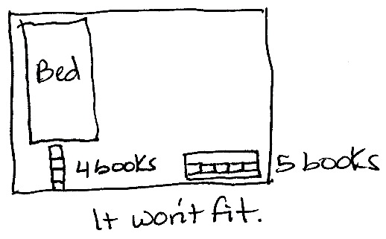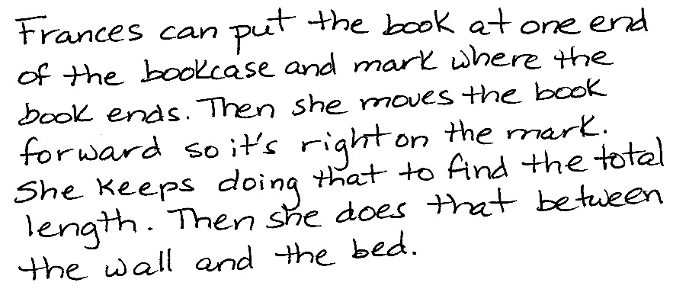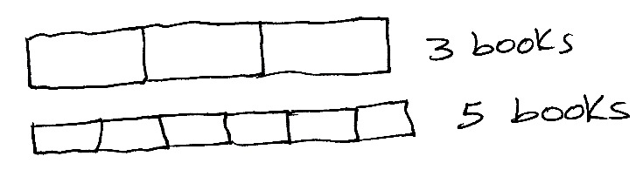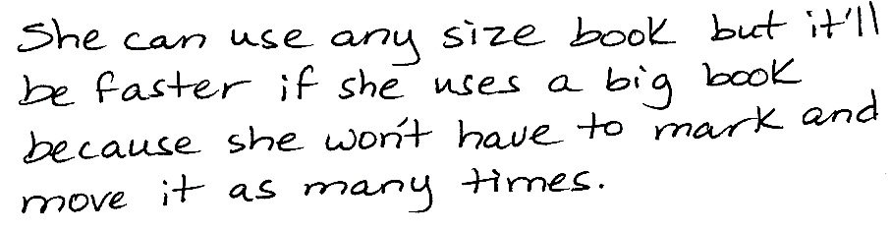

Note: Today’s Application Problem is designed to activate prior knowledge of measurement (the focus of Module 2), in particular, the concept of using iteration with one physical unit to measure, in anticipation of the Concept Development.
Concept Development (32 minutes)
Materials: (T) 1 inch tile, 1 centimeter cube (S) Personal white board with Application Problem work,
1 inch tile, Problem Set
Note: Today’s Concept Development draws upon measurement concepts and skills learned in Module 2. Students refresh and apply their knowledge about these concepts, but now they will use an inch tile instead of a centimeter cube.
Call students to bring their Application Problem work and sit in a circle on the carpet. Invite them to share their thinking.
T: When talking about our story problem, someone mentioned the mark and move forward strategy. Could you explain that a little more if Frances uses a book as a measurement tool?
S: She could put the book down at the beginning of the bookcase and mark where it ends and then move the book forward so it starts on that mark and mark where it ends again. She keeps doing that until the whole length of the bookcase is measured. She can’t leave any space between the book and the mark.
T: How might that help Frances solve her problem?
S: If the bookcase is 5 books long and the space between the wall and the bed is 4 books long, she knows the bookcase won’t fit. If she measures the bookcase and can fit the same number of books or more, then she knows it will fit.
T: Does the size of the book matter?
S: No, but she has to use the same-size book to measure the bookcase and the space. If she uses a small book, she’ll have to move it a lot of times to measure. If she uses a larger book, she’ll cover the space faster.
T: You remembered all of the important ideas!
T: (Hold up the centimeter cube.) Take a moment to remember how we used this earlier in the year. What is it called? How did we use it? (Allow students time to share with a partner.)
S: It’s a centimeter cube! We used it to measure things. Sometimes we used more than one cube, and sometimes we used just one. We did mark and move forward, and we had to be careful not to leave any space in between. We used it to make a ruler!
T: Today, we’re going to look at a different unit of measurement, the inch.
T: (Hold up an inch tile alongside the centimeter cube.) How does the size of the inch tile compare to the size of the centimeter cube?
S: The inch tile is bigger!
T: Can we use the inch tile to measure in the same way that we used the centimeter cube?
S: Yes!
Draw a 4-inch line on the board. Put a hash mark at the beginning and end of the line.
T: Watch how I use the inch tile to measure this line. I put the tile at the beginning of the line on the hash mark and make another mark where the tile ends. Then, I move the tile forward and place the edge right on top of the mark. (Demonstrate step by step until the total length of the line is measured.)
T: Talk with your partner: What do you notice about the spaces between the hash marks?
S: They’re all the same length.
T: Exactly! How many inch tiles long is my line?

NOTES ON
MULTIPLE MEANS
OF REPRESENTATION:
Some students may mistakenly count the hash marks and give an answer of 5 inch tiles. Visually demonstrate to them that the space from the beginning of the line to the first mark is 1 length unit by placing a tile there. Have students count as each subsequent space is filled with the tile.

S: 4 inch tiles long.
T: Correct! What happens if my line isn’t exactly 4 inch tiles long? Discuss with your partner.
S: If it’s a half or more of a tile longer, it is about 5 inch tiles long. If it’s less than half of a tile, it is about
4 inch tiles long.
T: Yes! (Demonstrate on the board by extending and shortening the line and measuring.)
T: Now, it’s your turn! We’re going to use the Problem Set for the rest of the lesson.
MP.6
T: Use your inch tile and the mark and move forward strategy to measure the objects listed on the Problem Set. Record each measurement in the table.
Note: This activity provides an opportunity to work with a small group that needs support with any aspects of today’s lesson.
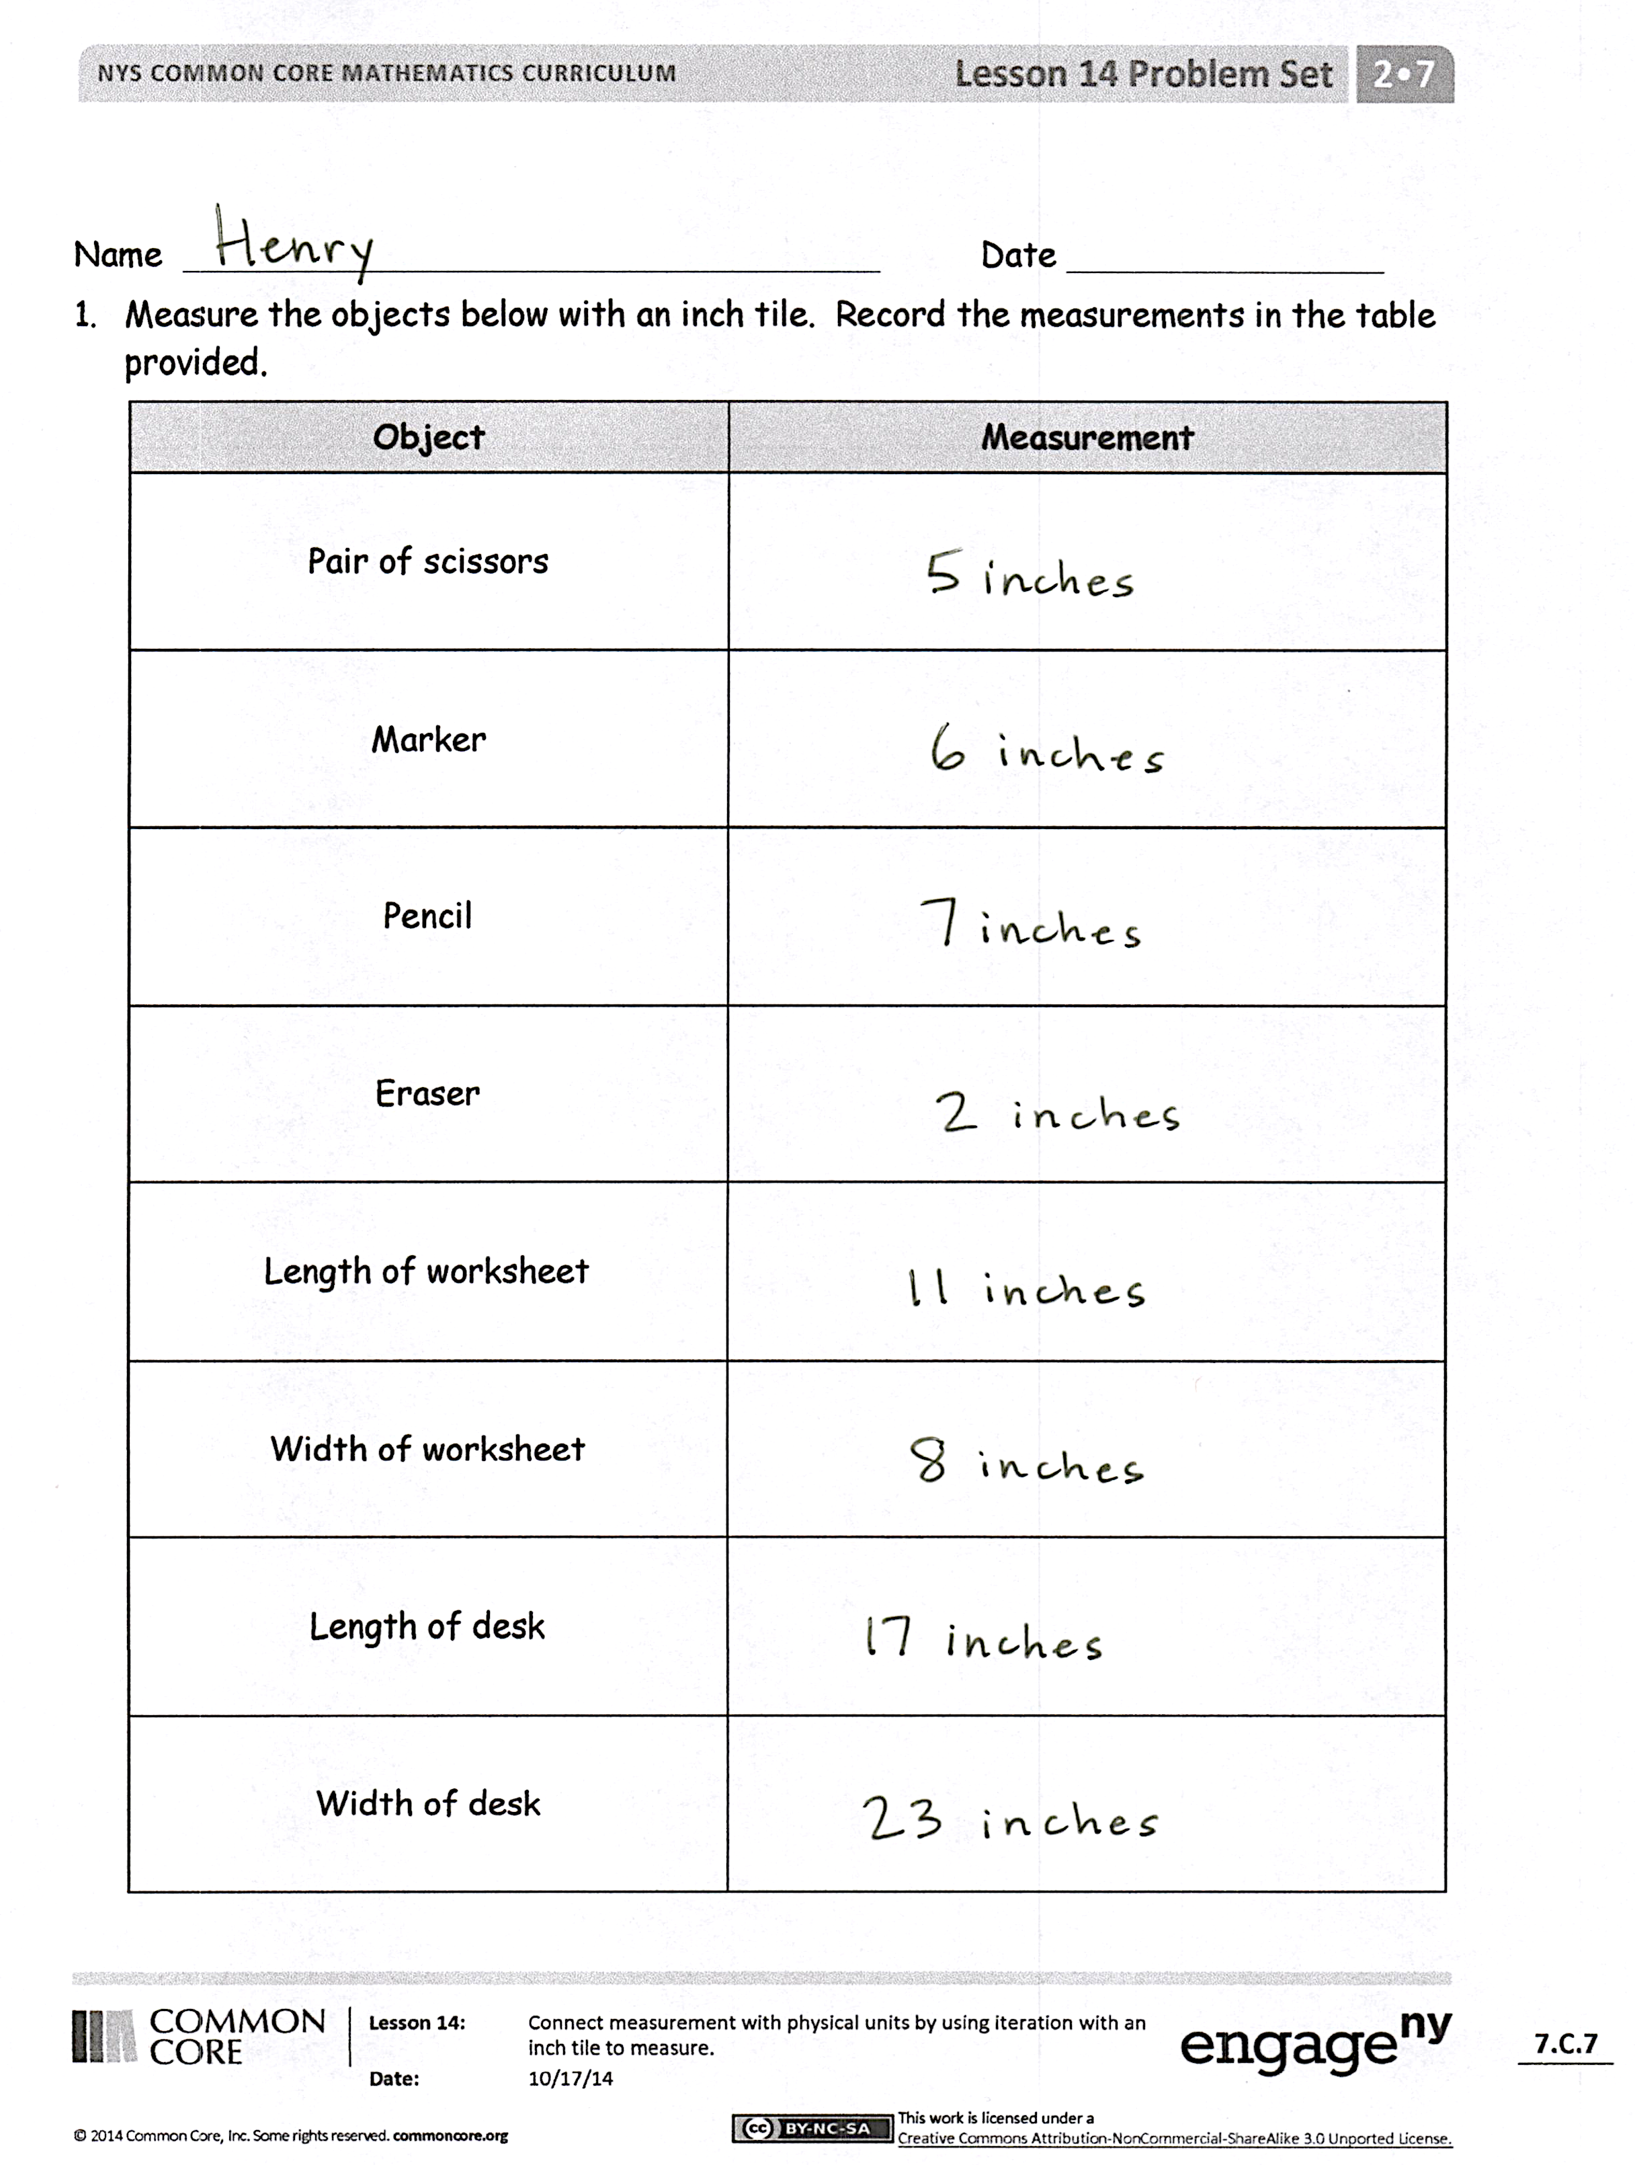
Problem Set (10 minutes)
Students should do their personal best to complete the Problem Set within the allotted 10 minutes. For some classes, it may be appropriate to modify the assignment by specifying which problems they work on first. Some problems do not specify a method for solving. Students should solve these problems using the RDW approach used for Application Problems.
Student Debrief (10 minutes)
Lesson Objective: Connect measurement with physical units by using iteration with an inch tile to measure.
The Student Debrief is intended to invite reflection and active processing of the total lesson experience.
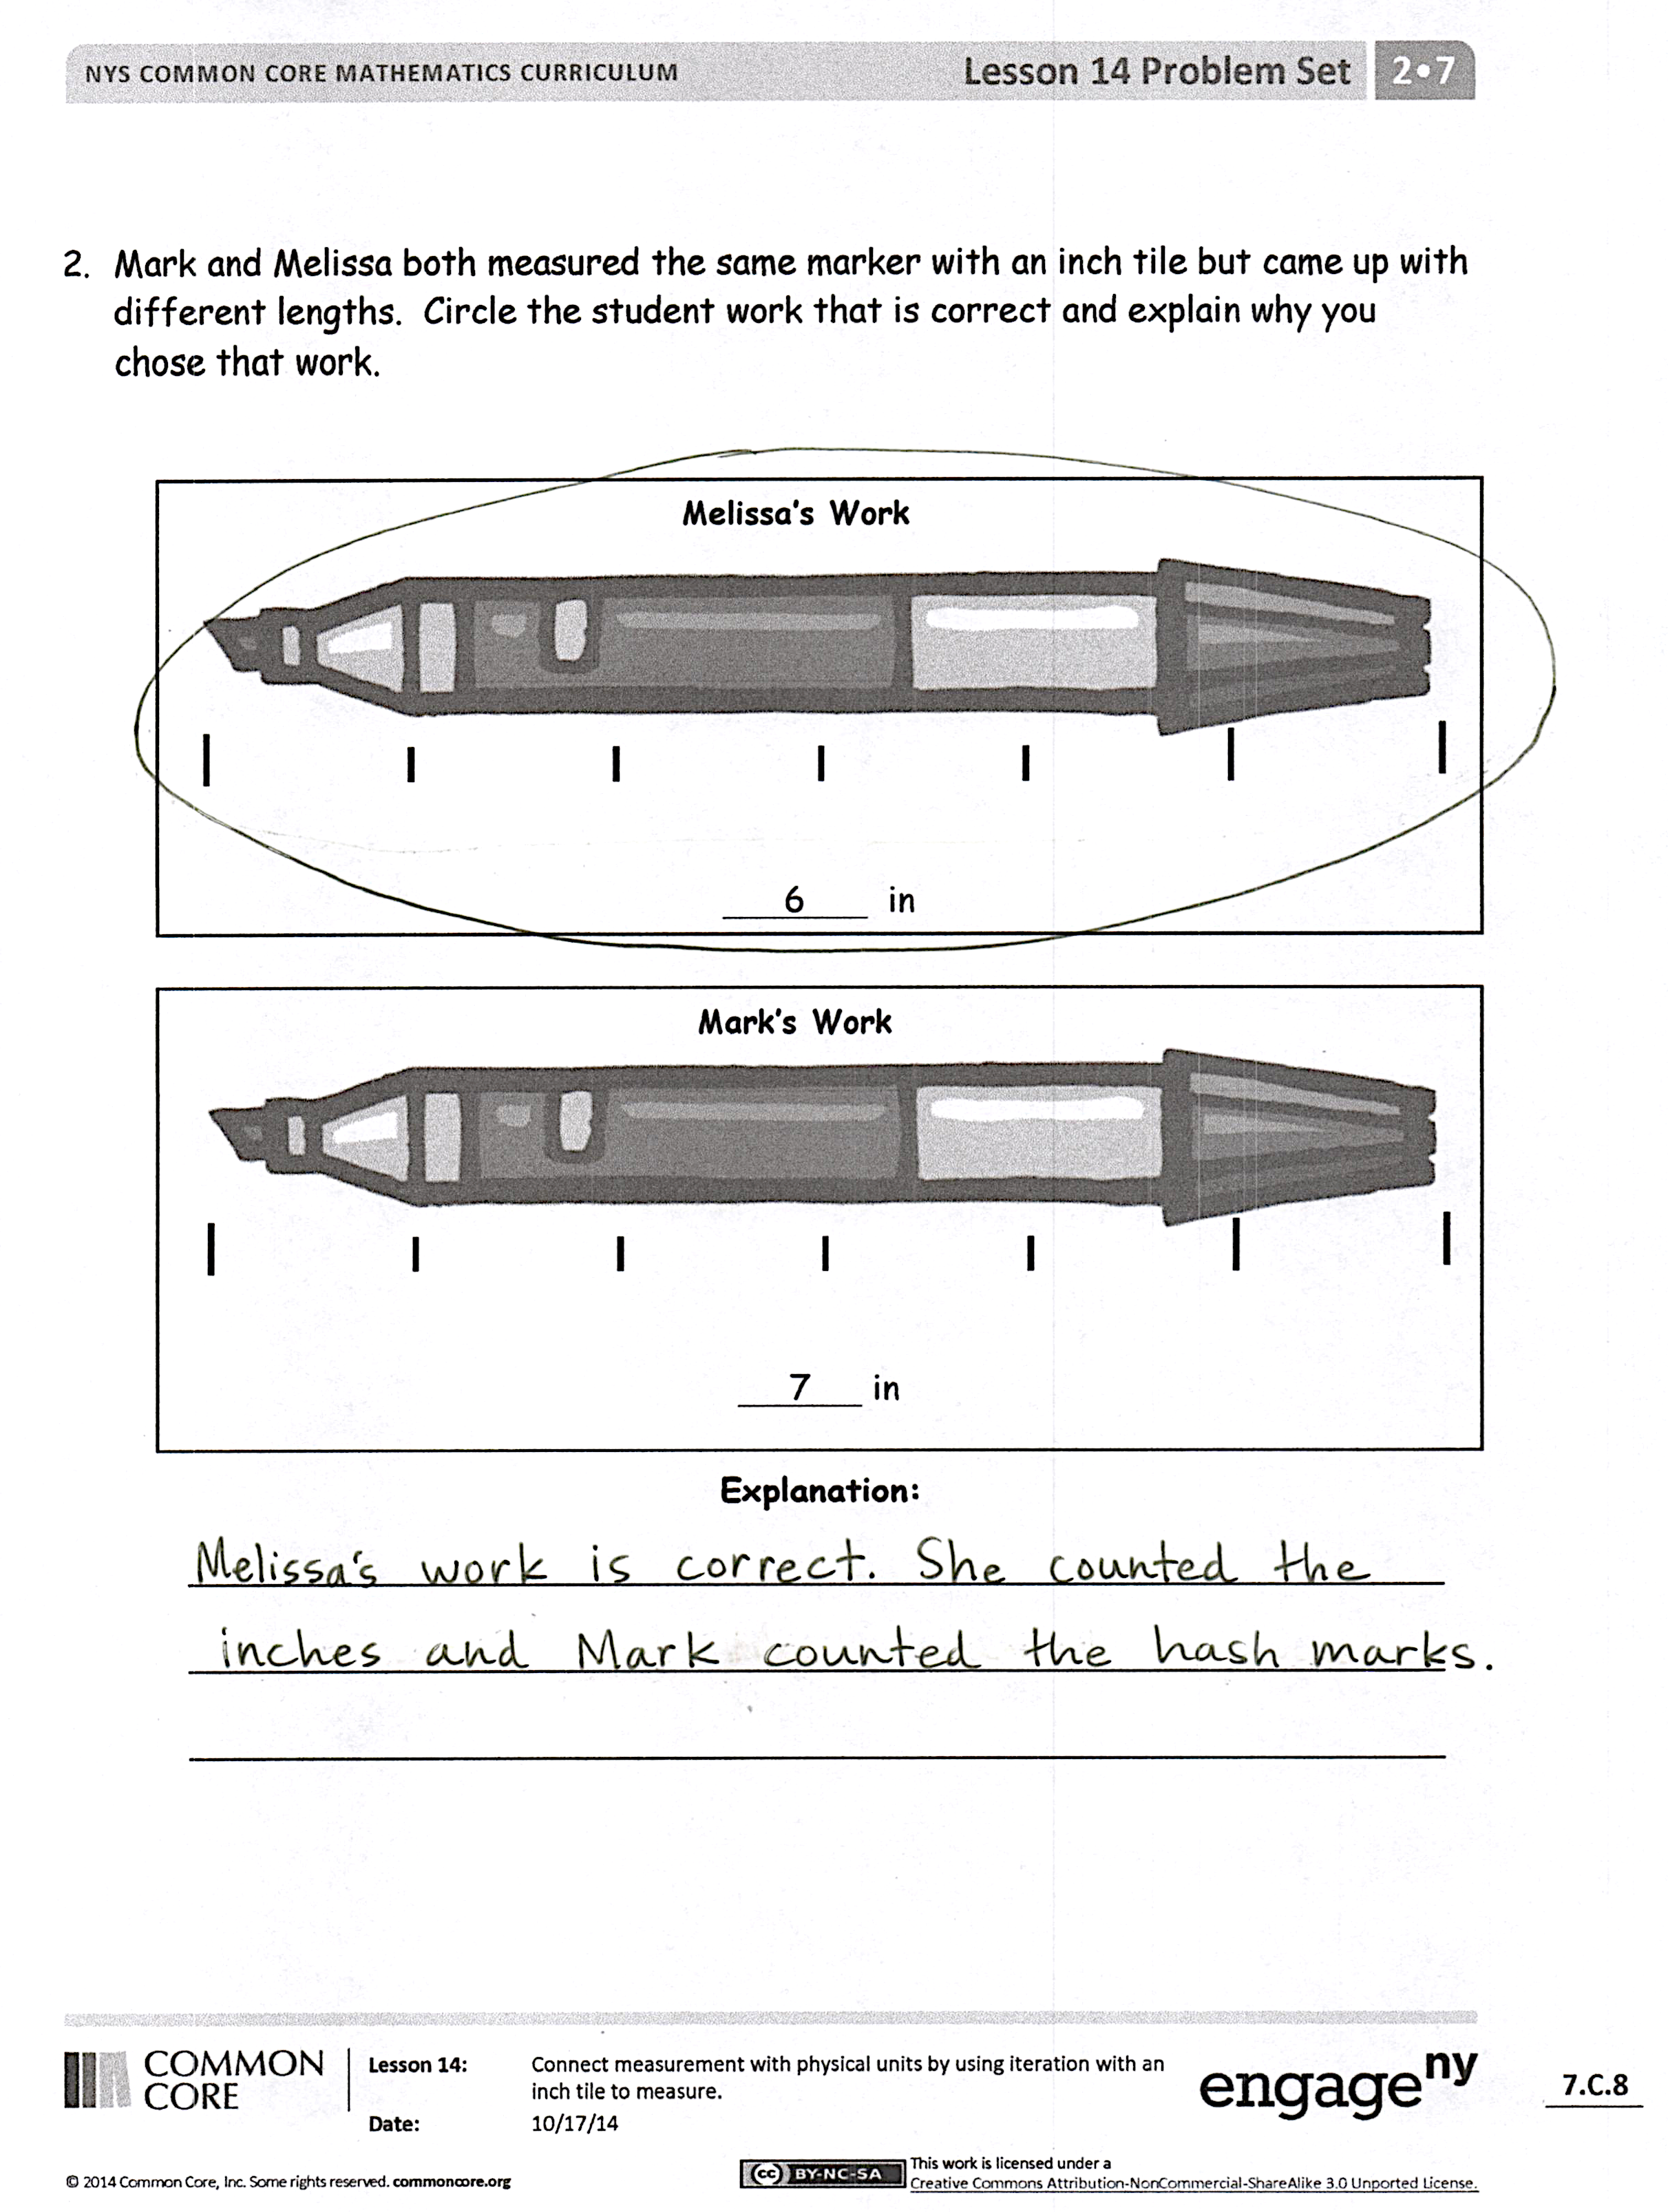
Invite students to review their solutions for the Problem Set. They should check work by comparing answers with a partner before going over answers as a class. Look for misconceptions or misunderstandings that can be addressed in the Debrief. Guide students in a conversation to debrief the Problem Set and process the lesson.
Any combination of the questions below may be used to lead the discussion.
- Look at the things you measured in your Problem Set. Talk to your partner about how attending to precision was particularly important today. (Using iteration and hash marks calls for precise work.)
- Did your measurement of each item in your Problem Set come out to the same number of inch tiles as your partner? If not, see if you can figure out why. (Counting hash marks instead of length unit.)
- Talk to your partner about why Melissa and Mark came up with different measurements for the marker.
- We remembered using centimeter cubes and practiced using inch tiles today. How is using larger length units helpful? Remember our bookcase problem. How are larger length units less precise?
- When is using smaller units helpful? Which of the items on your worksheet would you prefer to measure with inch tiles? With centimeter cubes? Why?
- When you are thinking about measuring, how would you decide on which length unit to use?
Exit Ticket (3 minutes)
After the Student Debrief, instruct students to complete the Exit Ticket. A review of their work will help with assessing students’ understanding of the concepts that were presented in today’s lesson and planning more effectively for future lessons. The questions may be read aloud to the students.
Note: The Homework requires students to have an inch tile to measure. Consider sending home 1-inch squares of paper instead of plastic tiles.
Name Date
- Measure the objects below with an inch tile. Record the measurements in the table provided.
Object | Measurement
Pair of scissors
Marker
Pencil
Eraser
Length of worksheet
Width of worksheet
Length of desk
Width of desk
- Mark and Melissa both measured the same marker with an inch tile but came up with different lengths. Circle the student work that is correct and explain why you chose that work.

Melissa’s Work Work

6 in
Mark’s Work

7 in

Explanation:
________________________________________________________________________________
________________________________________________________________________________
________________________________________________________________________________

Name Date
Measure the lines below with an inch tile.
Line A ___________________

Line A is ________ inches.

Line B _____________________________

Line B is ________ inches.

Line C ________________________

Line C is ________ inches.

Name Date
- Measure these objects found in your home with an inch tile. Record the measurements in the table provided.
Object | Measurement
Length of a kitchen fork
Height of a juice glass
Length across the center of a plate
Length of the refrigerator
Length of a kitchen drawer
Height of a can
Length of a picture frame
Length of a remote control
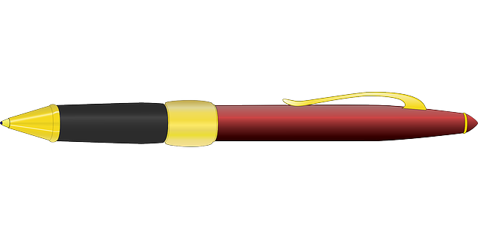
- Norberto begins measuring his pen with his inch tile. He marks off where each tile ends. After two times, he decides this process is taking too long and starts to guess where the tile would end and then marks it.

Explain why Norberto’s answer will not be correct.

____________________________________________________________

____________________________________________________________

____________________________________________________________

- Use your inch tile to measure the pen. How many inch tiles long is the pen?
11 - 1 | 11 - 2
11 - 3 | 11 - 4
11 - 5 | 11 - 6
11 - 7 | 11 - 8
11 - 9 | 12 - 3
12 - 4 | 12 - 5
12 - 6 | 12 - 7
12 - 8 | 12 - 9
13 - 4 | 13 - 5
13 - 6 | 13 - 7
13 - 8 | 13 - 9
14 - 5 | 14 - 6
14 - 7 | 14 - 8
14 - 9 | 15 - 6
15 - 7 | 15 - 8
15 - 9 | 16 - 7
16 - 8 | 16 - 9
17 - 8 | 17 - 9
18 - 9 | 19 - 11
20 - 19 | 20 - 1
20 - 18 | 20 - 2
20 – 17 | 20 - 3
20 – 16 | 20 - 4
20 – 15 | 20 - 5
20 – 14 | 20 - 6
20 - 13 | 20 - 7
20 – 12 | 20 - 8
20 – 11 | 20 - 9
20 – 10

subtraction fact flash cards set 2
subtraction fact flash cards set 2
subtraction fact flash cards set 2
subtraction fact flash cards set 2
subtraction fact flash cards set 2
subtraction fact flash cards set 2

