Lesson 13
Objective: Solve two-step word problems involving dollars or cents with totals within $100 or $1.

Suggested Lesson Structure
 Fluency Practice (10 minutes)
 Application Problem (5 minutes)
 Concept Development (35 minutes)
 Student Debrief (10 minutes)
Total Time (60 minutes)
Fluency Practice (10 minutes)
- Grade 2 Core Fluency Differentiated Practice Sets 2.OA.2 (5 minutes)
- Decomposition Tree 2.NBT.5 (5 minutes)
Grade 2 Core Fluency Differentiated Practice Sets (5 minutes)
Materials: (S) Core Fluency Practice Sets (Lesson 1 Core Fluency Practice Sets)
Note: During Topic B and for the remainder of the year, each day’s Fluency Practice includes an opportunity for review and mastery of the sums and differences with totals through 20 by means of the Core Fluency Practice Sets or Sprints. The process is detailed, and Practice Sets are provided in Lesson 1.
Decomposition Tree (5 minutes)
Materials: (S) Decomposition tree (Lesson 6 Fluency Template)
Note: Students are given 90 seconds to decompose a dollar.
T: (Distribute tree Template.)
T: You are going to break apart $1 on your Deco Tree for 90 seconds. Do as many problems as you can. Go!
S: (Work for 90 seconds.)
T: Now, exchange your tree with your partner, and check each other’s work. (Allow students 30–45 seconds to check.)
T: Return each other’s papers. Did you see another way to make $1 on your partner’s paper? (Allow students to share for another 30 seconds.)
T: Turn your paper over. Let’s break apart $1 for another minute.
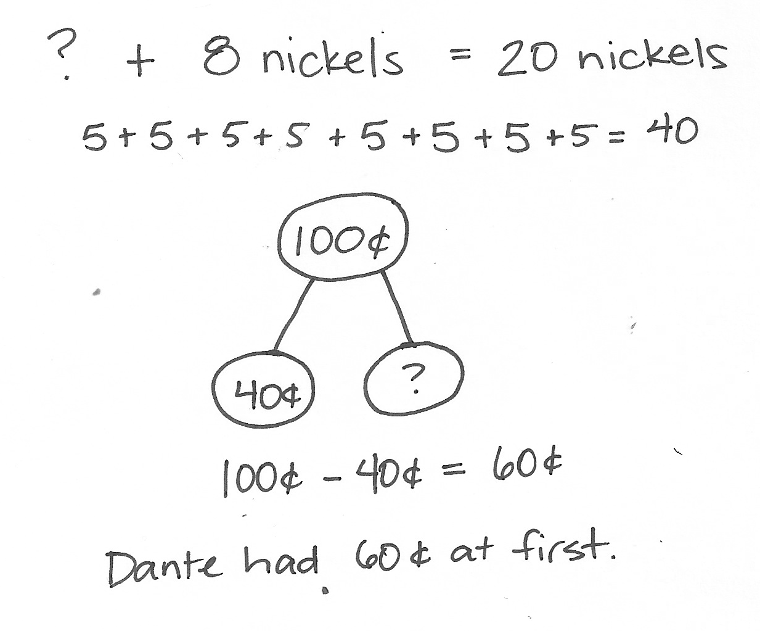
Application Problem (5 minutes)
Dante had some money in a jar. He puts 8 nickels into the jar. Now, he has 100 cents. How much money was in the jar at first?
Note: In this add to with start unknown problem, students must pay close attention to the question, as they may incorrectly jump to the conclusion that they should subtract 100 – 8. Ask questions that guide students toward seeing that 100 cents equals 20 nickels, or guide them toward calculating the value of 8 nickels and subtracting that from 100.

NOTES ON
MULTIPLE MEANS
OF ACTION AND EXPRESSION:
Support students who are performing below grade level by talking them through the Application Problem one step at a time: “How much money did Dante put in the jar? How much does he have now? Are nickels and cents the same unit? Can we add or subtract different units? What can we do to make them the same unit so that we can solve the problem?” And, if necessary, “What is the value of 8 nickels?”
Concept Development (35 minutes)
Materials: (T) Document camera (if available)
(S) Personal white board
Part 1: Solve an add to with change unknown type problem.
Gary has 2 dimes, 5 nickels, and 13 pennies. His brother gives him one more coin. Now, he has 68 cents. What coin did his brother give him?
T: What do we do first when we see a word problem?
S: Read it.
T: Yes. Let’s read the problem together.
T/S: (Read aloud.)

NOTES ON
MULTIPLE MEANS
OF ACTION AND EXPRESSION:
At times, students can discuss what they will draw before drawing. At other times, they might go ahead and draw. Use professional judgment to adapt to varying circumstances.
T: What can you draw?
S: Gary’s coins. We can draw 2 dimes, 5 nickels, 13 pennies, and a question mark coin. A tape diagram.
T: Great! Do it. (Pause while students draw.)
T: Turn and talk: Look at your drawing. What are you trying to find?
S: The value of the coin Gary’s brother gave him. We need to find the value of the question mark coin.
T: Go ahead and do that. Write a number sentence and statement to match your work. (Allow students time to work.) Explain to your partner how you solved the problem.

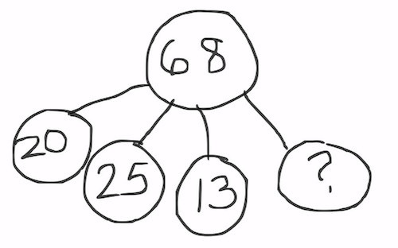
S: I skip-counted by tens, then fives, then ones: 10, 20, 25, 30, 35, 40, 45, 46, …58. Then, I counted 10 more to get to 68. First, I found the value of the dimes, nickels, and pennies. 20 + 25 + 13 = 58.
I know 68 is 10 more than 58, so the coin is a dime. First, I counted up the coins I know and got 58¢. 68¢ – 58¢ = 10¢.
T: What was the value of Gary’s money before his brother gave him a coin?
S: 58¢.
T: What’s your number sentence?
S: 58¢ + ___ = 68¢. 68¢ – 58¢ = 10¢.
T: And what is the statement of your solution?
S: Gary’s brother gave him a dime.
T: Yes! Look how we can also represent this problem with a number bond (pictured above to the right).
T: Turn and talk. Use part–whole language to describe how your drawing matches mine.
S: My tape diagram shows two parts and a whole. Your diagram shows each coin as a different part. That’s how I added to find the value of Gary’s coins.
T: Great work! Let’s do another one.
Part 2: Solve a two-step problem.
Hailey bought a pretzel stick for a dime and a nickel. She also bought a juice box for 18 cents more than the pretzel stick. How much did she spend on the pretzel and juice box?
T: What do we do first when we see a word problem?
S: Read it.
T: Yes. Let’s read the problem together.
T/S: (Read aloud.)
T: What can you draw?
S: The juice box and pretzel stick. I’m going to write how much they cost, too. A tape diagram for both.
T: Go ahead and draw. (Pause while students draw.)
T: Turn and talk: Look at your drawing. What are you trying to find?
S: How much Hailey spent on the pretzel and juice box. First, you need to know how much the juice box cost.
T: Go ahead and do that. Write a number sentence and statement to match your work. (Allow students time to work.) Explain to your partner how you solved.

S: I made two tape diagrams that were the same size. Then, I made the juice box tape diagram longer to show the extra 18¢. I added 15¢ + 18¢ = 33¢ to find out the cost of the juice box. To find the total, I added 30 + 10 + 3 + 5 = 48.
T: How much did the juice box cost?
S: 33 cents!
T: What’s your number sentence to find the total?
S: 15¢ + 33¢ = 48¢.
T: And what is the statement of your solution?
S: Hailey spent 48¢ on the pretzel and juice.
T: Terrific! Let’s work on one more problem together.
Part 3: Solve a take from with start unknown type problem.
Wendell bought a game at the store for $16. He had 2 five-dollar bills and 4 one-dollar bills left over. How much money did he have before buying the game?
T: Read the problem to me, everyone.
S: (Read chorally.)
T: Can you draw something?
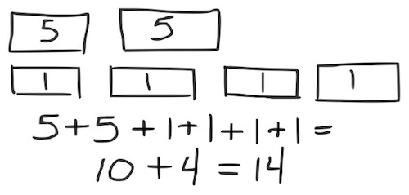
S: Yes!
T: Do that. (Provide work time.)
T: Turn and talk: Look at your drawing. What are you trying to find?
S: The amount of money he had before he bought the game. We need to find the value of his change to know.
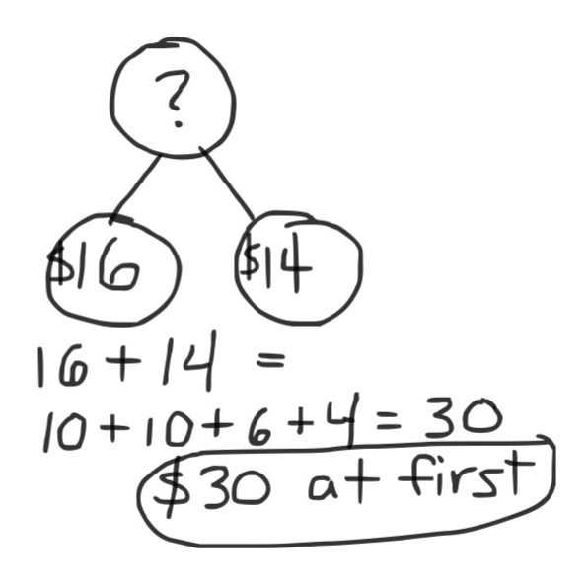
T: Go ahead and do that. Write a number sentence and statement to match your work. (Allow students time to work.) Explain to your partner how you solved the problem.
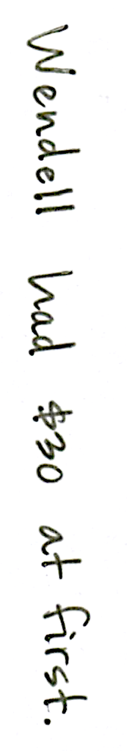
S: First, I drew Wendell’s bills and counted by fives and ones. He got $14 in change. I drew a number bond. The cost of the game is one part and the change is the other part.
I made 16 + 14 into 10 + 10 + 6 + 4. That’s 3 tens, or 30.
I added $16 + $10 + $4 = $30.
MP.1
T: What was the value of Wendell’s change?
S: $14.
T: What’s your number sentence?
S: $16 + $14 = $30.
T: And, what is the statement of your solution?
S: Wendell had $30 before buying the game.
T: Great. You’re now ready to work on the Problem Set. Remember the strategies we have been practicing.

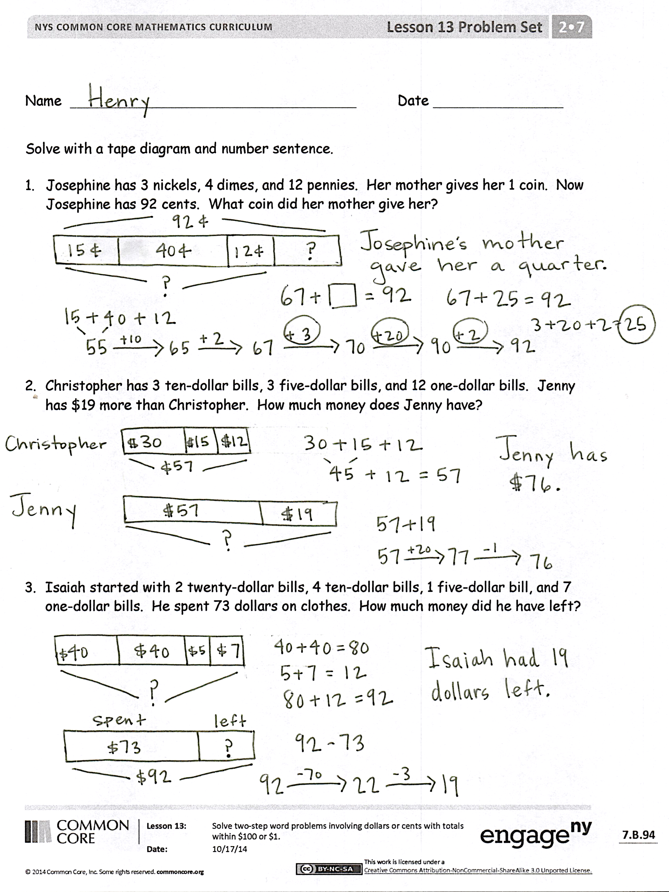
Problem Set (10 minutes)
Students should do their personal best to complete the Problem Set within the allotted 10 minutes. For some classes, it may be appropriate to modify the assignment by specifying which problems they work on first. Some problems do not specify a method for solving. Students should solve these problems using the RDW approach used for Application Problems.
Student Debrief (10 minutes)
Lesson Objective: Solve two-step word problems involving dollars or cents with totals within $100 or $1.
The Student Debrief is intended to invite reflection and active processing of the total lesson experience.
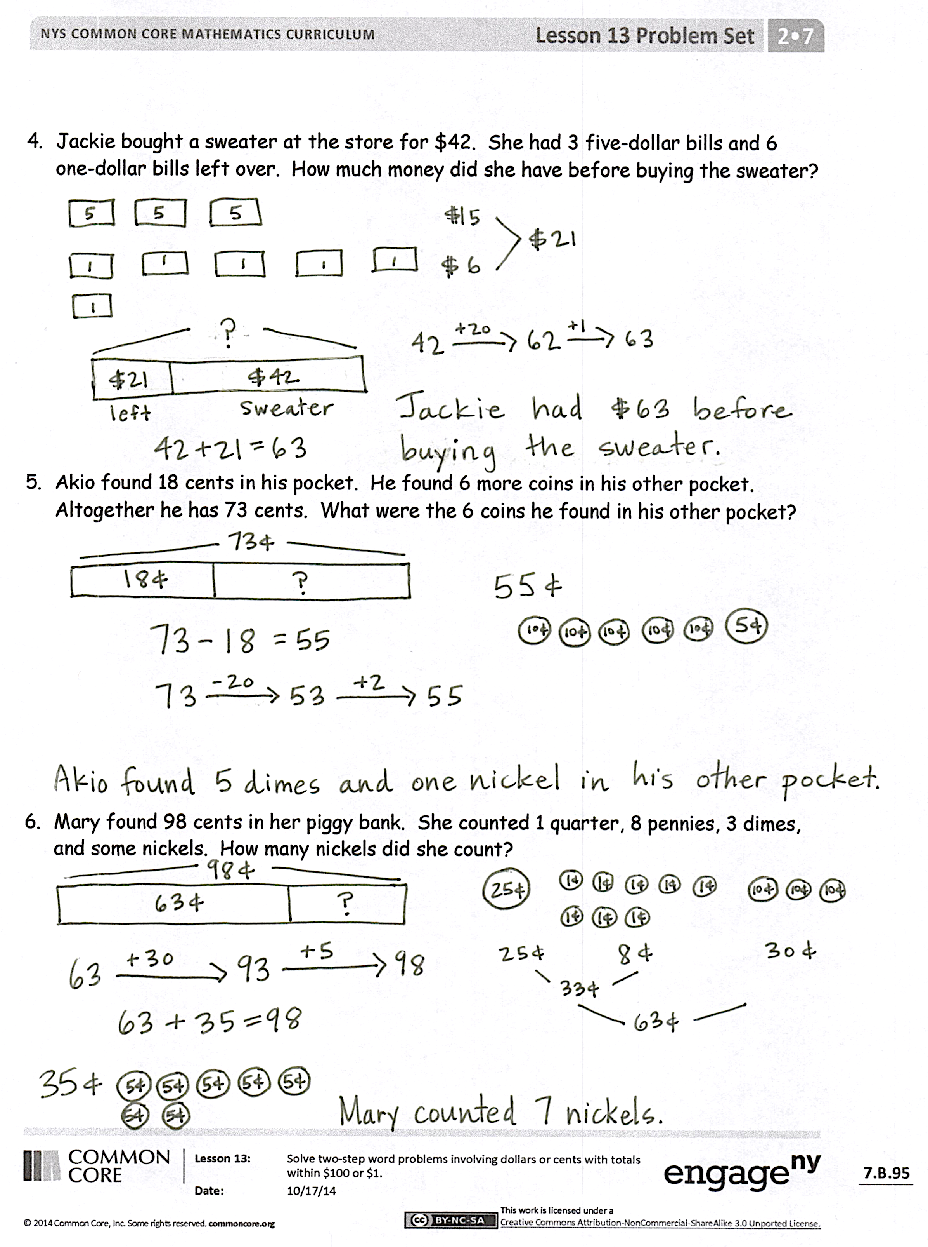
Invite students to review their solutions for the Problem Set. They should check work by comparing answers with a partner before going over answers as a class. Look for misconceptions or misunderstandings that can be addressed in the Debrief. Guide students in a conversation to debrief the Problem Set and process the lesson.
Any combination of the questions below may be used to lead the discussion.
- Before you begin solving a word problem, what are some things you should think about? (What type of models to use, whether there is more than one part to the problem, what operations to use, and what strategies I can use to help me.)
- Look at Problem 1 of your Problem Set. Could skip-counting help you solve one part of the problem quickly?
- Look at Problem 2. Tell your partner what you did first. Take your partner through your entire solution path.
- Talk to your partner about the models you used to solve word problems today. Share with your partner how you used a model on your Problem Set.
- Share your strategy for figuring out the coins Akio found in his pocket.
Exit Ticket (3 minutes)
After the Student Debrief, instruct students to complete the Exit Ticket. A review of their work will help with assessing students’ understanding of the concepts that were presented in today’s lesson and planning more effectively for future lessons. The questions may be read aloud to the students.

Name Date
Solve with a tape diagram and number sentence.
- Josephine has 3 nickels, 4 dimes, and 12 pennies. Her mother gives her 1 coin.
Now, Josephine has 92 cents. What coin did her mother give her?

- Christopher has 3 ten-dollar bills, 3 five-dollar bills, and 12 one-dollar bills.
Jenny has $19 more than Christopher. How much money does Jenny have?

- Isaiah started with 2 twenty-dollar bills, 4 ten-dollar bills, 1 five-dollar bill, and
7 one-dollar bills. He spent 73 dollars on clothes. How much money does he have left?

- Jackie bought a sweater at the store for $42. She had 3 five-dollar bills and
6 one-dollar bills left over. How much money did she have before buying the sweater?

- Akio found 18 cents in his pocket. He found 6 more coins in his other pocket. Altogether he has 73 cents. What were the 6 coins he found in his other pocket?

- Mary found 98 cents in her piggy bank. She counted 1 quarter, 8 pennies, 3 dimes, and some nickels. How many nickels did she count?

Name Date
Solve with a tape diagram and number sentence.
Gary went to the store with 4 ten-dollar bills, 3 five-dollar bills, and 7 one-dollar bills. He bought a sweater for $26. What bills did he leave the store with?

Name Date
- Kelly bought a pencil sharpener for 47 cents and a pencil for 35 cents. What was her change from $1?

- Hae Jung bought a pretzel for 3 dimes and a nickel. She also bought a juice box. She spent 92 cents. How much was the juice box?

- Nolan has 1 quarter, 1 nickel, and 21 pennies. His brother gave him 2 coins. Now, he has 86 cents. What 2 coins did his brother give him?

- Monique saved 2 ten-dollar bills, 4 five-dollar bills, and 15 one-dollar bills.
Harry saved $16 more than Monique. How much money does Harry have saved?

- Ryan went shopping with 3 twenty-dollar bills, 3 ten-dollar bills, 1 five-dollar bill, and 9 one-dollar bills. He spent 59 dollars on a video game. How much money does he have left?

- Heather had 3 ten-dollar bills and 4 five-dollar bills left after buying a new pair of sneakers for $29. How much money did she have before buying the sneakers?

