Lesson 12
Objective: Solve word problems involving different ways to make change from $1.

Suggested Lesson Structure
 Fluency Practice (12 minutes)
 Application Problem (5 minutes)
 Concept Development (33 minutes)
 Student Debrief (10 minutes)
Total Time (60 minutes)
Fluency Practice (12 minutes)
- Sprint: Adding Across a Ten 2.OA.2 (9 minutes)
- Making $1 2.NBT.5 (3 minutes)
Sprint: Adding Across a Ten (9 minutes)
Materials: (S) Adding Across a Ten Sprint
Note: This Sprint gives practice with the grade level fluency of adding within 20.
Making $1 (3 minutes)
Note: Students review making $1 by counting up with change unknown problems as review of previous lesson concepts.
T: (Post 45 cents + ______ = 100 cents.) Read the problem. How many cents are in $1?
S: 100 cents.
T: I have 45 cents. What is the next ten cents I can make?
S: 50 cents.
T: 45 cents needs how much more to make 50 cents?
S: 5 cents.
T: 50 cents needs how much more to make 100 cents?
S: 50 cents.
T: 45 cents and what makes 1 dollar?
S: 55 cents.
Continue with the following possible sequence: 28 cents, 73 cents, and 14 cents.
Application Problem (5 minutes)

NOTES ON
MULTIPLE MEANS
OF ENGAGEMENT:
Scaffold the Application Problem for students who are still having difficulties with part–whole relationships by providing a number bond Template and helping them fill it out: “Is 24 cents a part or the whole? How many pennies equal $1?”
T: We can write 100 cents as $1 in our number sentence.
Richie has 24 cents. How much more money does he need to make $1?
Note: This add to with change unknown type problem serves as a bridge from yesterday’s lesson, where students used simplifying strategies to make change from $1 but always represented the dollar as 100 cents within number sentences. Use this problem as a chance to introduce that students may write $1 – 24¢ = ___ or 24¢ + ___ = $1.
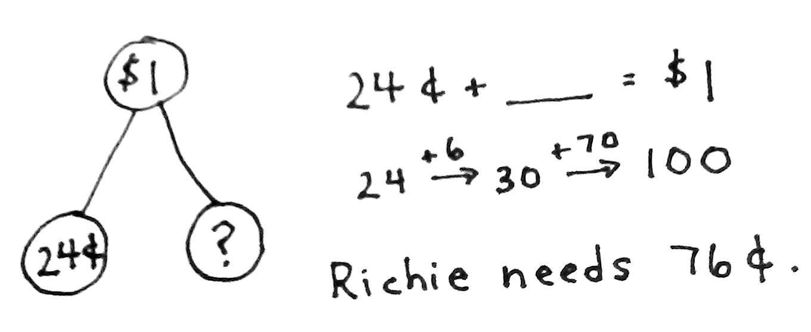
Concept Development (33 minutes)
Materials: (T) Chart with RDW steps
(S) Personal white board
Part 1: Solve a take from with result unknown type problem.
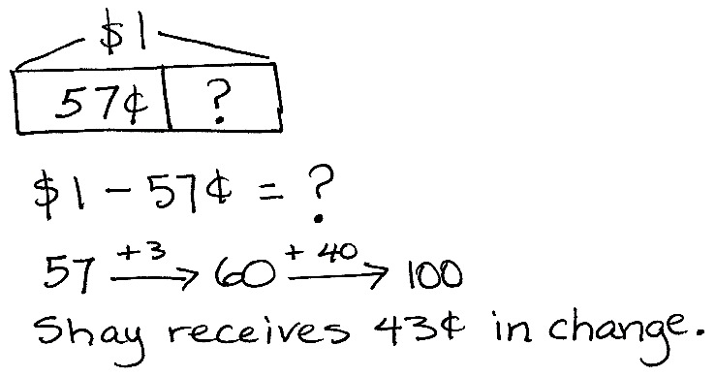
Shay buys a balloon for 57 cents. She hands the cashier 1 dollar. How much change will she receive?
T: What do we do first?
S: Read the problem.
T: Yes. Let’s read the problem together.
T/S: (Read aloud.)
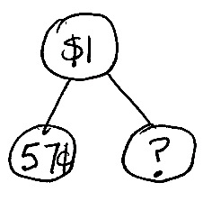
T: I’ll give you a minute to draw quietly. When I give the signal, talk to your partner about how your drawing (as shown to the right) matches the story. (Signal.)
S: Since 57 cents is part of 1 dollar, I drew a number bond. (See figure at right.) I drew a tape diagram with the total and a part. The question mark will be for the change.
T: Look at your drawing. What are you trying to find?
S: I am trying to find out how much change Shay will get back.
T: Go ahead and do that. Write a number sentence and statement to match your work. (Pause while students work.) Explain to your partner how you solved the problem.
S: I thought of the related addition: 57¢ + ____ = $1. Then, I used the arrow way to count on. (See figure above.) I wrote 100 – 57 = ____. I took away 1 from both numbers to make it easier to solve without renaming, so 99 – 56 = 43.
T: What’s the statement of your solution?
S: Shay receives 43 cents in change.
T: Reread the problem to yourself. Does your answer make sense? How do you know?
S: Yes, because if I add the cost of the balloon and the change, I get 100 cents. My answer makes sense, because 57 + 43 = 100. 57¢ + 43¢ = $1. I wrote it our new way we learned today, and it’s true because a dollar is the same as 100 cents.
T: That’s right! I think you’re ready for a challenge. Here we go….
Part 2: Solve a take from with change unknown type problem.
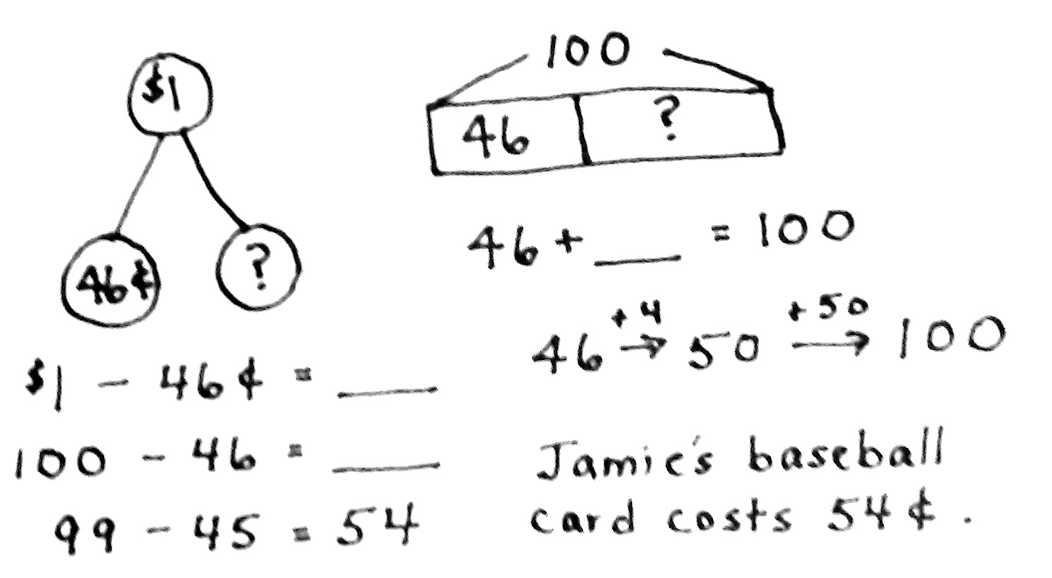
Jamie buys a baseball card. He gives the cashier 1 dollar. Jamie gets 2 dimes, 1 quarter, and 1 penny in change. How much did Jamie’s baseball card cost?
T: What do we do first?
S: Read the problem.
T: Yes. Let’s read the problem together.
T/S: (Read aloud.)
T: I’ll give you a minute to draw quietly. When I give the signal, talk to your partner about how your drawing matches the story. (See figure at right.)
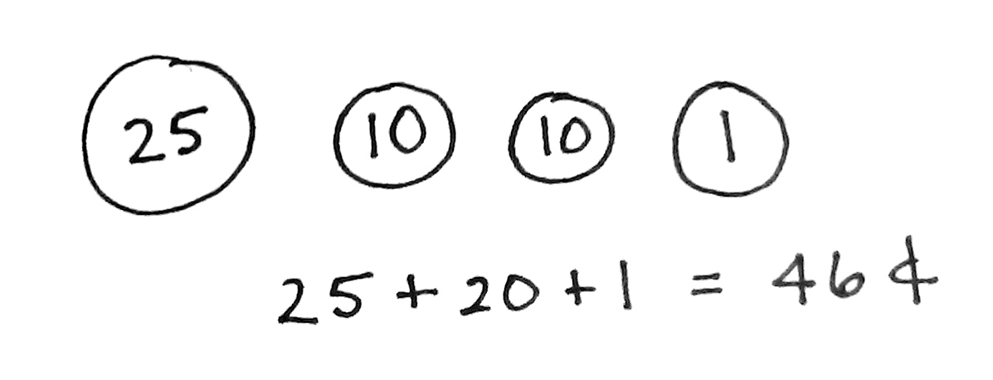
T: I drew Jamie’s change: 2 dimes, 1 quarter, and 1 penny. (See figure at right.) I drew a part–whole model, since I know $1 is the total. I drew a number bond. I know that Jamie’s change is one part, so the baseball card is the question mark.
T: Turn and talk: Look at your drawing. What are you trying to find?
S: I am trying to find the cost of Jamie’s baseball card. I’m trying to add something to 46 cents to make $1. I’m trying to subtract from $1 to find how much the baseball card costs.
MP.1
T: Write a number sentence and a statement to match your work. (Pause while students work.) Explain to your partner how you solved.

NOTES ON
MULTIPLE MEANS
OF EXPRESSION:
Support your English language learners’ language growth as well as their mathematical learning by using their background knowledge. For instance, for native Spanish speakers, connect the English words quarter, part, and whole with the Spanish cuarto, parte, and todo.
S: First, I added, 25 + 10 = 35. 35 + 10 = 45, plus 1 more equals 46. I added the quarter, then the two dimes, and then the penny. I wrote 25 + 20 + 1 = 46.
25 + 20 is 45; then, 1 more is 46. After I added, I subtracted 100 – 46 to get the other part. I took one away from both numbers to make it a simpler problem, so 99 – 45 = 54. I thought of addition:
46 + ____ = 100. Then, I used the arrow way to count on.
T: What’s the statement of your solution?
T: Jamie’s baseball card cost 54 cents.
T: Reread the problem to yourself. Does your answer make sense? How do you know?
S: Yes, because if I add Jamie’s change to the cost of the baseball card, it equals $1. My answer makes sense, because 46¢ + 54¢ = $1.
T: Yes! Now, work through this next one, and discuss it with a partner.
Part 3: Solve a multi-step add to with change unknown type problem.
Penelope wants to buy a toy whistle that costs $1. She has 15 pennies, 2 nickels, 2 dimes, and 1 quarter. How much more money does Penelope need to buy the whistle?
Extension: If Penelope’s brother gives her the rest of the money to buy the whistle, what different combinations of coins might he give her?
T: Follow these steps with your partner. (Read and post steps.)
- Read the problem.
- Draw a picture or model.
- Write a number sentence and statement to match your work.
- Reread the problem. Check to see if your answer makes sense.
T: (Circulate and provide support as needed.)
T: So, how much more money does Penelope need to buy the whistle? Make a statement.
S: Penelope needs 30 more cents to buy the whistle.
T: I saw you working hard on that extension question. Which combinations of coins might Penelope’s brother give her?
S: 1 quarter and 1 nickel. 3 dimes. 10 pennies and 2 dimes.
T: Nice work! Off to the Problem Set.
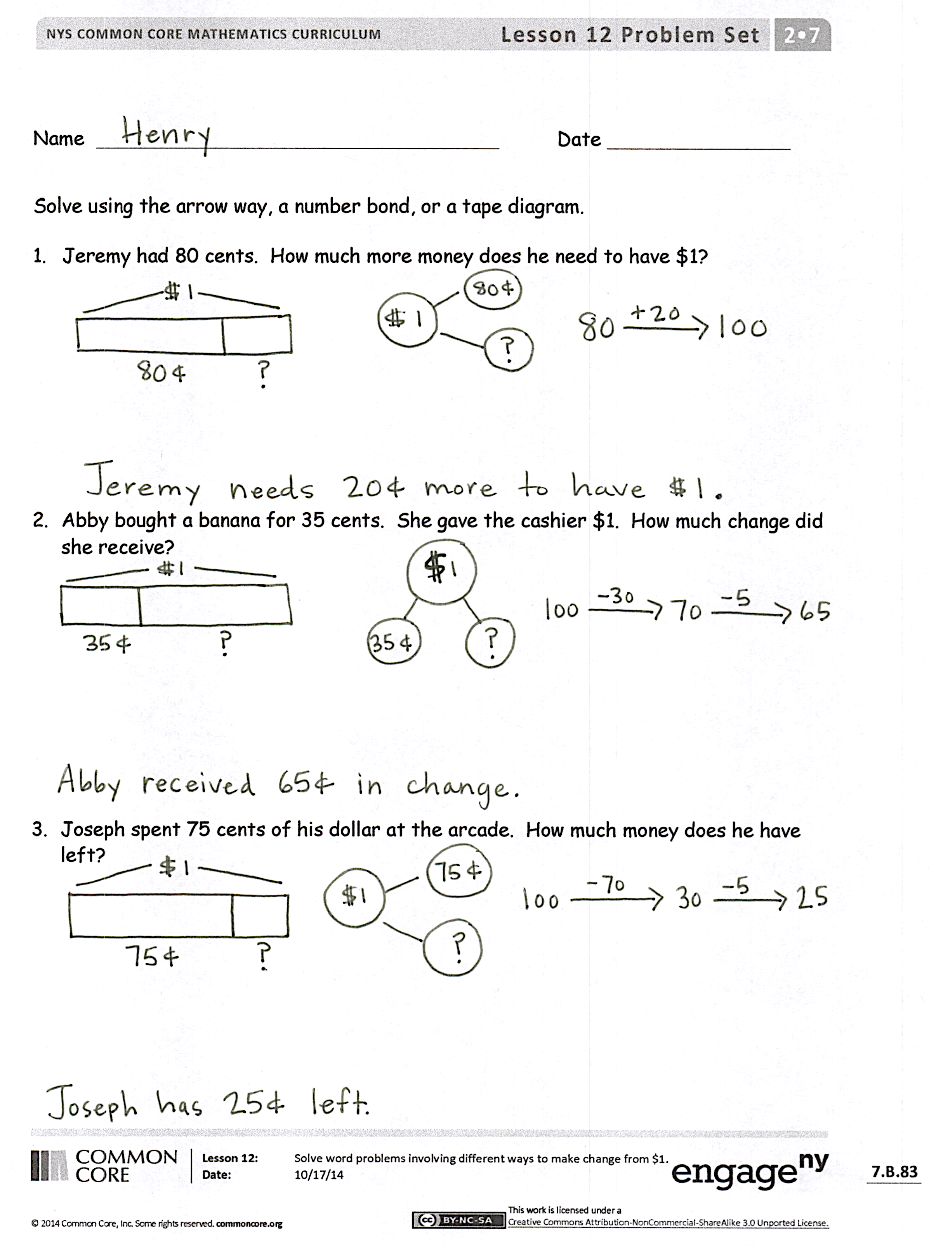
Problem Set (10 minutes)
Students should do their personal best to complete the Problem Set within the allotted 10 minutes. For some classes, it may be appropriate to modify the assignment by specifying which problems they work on first. Some problems do not specify a method for solving. Students should solve these problems using the RDW approach used for Application Problems.
Student Debrief (10 minutes)
Lesson Objective: Solve word problems involving different ways to make change from $1.
The Student Debrief is intended to invite reflection and active processing of the total lesson experience.
Invite students to review their solutions for the Problem Set. They should check work by comparing answers with a partner before going over answers as a class. Look for misconceptions or misunderstandings that can be addressed in the Debrief. Guide students in a conversation to debrief the Problem Set and process the lesson.
Any combination of the questions below may be used to lead the discussion.
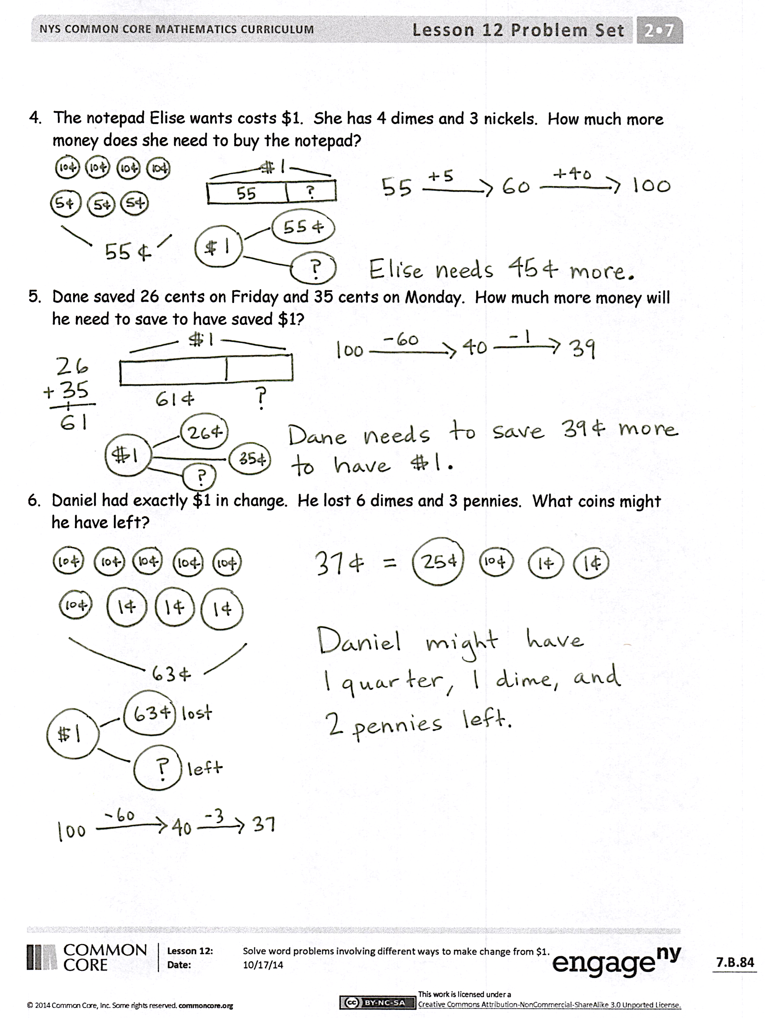
- What is another way we can think about $1?
(As 100¢.)
- Look at your Problem Set. In each problem, there are cents and 1 dollar. Talk to your partner about how these units are the same. How are these units different?
- Look at Problem 2, where Abby is buying a banana. (Write $1 – 35¢ = ___ on the board.) Did anyone use a subtraction sentence like this one with their model? Talk to your partner about why we can take 35 cents away from 1 dollar.
- When you think about trading $1 for 100¢, does it remind you about what you know about place value and changing units in a place value chart?
- Look at Problem 5 on the Problem Set. Describe the steps you took to solve.
Exit Ticket (3 minutes)
After the Student Debrief, instruct students to complete the Exit Ticket. A review of their work will help with assessing students’ understanding of the concepts that were presented in todays’ lesson and planning more effectively for future lessons. The questions may be read aloud to the students.

Number Correct: _______
A
Adding Across a Ten
 | 9 + 2 = |  |  |  | 4 + 7 =
 | 9 + 3 = |  |  |  | 4 + 8 =
 | 9 + 4 = |  |  |  | 5 + 6 =
 | 9 + 7 = |  |  |  | 5 + 7 =
 | 7 + 9 = |  |  |  | 3 + 8 =
 | 10 + 1 = |  |  |  | 3 + 9 =
 | 10 + 2 = |  |  |  | 2 + 9 =
 | 10 + 3 = |  |  |  | 5 + 10 =
 | 10 + 8 = |  |  |  | 5 + 8 =
 | 8 + 10 = |  |  |  | 9 + 6 =
 | 8 + 3 = |  |  |  | 6 + 9 =
 | 8 + 4 = |  |  |  | 7 + 6 =
 | 8 + 5 = |  |  |  | 6 + 7 =
 | 8 + 9 = |  |  |  | 8 + 6 =
 | 9 + 8 = |  |  |  | 6 + 8 =
 | 7 + 4 = |  |  |  | 8 + 7 =
 | 10 + 5 = |  |  |  | 7 + 8 =
 | 6 + 5 = |  |  |  | 6 + 6 =
 | 7 + 5 = |  |  |  | 7 + 7 =
 | 9 + 5 = |  |  |  | 8 + 8 =
 | 5 + 9 = |  |  |  | 9 + 9 =
 | 10 + 6 = |  |  |  | 4 + 9 =

Number Correct: _______
Improvement: _______
B
[KEY]

Adding Across a Ten
 | 10 + 1 = |  |  |  | 5 + 6 =
 | 10 + 2 = |  |  |  | 5 + 7 =
 | 10 + 3 = |  |  |  | 4 + 7 =
 | 10 + 9 = |  |  |  | 4 + 8 =
 | 9 + 10 = |  |  |  | 4 + 10 =
 | 9 + 2 = |  |  |  | 3 + 8 =
 | 9 + 3 = |  |  |  | 3 + 9 =
 | 9 + 4 = |  |  |  | 2 + 9 =
 | 9 + 8 = |  |  |  | 5 + 8 =
 | 8 + 9 = |  |  |  | 7 + 6 =
 | 8 + 3 = |  |  |  | 6 + 7 =
 | 8 + 4 = |  |  |  | 8 + 6 =
 | 8 + 5 = |  |  |  | 6 + 8 =
 | 8 + 7 = |  |  |  | 9 + 6 =
 | 7 + 8 = |  |  |  | 6 + 9 =
 | 7 + 4 = |  |  |  | 9 + 7 =
 | 10 + 4 = |  |  |  | 7 + 9 =
 | 6 + 5 = |  |  |  | 6 + 6 =
 | 7 + 5 = |  |  |  | 7 + 7 =
 | 9 + 5 = |  |  |  | 8 + 8 =
 | 5 + 9 = |  |  |  | 9 + 9 =
 | 10 + 8 = |  |  |  | 4 + 9 =

Name Date
Solve using the arrow way, a number bond, or a tape diagram.
- Jeremy had 80 cents. How much more money does he need to have $1?

- Abby bought a banana for 35 cents. She gave the cashier $1. How much change did she receive?

- Joseph spent 75 cents of his dollar at the arcade. How much money does he have left?

- The notepad Elise wants costs $1. She has 4 dimes and 3 nickels. How much more money does she need to buy the notepad?

- Dane saved 26 cents on Friday and 35 cents on Monday. How much more money will he need to save to have saved $1?

- Daniel had exactly $1 in change. He lost 6 dimes and 3 pennies. What coins might he have left?

Name Date
Solve using the arrow way, a number bond, or a tape diagram.
Jacob bought a piece of gum for 26 cents and a newspaper for 61 cents. He gave the cashier $1. How much money did he get back?

Name Date
Solve using the arrow way, a number bond, or a tape diagram.
- Kevin had 100 cents. He spent 3 dimes, 3 nickels, and 4 pennies on a balloon.
How much money does he have left?

- Colin bought a postcard for 45 cents. He gave the cashier $1. How much change did he receive?

- Eileen spent 75 cents of her dollar at the market. How much money does she have left?

- The puzzle Casey wants costs $1. She has 6 nickels, 1 dime, and 11 pennies.
How much more money does she need to buy the puzzle?

- Garret found 19 cents in the sofa and 34 cents under his bed. How much more money will he need to find to have $1?

- Kelly has 38 fewer cents than Molly. Molly has $1. How much money does Kelly have?

- Mario has 41 more cents than Ryan. Mario has $1. How much money does Ryan have?

