Lesson 11
Objective: Use different strategies to make $1 or make change from $1.

Suggested Lesson Structure
 Fluency Practice (12 minutes)
 Application Problem (6 minutes)
 Concept Development (32 minutes)
 Student Debrief (10 minutes)
Total Time (60 minutes)
Fluency Practice (12 minutes)
- Sprint: Subtraction from Teens 2.OA.2 (9 minutes)
- Coin Exchange 2.NBT.5 (3 minutes)
Sprint: Subtraction from Teens (9 minutes)
Materials: (S) Subtraction from Teens Sprint
Note: Students practice subtraction from teens in order to gain mastery of the sums and differences within 20.
Coin Exchange (3 minutes)
Materials: (S) Personal white board
Note: In this activity, students review Lesson 10 by exchanging change combinations for the fewest coins.
T: I have 2 dimes and a nickel. How much do I have?
S: 25 cents.
T: On your personal white boards, show me at least one more way to make the same amount.
T: (Allow students time to work.) Show me your boards. (Review their boards.)
T: Which way uses the fewest coins?
S: 1 quarter.
T: I have 4 dimes and 2 nickels. How much do I have?
S: 50 cents.
T: On your boards, show me at least one more way to make the same amount.
T: Which way uses the fewest coins?
S: 2 quarters.
Continue with the following possible sequence: 7 nickels, 6 dimes, and 2 dimes.
Application Problem (6 minutes)
Tracy has 85 cents in her change purse. She has 4 coins.
- Which coins are they?
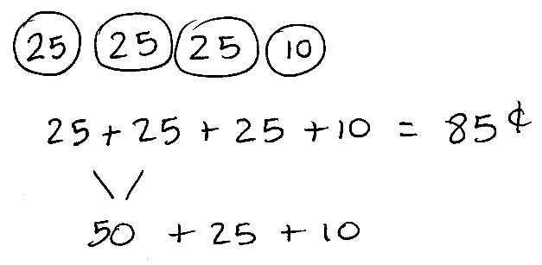
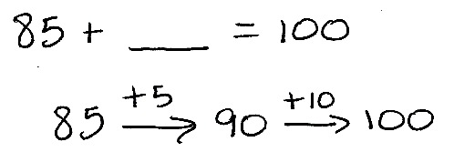
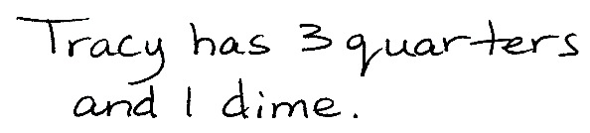
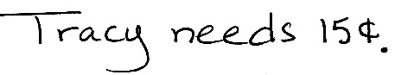
- How much more money will Tracy need if she wants to buy a bouncy ball for $1?

NOTES ON
MULTIPLE MEANS
OF ENGAGEMENT:
Scaffold the Application Problem for English language learners by giving them coins. They can use the manipulatives to solve and share their solution.
Note: The purpose of this Application Problem is twofold. First, it reviews the concept of representing a quantity using the fewest number of coins. Second, it serves as a bridge to today’s lesson about making change from $1.
Concept Development (32 minutes)
Materials: (T) Various coins, dollar bill (S) Personal white board
Part 1: Make a dollar from a given amount.
T: I have 35 cents in my hand. (Show 1 quarter and 1 dime.)
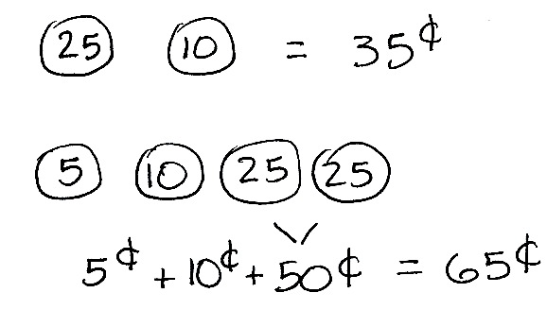
T: How much more do I need to have 100 cents or a dollar? Talk to your partner.
S: You can add a nickel, which will be 40 cents. Then, add another dime, to make 50, and then add 2 quarters, because that’s another 50. You can add 5 to make a ten and then add on 60. So, you need 65 cents more. You can subtract 35 from 100. 100 – 30 is 70, 70 – 5 is 65.
MP.1
T: I can write a number sentence like this: 35¢ + ____ = 100¢. Then, I can solve by counting up with coins (as shown at right).
T: So, 35 cents plus what equals 100 cents?
S: 65 cents!
T: Can I also write a number sentence like this? (Write 35 + ____ = 100 on the board.)
S: Yes. 100 cents is just shown as the number 100. We know that we are talking about cents.
One dollar can be the whole, too. We’re counting up to a dollar. That is the same as 100 cents or just a hundred.
T: (Hold up a dollar bill.) I have a dollar in my hand in change. What do you know about change?
S: It’s the money you get back at the store. If you buy something and it costs less than what you give the cashier, you get change. If you buy something for 50 cents, but you only have a dollar, you’ll get change.
T: Yes. The cashier takes your money and keeps the part to pay for your things. She gives you back the part that is left over. The leftover money is your change.
T: Now that you know about change, let’s solve a problem where we make change from a dollar.
T: I’ll give Student A 28 cents (count out a quarter and 3 pennies). On your personal white board, write a number sentence to represent how much I have left. For now, let’s represent $1 as either 100 or 100 cents so that all our units are the same. (Pause.)
T: Show me.
S: (Show 100¢ – 28¢ = ____. 28¢ + _____ = 100¢. 100 – 28 = ____. 100 cents – 28 cents = ____.)
T: Which of your suggestions uses addition to find the missing part?
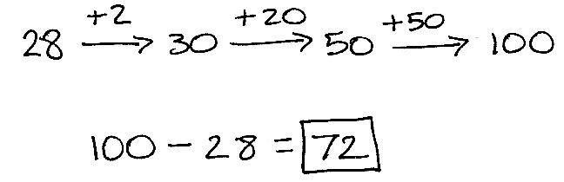
S: 28¢ + _____ = 100¢.
T: Solve using the arrow way to add on or count up (as shown on right). Then, share your work with a partner.
T: How much will I have left?
S: 72 cents!
T: Yes! Let’s check this by counting up. Start with 28 cents. Let’s add the dimes, then the pennies:
38, 48, 58, 68, 78, 88, 98, 99, 100. What do we have now?
S: A dollar!
T: Let’s try some more problems with making change from a dollar.
Part 2: Make change from a dollar.
T: I’m holding some coins in my hand. (Hide 83 cents in hand.)
T: Student B has 1 dime, 1 nickel, and 2 pennies in her hand. What is the value of her coins?
S: 17 cents.
T: Together, we have $1. Talk to your partner. How much money is hiding in my hand?
Use part–whole language as you talk.
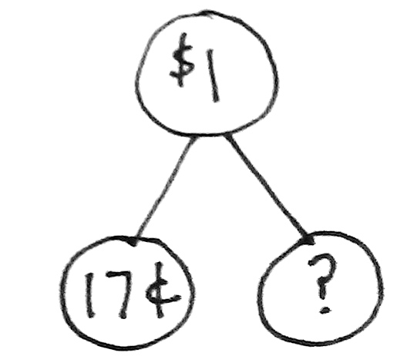
S: I know that one part is hiding and the other part is 17¢. I know that $1 is the whole. I know that if 17¢ is one part, I can add another part to make $1.
T: On your personal white board, draw a number bond to show what you know. (See figure to the right.)
T: We agree that the whole is $1, and one part is 17¢. Now, write an equation from the number bond and solve. (Provide work time.) Show me.
S: (17 + 83 = 100. 100¢ – 17¢ = 83¢.)
T: Let’s see if you were right! (Open hand for students to count coins.) I’m holding 3 dimes, 2 quarters, 3 pennies. Draw it on your boards, find the total, and circle your answer. (Provide work time.) Show me.
S: (Show 83 cents.)
T: If I had a dollar and I wanted to buy something that cost 83 cents, how much change should I receive?
S: 17 cents!
T: Turn and talk. What coins would I probably get?
S: A dime, a nickel, and 2 pennies. Three nickels and 2 pennies.
T: Let’s try another situation. Yesterday, I had $1 in coins, and then I spent some on some candy. The cashier gave me 66¢ in change. (Count on with 2 quarters, 1 dime, 1 nickel, 1 penny.) How much did I spend?
T: Can you draw something?
S: Yes!
T: Do that.
T: (Provide work time.) Look at your drawing. Turn and talk: What are you trying to find?
S: We need to find out how much the candy cost. We have the whole and a part. We need to find the missing part.
T: Write a number sentence and statement to match your work. (Pause while students work.) Explain to your partner how you solved.
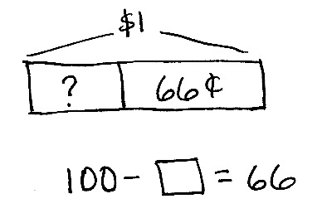
S: I drew 66¢. Then, I added 4 pennies to make 70. Then, I added a quarter and a nickel to make $1. I drew a tape diagram. Then, I subtracted 66¢ from 100¢. I drew a number bond with 66¢ in one part and a question mark in the other part.
I put $1 in the whole.
T: I see a couple of different number sentences. Let’s share them.
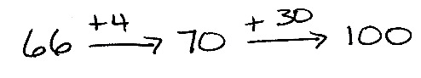
S: 100 – ____ = 66. 66¢ + ____ = 100¢.
100 cents – 66 cents = ____ cents.
____ + 66 cents = 1 dollar.
T: So, the answer is…?
S: 34 cents!
T: These are the coins the cashier kept. (Show a quarter, a nickel, and 4 pennies.) Turn and talk. Count up from 66 to see if together they make a dollar.
S: Sixty-six plus 4 makes 70, and then a nickel makes 75, and then another quarter makes a dollar.
Sixty-six and 4 makes 70, plus 25 is 95, and then another nickel makes a dollar.
T: Does 34¢ + 66¢ = 100¢?
S: Yes!
T: And is 100 cents equal to a dollar?
S: Yes!
T: I think you’re ready to work through a few problems with a partner.

NOTES ON
MULTIPLE MEANS
OF ACTION AND EXPRESSION:
Challenge students who are performing above grade level to write their own word problems to contextualize the numbers and operations in the lesson. Encourage students to swap and share their word problems with other students or with the class.
Part 3: Choose your own strategy to solve.
Instruct partners to solve the following problems on their personal white board:
- 100 – 45 = ____
- 100¢ – 29¢ = ____
- ____ + 72 cents = 100 cents
Then, instruct students to explain their solution strategies to a partner. Circulate and listen in on student conversations to check for understanding. Then, invite students to complete the Problem Set independently.
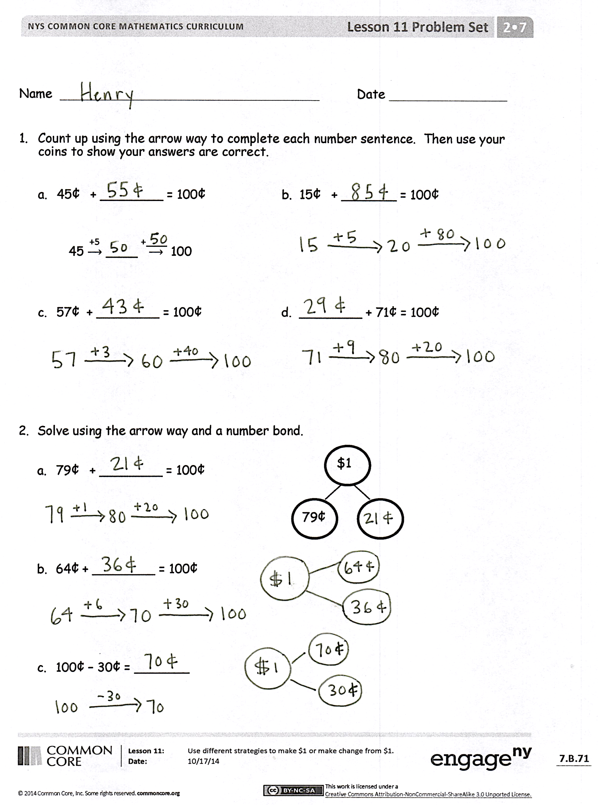
Problem Set (10 minutes)
Students should do their personal best to complete the Problem Set within the allotted 10 minutes. For some classes, it may be appropriate to modify the assignment by specifying which problems they work on first. Some problems do not specify a method for solving. Students should solve these problems using the RDW approach used for Application Problems.
Student Debrief (10 minutes)
Lesson Objective: Use different strategies to make $1 or make change from $1.
The Student Debrief is intended to invite reflection and active processing of the total lesson experience.
Invite students to review their solutions for the Problem Set. They should check work by comparing answers with a partner before going over answers as a class. Look for misconceptions or misunderstandings that can be addressed in the Debrief. Guide students in a conversation to debrief the Problem Set and process the lesson.

Any combination of the questions below may be used to lead the discussion.
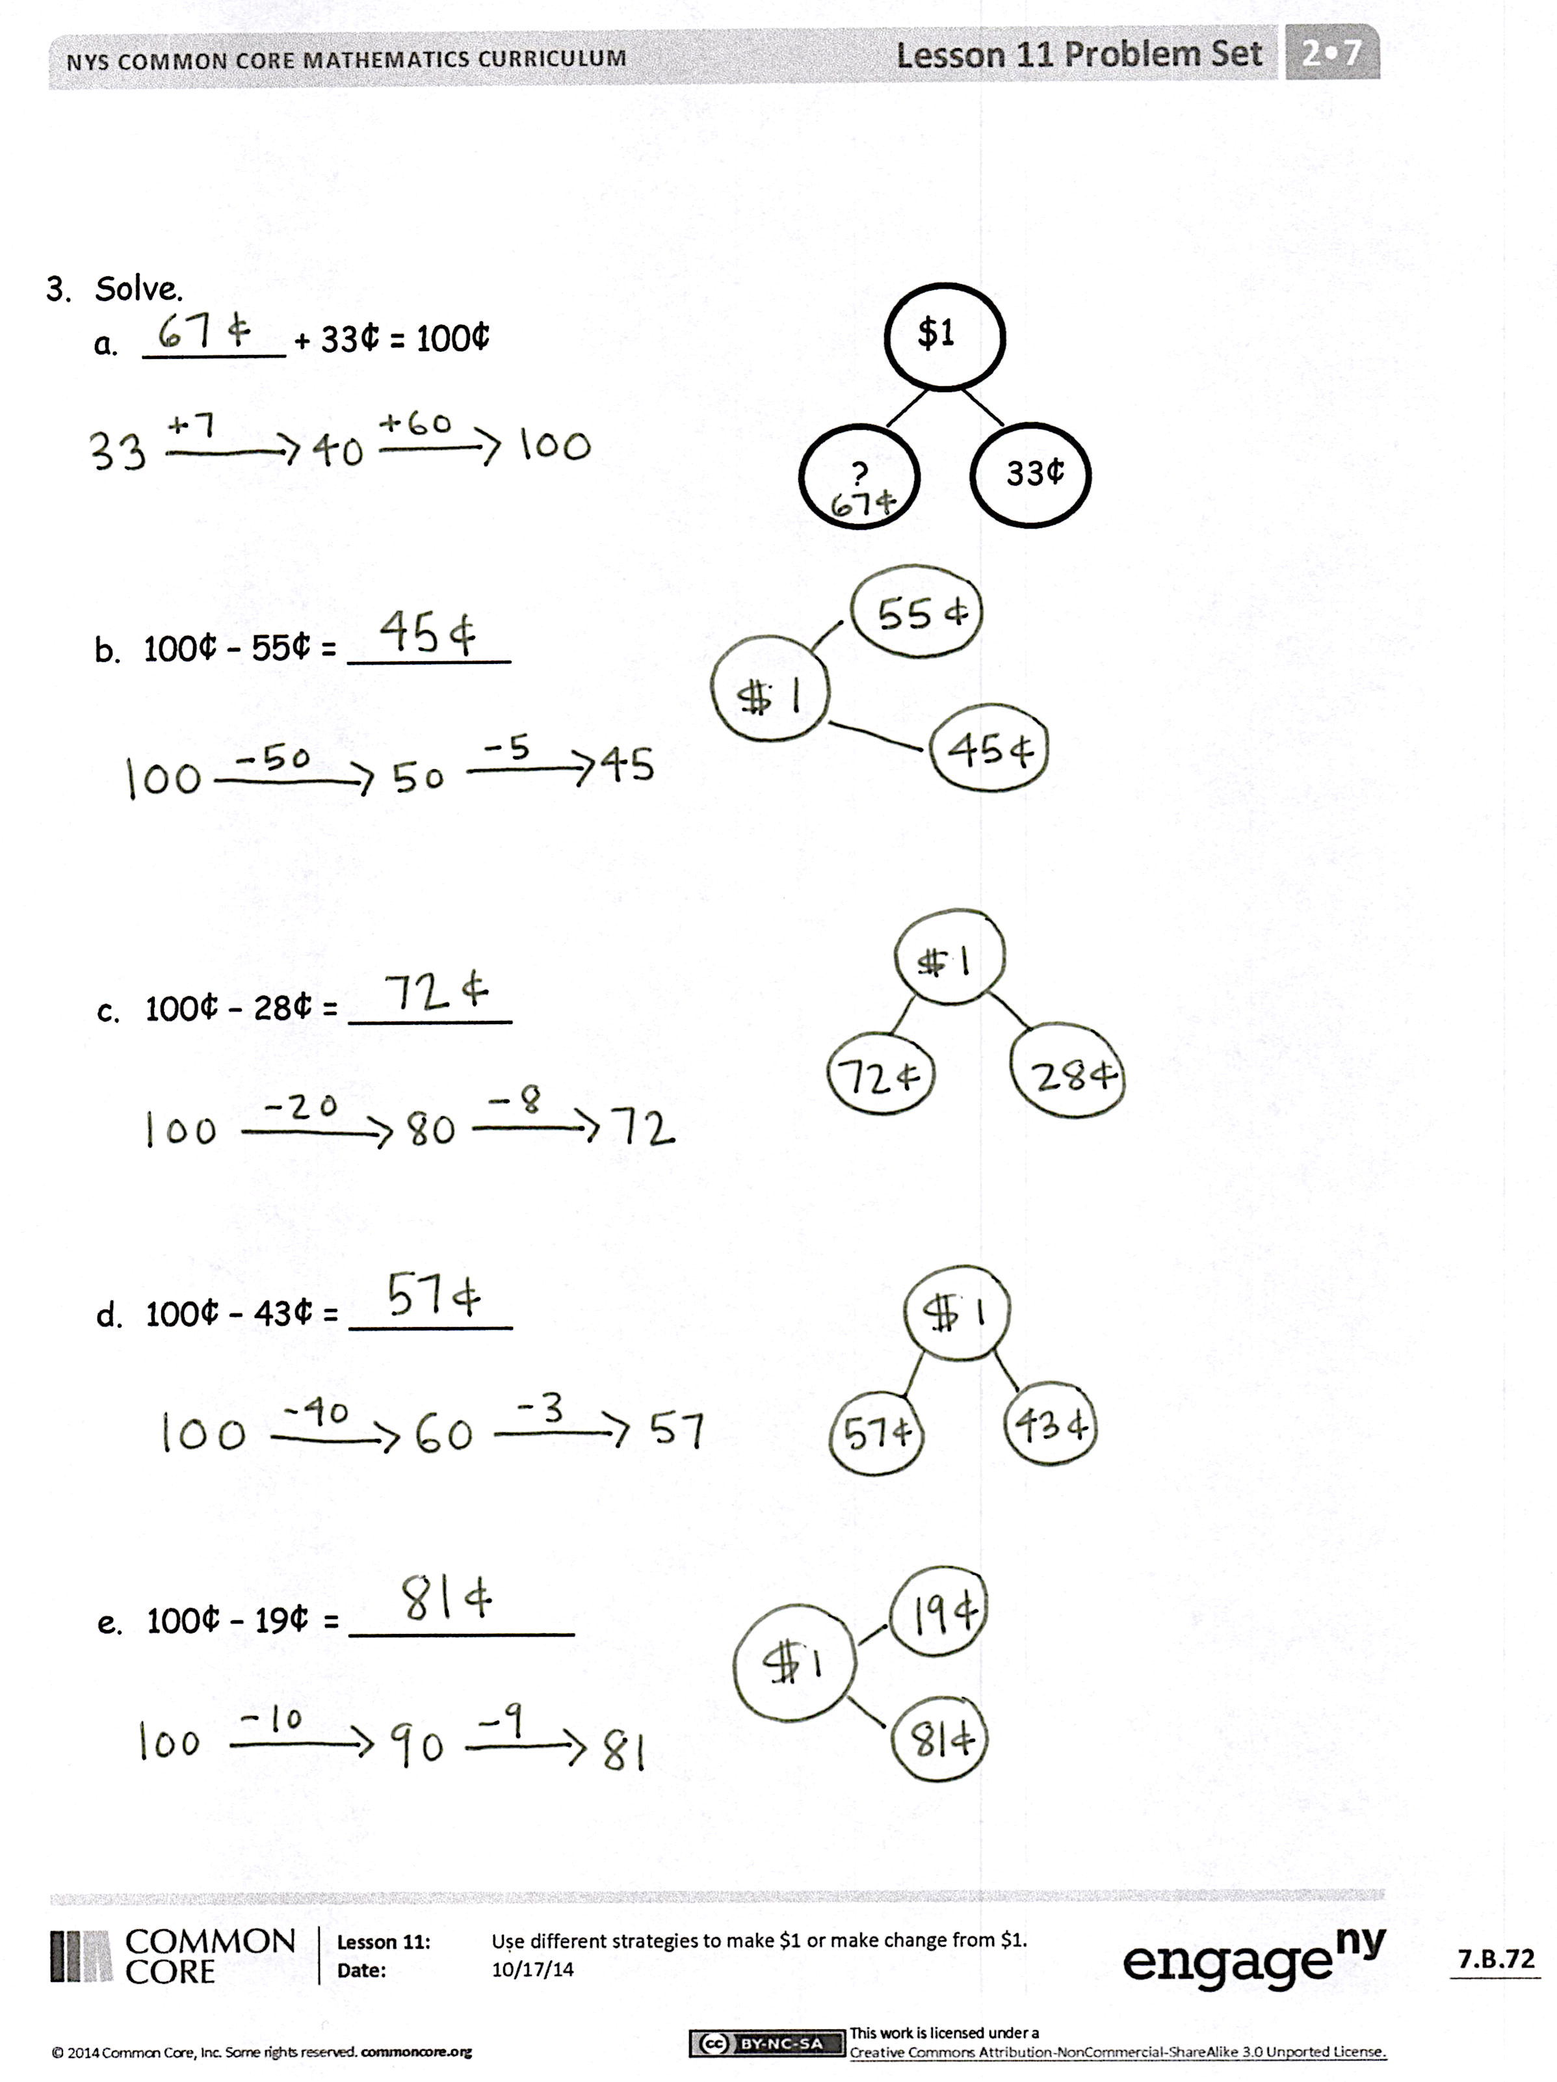
- Look at your Problem Set, and compare your coin choices with your partner’s when you solved each problem the arrow way. Did you make the same coin choices as your partner? Is one of your ways easier to get to $1?
- When we are using the arrow way, are friendly numbers important? Show your partner one problem on your Problem Set where you used a friendly number.
- Look at the second page of the Problem Set. Explain to your partner the strategy you used to figure out the two parts that made $1.
- Look at the second page of the Problem Set. Point to where you see the $1 in each money equation. Use part–whole language to tell your partner about each part of the money equation.
- Explain to your partner how you would think about the two parts that make a dollar as an addition problem. How would you think about it as a subtraction problem?
Exit Ticket (3 minutes)
After the Student Debrief, instruct students to complete the Exit Ticket. A review of their work will help with assessing students’ understanding of the concepts that were presented in todays’ lesson and planning more effectively for future lessons. The questions may be read aloud to the students.
Number Correct: _______
A
Subtraction from Teens
 | 11 – 10 = |  |  |  | 19 – 9 =
 | 12 – 10 = |  |  |  | 15 – 6 =
 | 13 – 10 = |  |  |  | 15 – 7 =
 | 19 – 10 = |  |  |  | 15 – 9 =
 | 11 – 1 = |  |  |  | 20 – 10 =
 | 12 – 2 = |  |  |  | 14 – 5 =
 | 13 – 3 = |  |  |  | 14 – 6 =
 | 17 – 7 = |  |  |  | 14 – 7 =
 | 11 – 2 = |  |  |  | 14 – 9 =
 | 11 – 3 = |  |  |  | 15 – 5 =
 | 11 – 4 = |  |  |  | 17 – 8 =
 | 11 – 8 = |  |  |  | 17 – 9 =
 | 18 – 8 = |  |  |  | 18 – 8 =
 | 13 – 4 = |  |  |  | 16 – 7 =
 | 13 – 5 = |  |  |  | 16 – 8 =
 | 13 – 6 = |  |  |  | 16 – 9 =
 | 13 – 8 = |  |  |  | 17 – 10 =
 | 16 – 6 = |  |  |  | 12 – 8 =
 | 12 – 3 = |  |  |  | 18 – 9 =
 | 12 – 4 = |  |  |  | 11 – 9 =
 | 12 – 5 = |  |  |  | 15 – 8 =
 | 12 – 9 = |  |  |  | 13 – 7 =

Number Correct: _______
Improvement: _______
B
[KEY]

Subtraction from Teens
 | 11 – 1 = |  |  |  | 16 – 6 =
 | 12 – 2 = |  |  |  | 14 – 5 =
 | 13 – 3 = |  |  |  | 14 – 6 =
 | 18 – 8 = |  |  |  | 14 – 7 =
 | 11 – 10 = |  |  |  | 14 – 9 =
 | 12 – 10 = |  |  |  | 20 – 10 =
 | 13 – 10 = |  |  |  | 15 – 6 =
 | 18 – 10 = |  |  |  | 15 – 7 =
 | 11 – 2 = |  |  |  | 15 – 9 =
 | 11 – 3 = |  |  |  | 14 – 4 =
 | 11 – 4 = |  |  |  | 16 – 7 =
 | 11 – 7 = |  |  |  | 16 – 8 =
 | 19 – 9 = |  |  |  | 16 – 9 =
 | 12 – 3 = |  |  |  | 20 – 10 =
 | 12 – 4 = |  |  |  | 17 – 8 =
 | 12 – 5 = |  |  |  | 17 – 9 =
 | 12 – 8 = |  |  |  | 16 – 10 =
 | 17 – 7 = |  |  |  | 18 – 9 =
 | 13 – 4 = |  |  |  | 12 – 9 =
 | 13 – 5 = |  |  |  | 13 – 7 =
 | 13 – 6 = |  |  |  | 11 – 8 =
 | 13 – 9 = |  |  |  | 15 – 8 =

Name Date
- Count up using the arrow way to complete each number sentence. Then, use your coins to show your answers are correct.
- 45¢ + ________ = 100¢ b. 15¢ + _______ = 100¢

+____
+5
45 $⟶$ ____ $⟶$ 100

- 57¢ + ________ = 100¢ d. ________ + 71¢ = 100¢

- Solve using the arrow way and a number bond.
$1
79¢
  - 79¢ + ________ = 100¢

  - 64¢ + ________ = 100¢

  - 100¢ – 30¢ = _______

- Solve.
  - _______ + 33¢ = 100¢
$1
?

33¢

  - 100¢ – 55¢ = ________

  - 100¢ – 28¢ = ________

  - 100¢ – 43¢ = ________

  - 100¢ – 19¢ = ___________

Name Date
Solve.
- 100¢ – 46¢ = ________

- _______ + 64¢ = 100¢

- _______ + 13 cents = 100 cents

Name Date
- Count up using the arrow way to complete each number sentence. Then, use coins to check your answers, if possible.
- 25¢ + ________ = 100¢ b. 45¢ + _______ = 100¢

+____
+5
25 $⟶$ ____ $⟶$ 100

- 62¢ + ________ = 100¢ d. ________ + 79¢ = 100¢

- Solve using the arrow way and a number bond.
$1
19¢
  - 19¢ + ________ = 100¢

  - 77¢ + ________ = 100¢

  - 100¢ – 53¢ = _______

- Solve.
  - _______ + 38¢ = 100¢

  - 100¢ – 65¢ = ________

  - 100¢ – 41¢ = ________

  - 100¢ – 27¢ = ________

  - 100¢ – 14¢ = ___________

