Lesson 10
Objective: Use the fewest number of coins to make a given value.

Suggested Lesson Structure
 Fluency Practice (10 minutes)
 Application Problem (6 minutes)
 Concept Development (34 minutes)
 Student Debrief (10 minutes)
Total Time (60 minutes)
Fluency Practice (10 minutes)
- Grade 2 Core Fluency Differentiated Practice Sets 2.OA.2 (5 minutes)
- Decomposition Tree 2.NBT.5 (5 minutes)
Grade 2 Core Fluency Differentiated Practice Sets (5 minutes)
Materials: (S) Core Fluency Practice Sets (Lesson 1 Core Fluency Practice Sets)
Note: During Topic B and for the remainder of the year, each day’s Fluency Practice includes an opportunity for review and mastery of the sums and differences with totals within 20 by means of the Core Fluency Practice Sets or Sprints. The process is detailed and Practice Sets are provided in Lesson 1.
Decomposition Tree (5 minutes)
Materials: (S) Decomposition tree (Lesson 6 Fluency Template)
Note: Today, students decompose 95 cents, applying their work from earlier in the topic.
T: (Distribute tree Template.)
T: You are going to break apart 95¢ on your Deco Tree for 90 seconds. Do as many problems as you can. Go!
S: (Work for 90 seconds.)
T: Now, exchange your tree with your partner, and check each other’s work. (Allow students 30–45 seconds to check.)
T: Return each other’s papers. Did you see another way to make 95¢ on your partner’s paper?
(Allow students to share for another 30 seconds.)
T: Turn your paper over. Let’s break apart 95¢ for another minute.
Application Problem (6 minutes)
Andrew, Brett, and Jay all have 1 dollar in change in their pockets. They each have a different combination of coins. What coins might each boy have in his pocket?
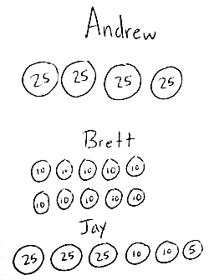
Note: This Application Problem provides practice of Lesson 9 and includes an extension (showing three combinations rather than two). To differentiate, students may be asked only to show Andrew’s and Brett’s coins and then talk to a friend to find a different combination that could be Jay’s.

NOTES ON
MULTIPLE MEANS
OF ENGAGEMENT:
Scaffold the Application Problem for students who are working below grade level by providing them with coins.
Concept Development (34 minutes)
Materials: (S) Personal white board, small plastic bag with 4 quarters, 10 dimes, 10 nickels, and 10 pennies
Assign partners.
Part 1: Find the fewest number of coins.
T: With your partner, show 50 cents in two ways.
S: (Arrange coins on work mats.)
T: Turn and talk with a partner group near you: How did you make 50 cents?
S: I counted 5 dimes: 10, 20, 30, 40, 50. I used 2 quarters. 25 + 25 = 50. I used 1 quarter and
5 nickels.
T: If you were giving someone 50 cents, which combination of coins do you think they would rather have?
S: Probably 2 quarters because it’s easy to hold. Two quarters are easier to carry because they’re only 2 coins.
T: It is easier if we carry fewer coins, so when we give someone change we try to give the fewest coins possible.
T: With your partner, show 40 cents with as few coins as possible.
S: (Arrange coins on work mats.)
T: How did you make 40 cents?
S: I used 4 dimes. I used 1 quarter and 3 nickels. I used 1 quarter, 1 dime, and 1 nickel.
T: Which way has the fewest coins?
S: 1 quarter, 1 dime, and 1 nickel.
T: What strategies did you use to determine the fewest number of coins?
S: I didn’t use pennies. I used a dime instead of 2 nickels. I tried to use a quarter because it is worth the most.
T: Yes. To use the fewest coins, we want to use coins with the greatest possible value.
Part 2: Use the fewest coins by changing coins for higher value coins.
T: This time, everyone count out 35 cents using 3 dimes and 1 nickel.
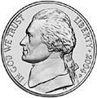
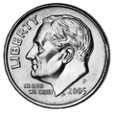
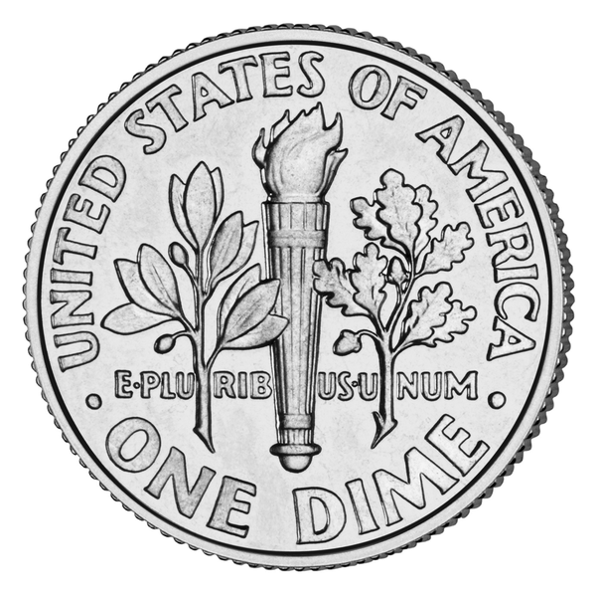
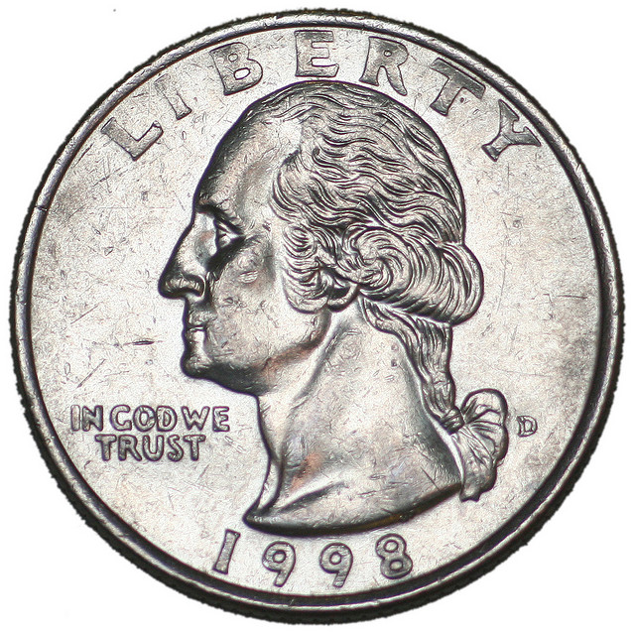
S: (Count change.)
T: How many coins do you have?
S: 4.
T: Can we exchange to have fewer coins?
S: Yes!
T: Tell your partner: What coins can you exchange so you have fewer coins?
S: 2 dimes and 1 nickel for 1 quarter!
T: Do that!
S: (Exchange coins.)
T: And how many coins do you have on your mat?
S: 2.

NOTES ON
MULTIPLE MEANS
OF ENGAGEMENT:
English language learners will benefit throughout the lesson from having sentence starters to help them talk with a partner:
- I changed (exchanged) ____ for ____.
- I added five cents more by using _____.
- I made 30 cents by using _____.
T: That is a lot fewer! Can we make any other exchange?
S: No!
T: Now, everyone count out 60 cents using 4 dimes and 4 nickels.
S: (Count change.)
T: How many coins do you have?
S: 8.
T: Look at your coins. Tell your partner any way you can exchange for a coin with a greater value.
S: I can change these 4 nickels for 2 dimes. I can change 2 dimes and 1 nickel for 1 quarter. I have 60 cents; if I put one dime aside, I can switch the rest for 2 quarters.
T: Yes. Any time we have 50 cents, we can use 2 quarters!
T: How can we change our coins for two quarters?
S: Change 4 dimes and 2 nickels for 2 quarters. Change 4 nickels and 3 dimes for 2 quarters.
T: Make the change.

T: How many coins do you have now?
S: 3.
T: Can we exchange any more coins?
S: No!
T: That means we have shown our value with the fewest number of coins possible.
Part 3: Exploring to use the fewest number of coins for a given total.
T: How can we make 27 cents using the fewest number of coins possible?
S: 1 quarter and 2 pennies.
T: How did you know?
S: Because 27 is 25 and 2 more. A quarter is very close to 27 cents.
T: When we decompose the total into parts, we can get the fewest number of coins quickly by using the coins with the greatest value!
T: What parts can we make with coins of higher value?
S: Twenty-five. Ten. Five.
T: Let’s try another. With your partner, show 60 cents with the fewest number of coins possible by decomposing 60 into as many twenty-fives as you can, and then tens, and then fives.
MP.2
S: (Make 60 cents.)
T: How did you decompose 60 to show it in coins?
S: I know that 60 is 50 + 10 and 50 is 2 quarters. I know that 60 is 30 + 30, so I made 2 thirties with a quarter and a nickel each. Then, I switched the 2 nickels for a dime!
T: What is another way we could have made 60 cents? Turn and talk.
S: Six dimes because 10, 20, 30, 40, 50, 60.
Repeat the above process with the following sequence: 43 cents, 80 cents, and 1 dollar.
Problem Set (10 minutes)
Students should do their personal best to complete the Problem Set within the allotted 10 minutes. For some classes, it may be appropriate to modify the assignment by specifying which problems they work on first. Some problems do not specify a method for solving. Students should solve these problems using the RDW approach used for Application Problems.

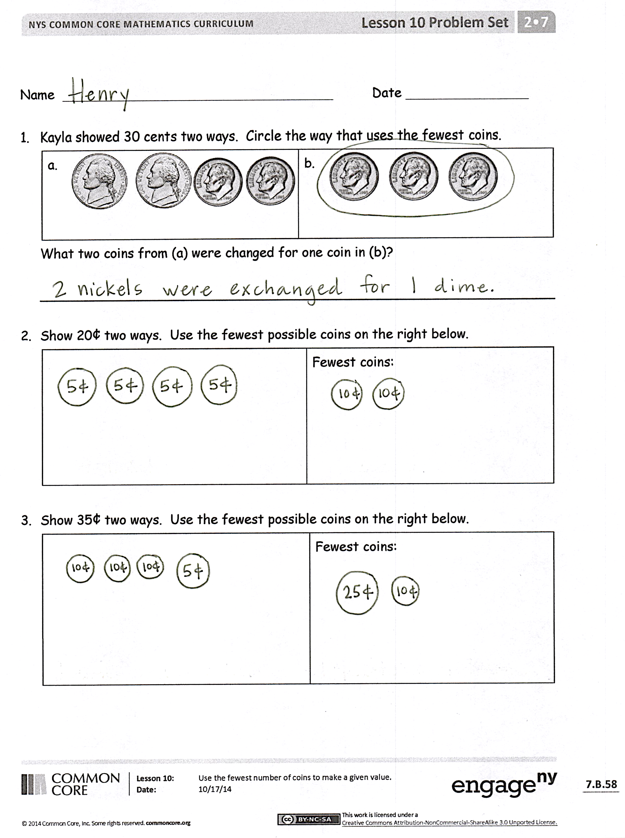
Student Debrief (10 minutes)
Lesson Objective: Use the fewest number of coins to make a given value.
The Student Debrief is intended to invite reflection and active processing of the total lesson experience.
Invite students to review their solutions for the Problem Set. They should check work by comparing answers with a partner before going over answers as a class. Look for misconceptions or misunderstandings that can be addressed in the Debrief. Guide students in a conversation to debrief the Problem Set and process the lesson.
Any combination of the questions below may be used to lead the discussion.
- Compare your Problem Set with your partner’s. What coin was used the most when showing an amount with the fewest coins? Why did this happen?
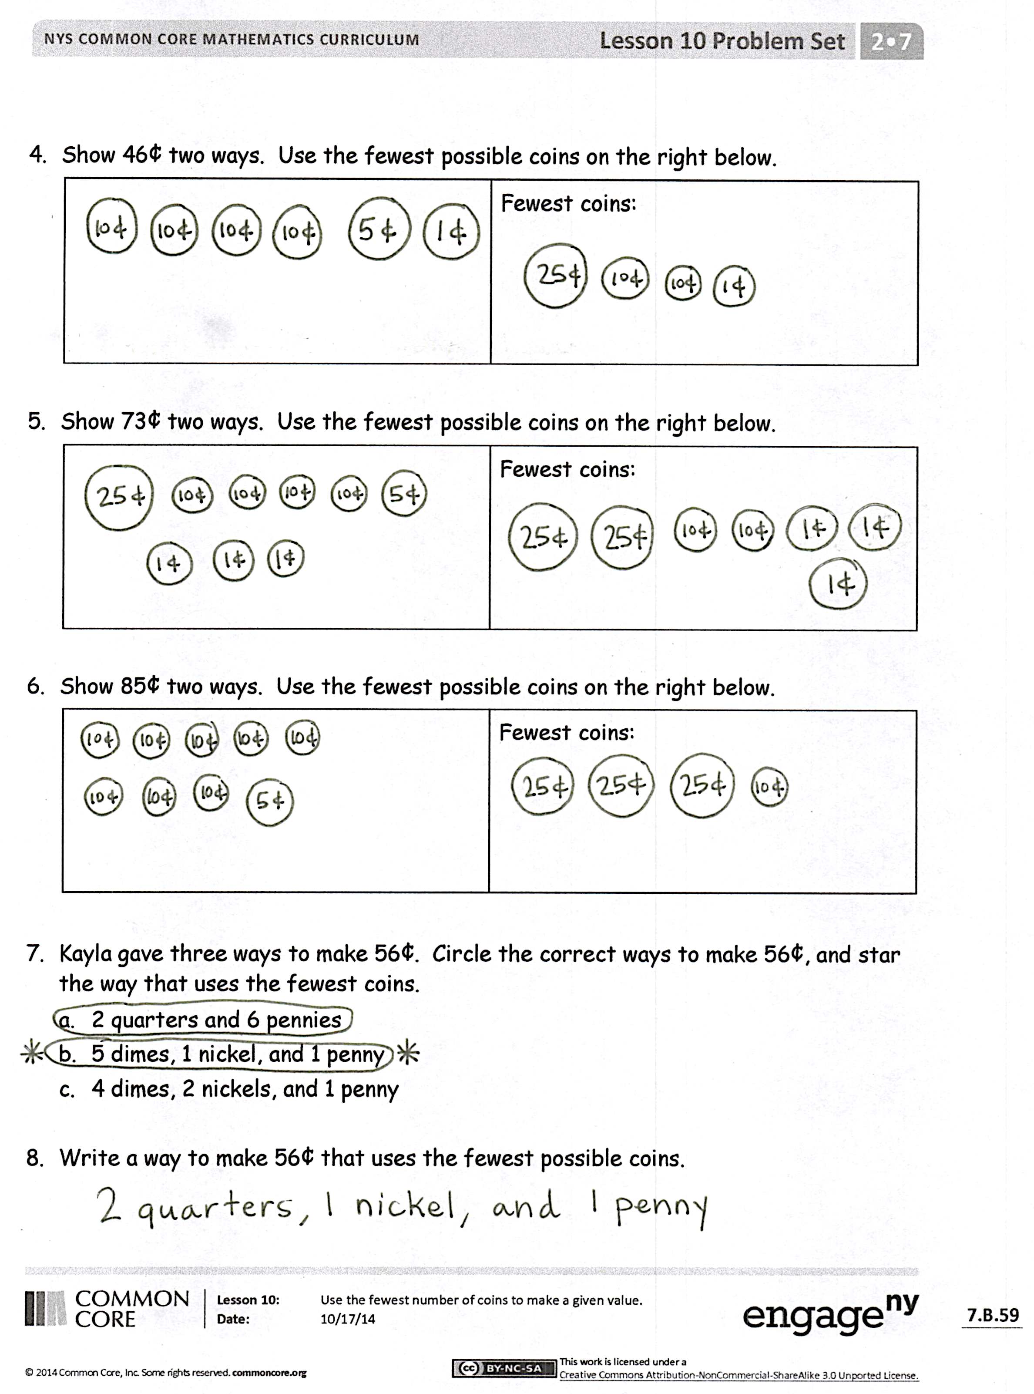
- Yesterday, when we showed the same amount in different ways, did you always use the same coins as your partner? (No. There were lots of combinations.) Why did this happen?
- When you want to use the fewest possible coins, what is a good strategy to use?
- Look at Problem 8 on your Problem Set. Talk to your partner about how you thought about 56 cents to figure out how to make it with the least number of coins possible.
- Can you think of why you would want to use the fewest number of coins possible? (Because it is more convenient to carry and count. Because it is more efficient.)
Exit Ticket (3 minutes)
After the Student Debrief, instruct students to complete the Exit Ticket. A review of their work will help with assessing students’ understanding of the concepts that were presented in todays’ lesson and planning more effectively for future lessons. The questions may be read aloud to the students.

Name Date
- Kayla showed 30 cents two ways. Circle the way that uses the fewest coins.
a. | b.
What two coins from (a) were changed for one coin in (b)?

_______________________________________________________________

- Show 20¢ two ways. Use the fewest possible coins on the right below.
Fewest coins:

- Show 35¢ two ways. Use the fewest possible coins on the right below.
Fewest coins:

- Show 46¢ two ways. Use the fewest possible coins on the right below.
Fewest coins:

- Show 73¢ two ways. Use the fewest possible coins on the right below.
Fewest coins:

- Show 85¢ two ways. Use the fewest possible coins on the right below.
Fewest coins:

- Kayla gave three ways to make 56¢. Circle the correct ways to make 56¢, and star the way that uses the fewest coins.
  - 2 quarters and 6 pennies
  - 5 dimes, 1 nickel, and 1 penny
  - 4 dimes, 2 nickels, and 1 penny

- Write a way to make 56¢ that uses the fewest possible coins.

Name Date
- Show 36 cents two ways. Use the fewest possible coins on the right below.
Fewest coins:

- Show 74 cents two ways. Use the fewest possible coins on the right below.
Fewest coins:

Name Date
- Tara showed 30 cents two ways. Circle the way that uses the fewest coins.
a. | b.
What coins from (a) were changed for one coin in (b)?

_______________________________________________________________

- Show 40¢ two ways. Use the fewest possible coins on the right below.
Fewest coins:

- Show 55¢ two ways. Use the fewest possible coins on the right below.
Fewest coins:

- Show 66¢ two ways. Use the fewest possible coins on the right below.
Fewest coins:

- Show 80¢ two ways. Use the fewest possible coins on the right below.
Fewest coins:

- Show $1 two ways. Use the fewest possible coins on the right below.
Fewest coins:

- Tara made a mistake when asked for two ways to show 91¢. Circle her mistake, and explain what she did wrong.
3 quarters, 1 dime, 1 nickel, 1 penny | Fewest coins:  9 dimes, 1 penny

_______________________________________________________________

_______________________________________________________________

_______________________________________________________________

