Lesson 9
Objective: Solve word problems involving different combinations of coins with the same total value.

Suggested Lesson Structure
 Fluency Practice (10 minutes)
 Application Problem (7 minutes)
 Concept Development (33 minutes)
 Student Debrief (10 minutes)
Total Time (60 minutes)
Fluency Practice (10 minutes)
- Grade 2 Core Fluency Differentiated Practice Sets 2.OA.2 (5 minutes)
- Decomposition Tree 2.NBT.5 (5 minutes)
Grade 2 Core Fluency Differentiated Practice Sets (5 minutes)
Materials: (S) Core Fluency Practice Sets (Lesson 1 Core Fluency Practice Sets)
Note: During Topic B and for the remainder of the year, each day’s Fluency Practice includes an opportunity for review and mastery of the sums and differences with totals through 20 by means of the Core Fluency Practice Sets or Sprints. The process is detailed and Practice Sets are provided in Lesson 1.
Decomposition Tree (5 minutes)
Materials: (S) Decomposition tree (Lesson 6 Fluency Template)
Note: Students are given 90 seconds to decompose a specified amount in as many ways as they can. This fluency activity allows students to work at their own skill level and decompose amounts in a multitude of ways in a short amount of time. When decomposing the number a second time, students are more likely to try other representations that they saw on their partner’s paper.
T: (Distribute tree Template.)
T: You are going to break apart 75¢ on your Deco Tree for 90 seconds. Do as many problems as you can. Go!
S: (Work for 90 seconds.)
T: Now, exchange your tree with your partner, and check each other’s work carefully.
T: (Allow students 30–45 seconds to check.) Return each other’s papers. Did you see another way to make 75¢ on your partner’s paper?
S: (Share for 30 seconds.)
T: Turn your paper over. Let’s break apart 75¢ for another minute.
Application Problem (7 minutes)
Clark has 3 ten-dollar bills and 6 five-dollar bills. He has 2 more ten-dollar bills and 2 more five-dollar bills than Shannon. How much money does Shannon have?
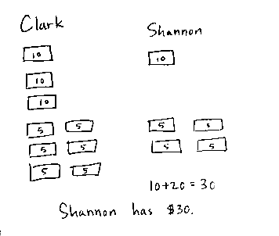
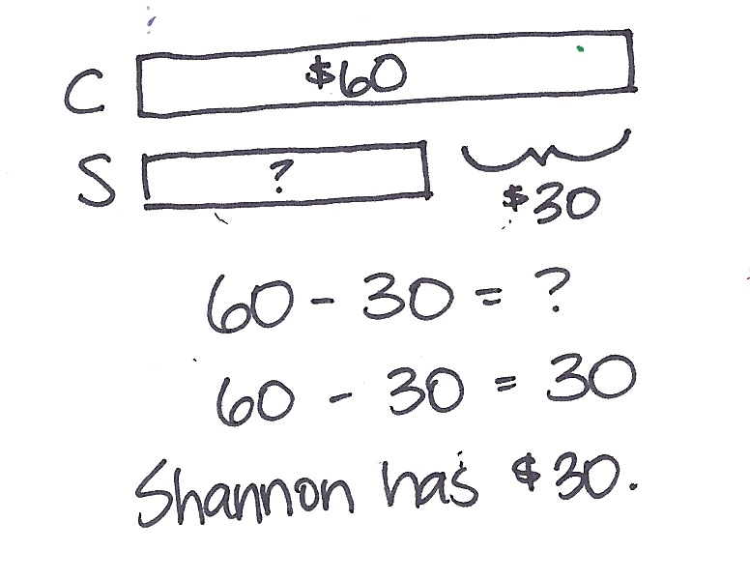

NOTES ON
MULTIPLE MEANS
OF REPRESENTATION:
Comparison problems present a comprehension challenge to some students, including English language learners. These students will benefit from acting out the Application Problem first. They can then make connections through drawing and, finally, with a number sentence.

Note: Allow students who are able to work independently, and offer guidance to students who need support.
Concept Development (33 minutes)
Materials: (T) 1 dime, 3 nickels, 5 pennies, 2 personal white boards (S) Personal white board, bag with the following coins: 4 quarters, 10 nickels, 10 dimes, 10 pennies
Assign partners before beginning instruction.
Part 1: Manipulate different combinations of coins to make the same total value.
T: (Show 1 dime and 5 pennies on one mat and 3 nickels on another mat.)
T: What is the value of the coins on this mat? (Point to the dime and pennies.)
S: 15 cents!
T: What is the value of the coins on this mat? (Point to the nickels.)
S: 15 cents!
T: So, the values are equal?
S: Yes!
T: How can that be? The coins are different!
S: That one is 10 cents and 5 more. The other is 5 + 5 + 5, so they are both 15 cents. Three nickels is 15 cents. A dime and 5 pennies is also 15 cents.
T: Aha! So, we used different coins to make the same value?
S: Yes!
T: Let’s try that! I will say an amount, and you work with your partner to show the amount in two different ways.
T: With your partner, show 28 cents two different ways.
S: (Arrange coins on their mats while discussing with their partners.)
T: How did you make 28 cents?
S: I used a quarter and 3 pennies. My partner used 2 dimes and 8 pennies. I also used a quarter and 3 pennies, but my partner used 2 dimes, 1 nickel, and 3 pennies.
Repeat the above sequence with the following amounts: 56 cents, 75 cents, and 1 dollar.
Part 2: Manipulate different combinations of coins in the context of word problems.
Problem 1: Tony gets 83¢ change back from the cashier at the corner store. What coins might Tony have received?
T: Read the problem to me, everyone.
S: (Read chorally.)

NOTES ON
MULTIPLE MEANS
OF ENGAGEMENT:
Challenge students working above grade level to show you 83¢ two ways: using the least number of coins and using the greatest number of coins. Ask your students to explain how they came up with their solutions and how it is possible for both solutions to have the same value.
T: Can you draw something?
S: Yes!
T: Do that. (Allow students time to work.)
T: How did you show Tony’s change?
S: I drew 8 dimes and 3 pennies. I made 50¢ using
2 quarters, then added 3 dimes to make 80¢, and then added 3 pennies to make 83¢. I used 3 quarters,
1 nickel, and 3 pennies.
T: Write your coin combinations and the total value below your drawing. If you used 8 dimes and
3 pennies, write that underneath like this. (Model writing the coin combination with the total value on the board, e.g., 8 dimes, 3 pennies = 83 cents.)
T: Now, pretend that the cashier has run out of quarters. Draw Tony’s change in another way without using quarters. Write your coin combination and total value below.
S: Mine still works! I traded each of my quarters for 2 dimes and a nickel. Now, I have 7 dimes,
2 nickels, and 3 pennies. I didn’t use a quarter before, but this time I used 6 dimes and 4 nickels instead of 7 dimes and 2 nickels to show 80 cents.

Problem 2: Carla has 4 dimes, 1 quarter, and 2 nickels to spend at the snack stand. Peyton has 3 coins, but he has the same amount of money to spend. What coins must Peyton have? How do you know?
MP.6
T: Read the problem to me, everyone.
S: (Read chorally.)
T: Can you draw something?
S: Yes!
T: Time to draw! (Allow students time to work.)
T: What did you draw?
S: 4 dimes, 1 quarter, and 2 nickels. A tape diagram with one part 40 cents, one part 25 cents, and one part 10 cents.
T: What is the value of Carla’s money?
S: 75 cents.
MP.6
T: Show your partner how you found or can find three coins that make 75¢. (Allow time for sharing.) What coins did Peyton have?
S: 3 quarters.
T: How do you know?
S: We added 25 + 25 + 25 to make 75. We couldn’t make 75¢ with three coins if we used dimes, nickels, or pennies.
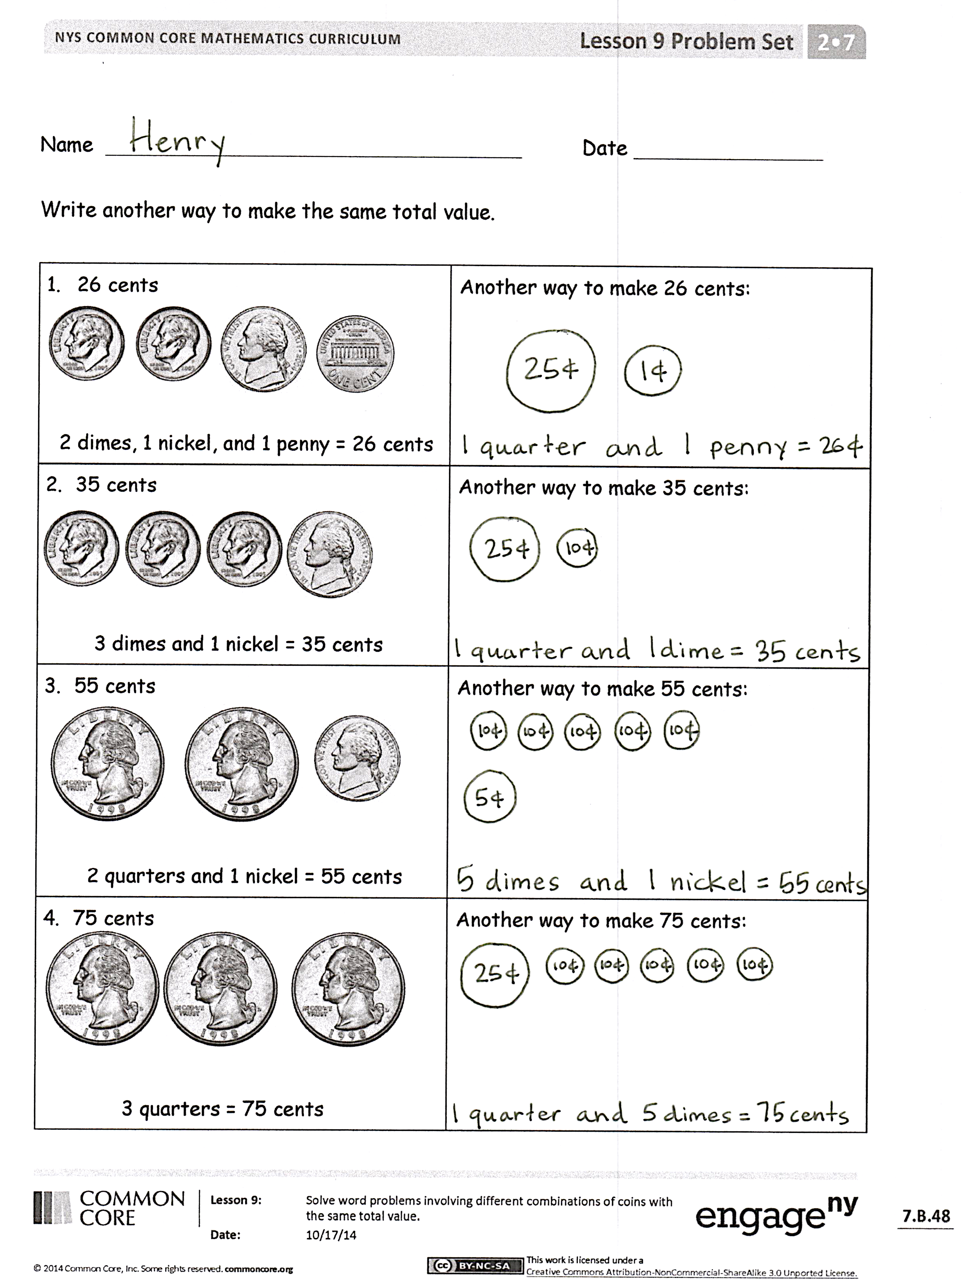
Problem Set (10 minutes)
Students should do their personal best to complete the Problem Set within the allotted 10 minutes. For some classes, it may be appropriate to modify the assignment by specifying which problems they work on first. Some problems do not specify a method for solving. Students should solve these problems using the RDW approach used for Application Problems.
Student Debrief (10 minutes)
Lesson Objective: Solve word problems involving different combinations of coins with the same total value.
The Student Debrief is intended to invite reflection and active processing of the total lesson experience.
Invite students to review their solutions for the Problem Set. They should check work by comparing answers with a partner before going over answers as a class. Look for misconceptions or misunderstandings that can be addressed in the Debrief. Guide students in a conversation to debrief the Problem Set and process the lesson.
Any combination of the questions below may be used to lead the discussion.
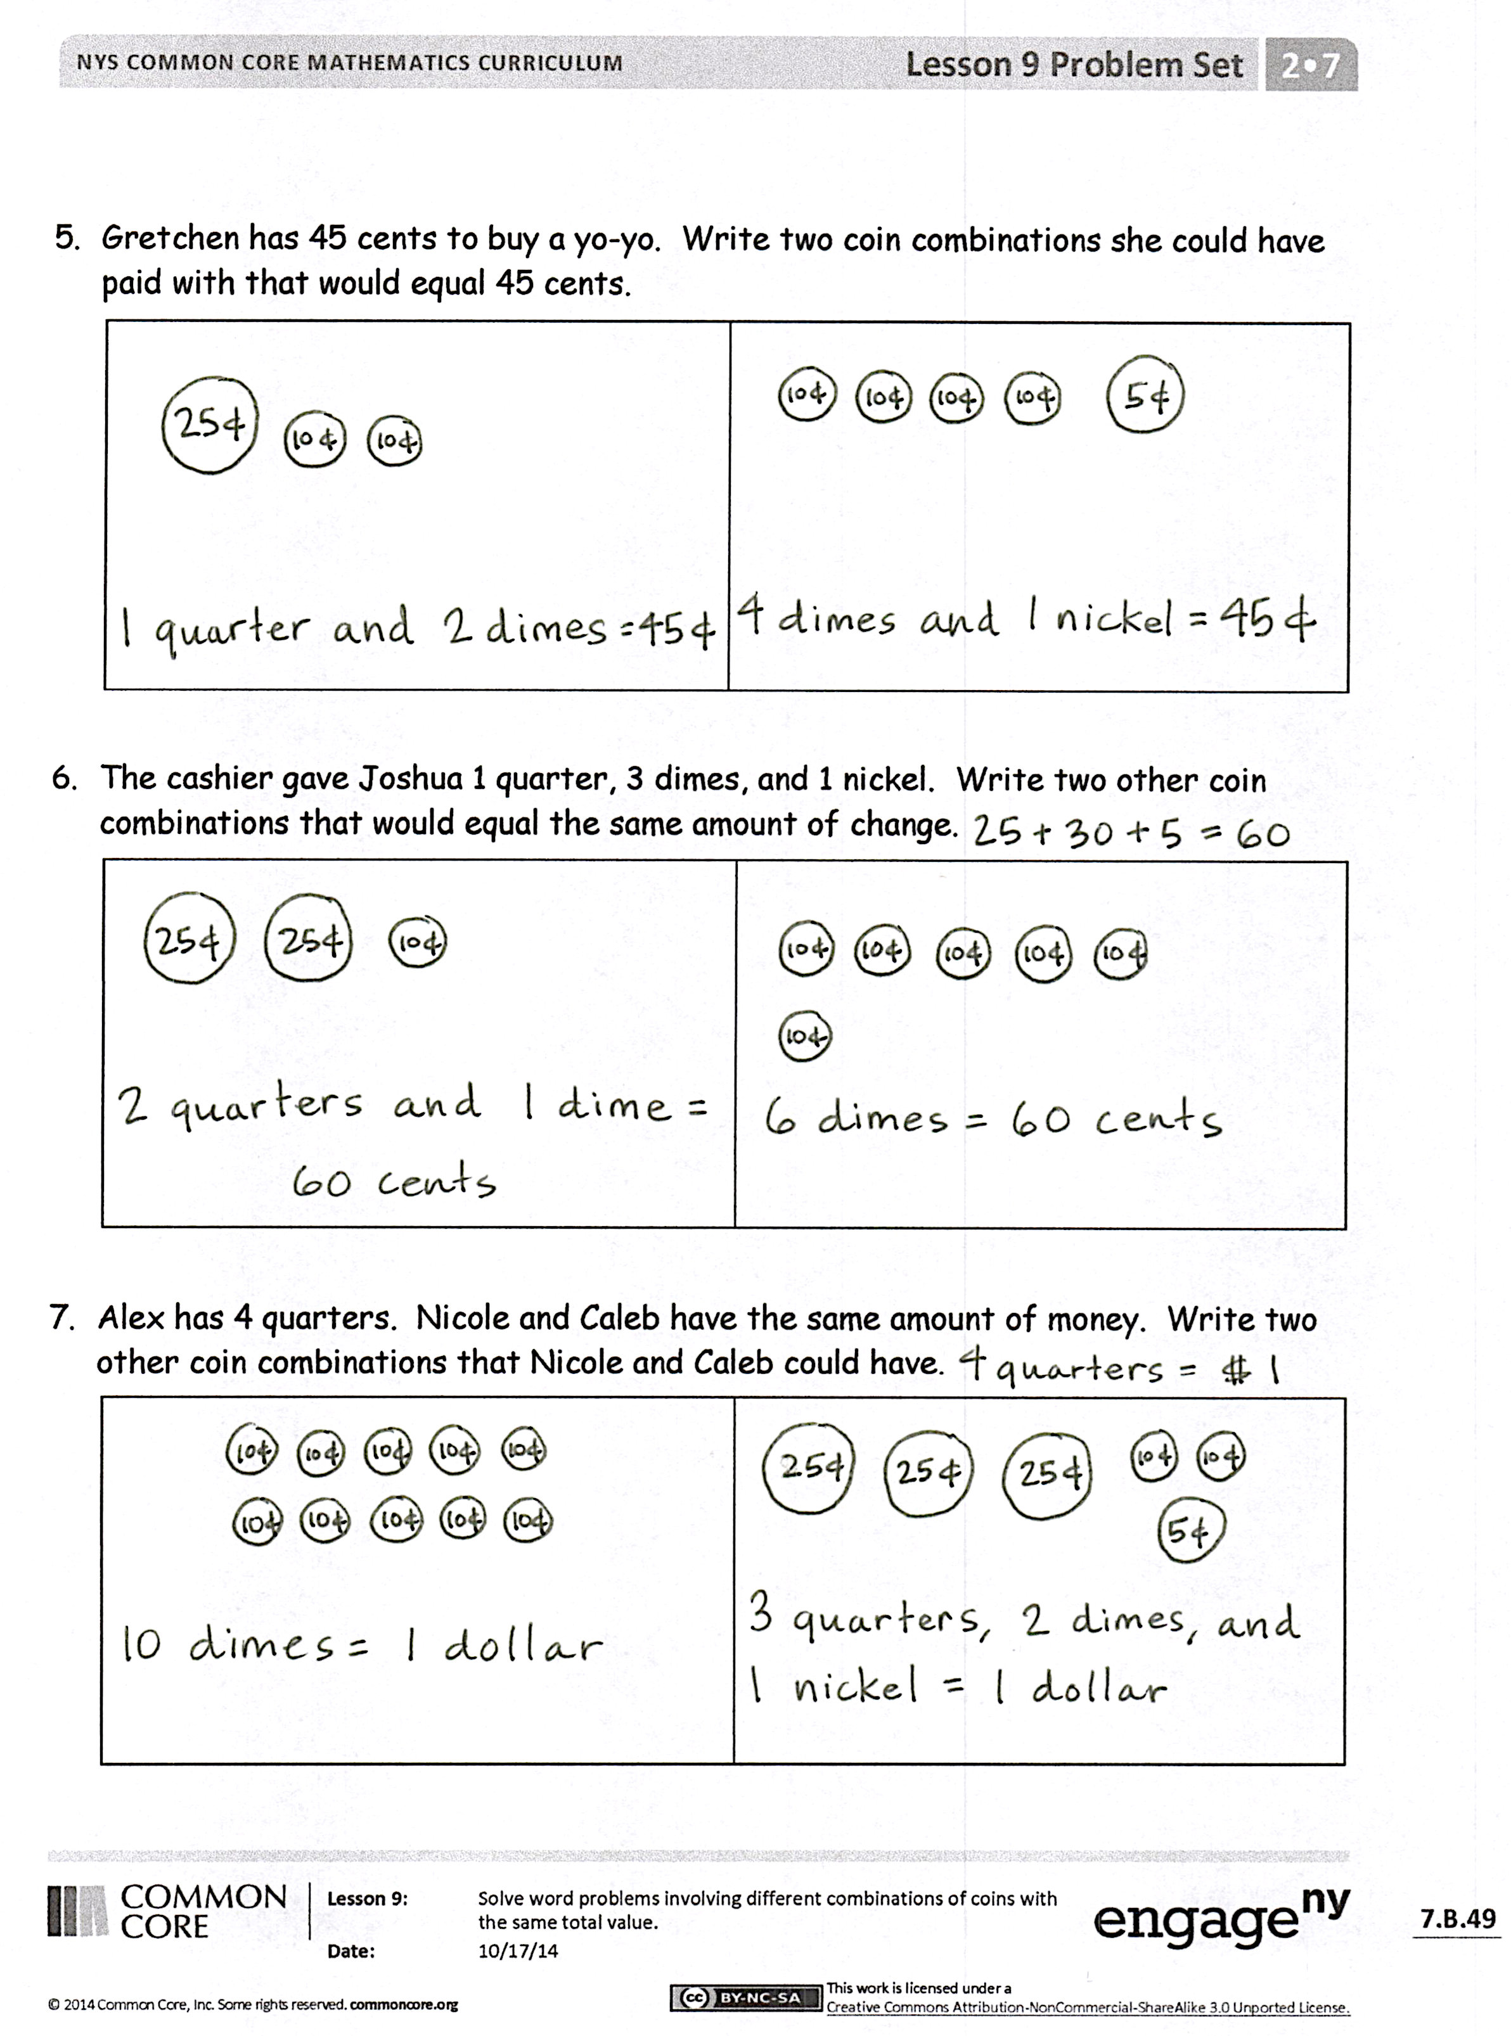
- Look at your partner’s coin combinations for
26 cents. Did you use the same combinations as your partner? Are there more combinations that you and your partner did not think of?
- Look at Problem 2, 35 cents. With your partner, think about how you could make 35 cents using the least number of coins. How could you make 35 cents using the largest number of coins?
- Can you think of other math skills we have learned where the same value can be represented in different ways?
- With your partner, find all the different coin combinations for 15 cents.
Exit Ticket (3 minutes)
After the Student Debrief, instruct students to complete the Exit Ticket. A review of their work will help with assessing students’ understanding of the concepts that were presented in today’s lesson and planning more effectively for future lessons. The questions may be read aloud to the students.

Name Date
Write another way to make the same total value.
- 26 cents  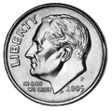  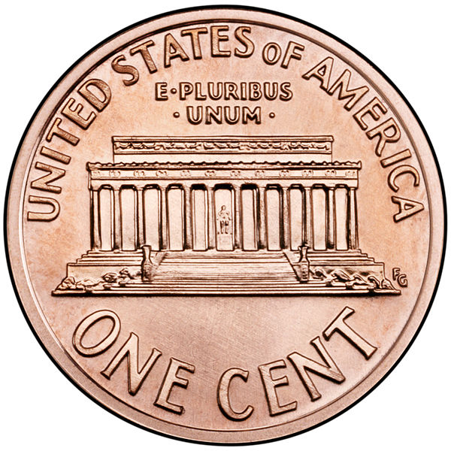  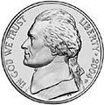  2 dimes, 1 nickel, and 1 penny = 26 cents | Another way to make 26 cents:
- 35 cents  3 dimes and 1 nickel = 35 cents | Another way to make 35 cents:
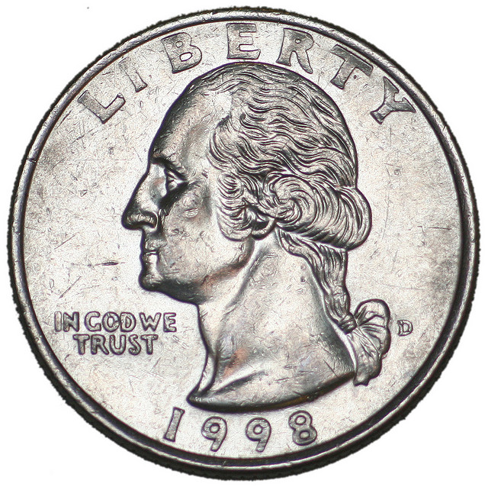  - 55 cents  2 quarters and 1 nickel = 55 cents | Another way to make 55 cents:
- 75 cents  3 quarters = 75 cents | Another way to make 75 cents:

- Gretchen has 45 cents to buy a yo-yo. Write two coin combinations she could have paid with that would equal 45 cents.

- The cashier gave Joshua 1 quarter, 3 dimes, and 1 nickel. Write two other coin combinations that would equal the same amount of change.

- Alex has 4 quarters. Nicole and Caleb have the same amount of money. Write two other coin combinations that Nicole and Caleb could have.

Name Date
Smith has 88 pennies in his piggy bank. Write two other coin combinations he could have that would equal the same amount.

Name Date
Draw coins to show another way to make the same total value.
- 25 cents  1 dime and 3 nickels = 25 cents | Another way to make 25 cents:
- 40 cents  4 dimes = 40 cents | Another way to make 40 cents:
- 60 cents  2 quarters and 1 dime = 60 cents | Another way to make 60 cents:
- 80 cents  3 quarters and 1 nickel = 80 cents | Another way to make 80 cents:

- Samantha has 67 cents in her pocket. Write two coin combinations she could have that would equal the same amount.

- The store clerk gave Jeremy 2 quarters, 3 nickels, and 4 pennies. Write two other coin combinations that would equal the same amount of change.

- Chelsea has 10 dimes. Write two other coin combinations she could have that would equal the same amount.

