Lesson 8
Objective: Solve word problems involving the total value of a group of bills.

Suggested Lesson Structure
 Fluency Practice (12 minutes)
 Application Problem (6 minutes)
 Concept Development (32 minutes)
 Student Debrief (10 minutes)
Total Time (60 minutes)
Fluency Practice (12 minutes)
- Sprint: Adding Across a Ten 2.OA.2 (9 minutes)
- More and Less 2.NBT.5 (3 minutes)
Sprint: Adding Across a Ten (9 minutes)
Materials: (S) Adding Across a Ten Sprint
Note: This Sprint gives practice with the grade level fluency of adding within 20.
More and Less (3 minutes)
Note: In this activity, students practice adding and subtracting coins. Because the addition of the value of a quarter may still be challenging for some, the use of a signal to invite a choral response is suggested.
T: The value of one dime more than a quarter is…?
S: 35 cents.
T: Give the number sentence using cents as the unit.
S: 25 cents + 10 cents = 35 cents.
T: Wait for the signal. The value of 1 quarter more than 35 cents is…? (Signal when students are ready.)
S: 60 cents!
T: Give the number sentence.
S: 35 cents + 25 cents = 60 cents.
T: The value of 1 quarter more than 60 cents is…?
S: 85 cents.
T: Give the number sentence.
S: 60 cents + 25 cents = 85 cents.
T: The value of a dime and nickel more than 85 cents is…?
S: 100 cents. 1 dollar!
T: Give the number sentence.
S: 85 cents + 15 cents = 100 cents.
Continue to repeat this line of questioning as time permits, restarting at zero after reaching 100 cents.
Application Problem (6 minutes)

NOTES ON
MULTIPLE MEANS
OF ACTION AND EXPRESSION :
Scaffold the Application Problem for students who are working below grade level by providing them with coins to use. Work with students one step at a time while they add up the value of the coins: “What is the value of a quarter? 2 quarters? 1 dime, 2 dimes, 3 dimes, 4 dimes? Two nickels equals how much? Let’s add them all up together.”
Kiko’s brother says that he will trade her 2 quarters, 4 dimes, and 2 nickels for a one-dollar bill. Is this a fair trade? How do you know?
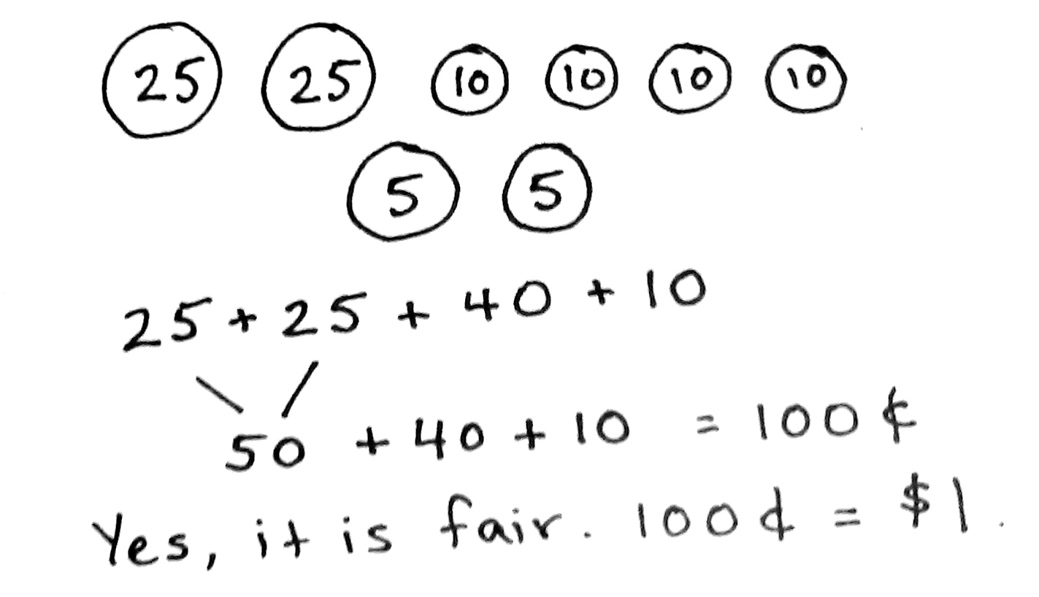

Note: This problem affords students the chance to practice ordering coins from greatest to least and then finding the total. It also asks students to make a judgment call based on their solution. The comparison to $1 serves as a bridge to today’s lesson with dollar bills.
Concept Development (32 minutes)
Materials: (T) Play money dollar bills (S) Personal white board
Part 1: Solve a put together with total unknown type problem.
Alyssa has 5 five-dollar bills, 12 one-dollar bills, and 3 ten-dollar bills in her wallet. How much money is in her wallet?
T: What do we do first when we see a word problem?
S: Read the whole thing.
T: Yes. Let’s read the problem together.
T/S: (Read aloud.)
T: What can you draw?
S: All the dollar bills. 3 ten-dollar bills, 5 five-dollar bills, and 12 one-dollar bills.
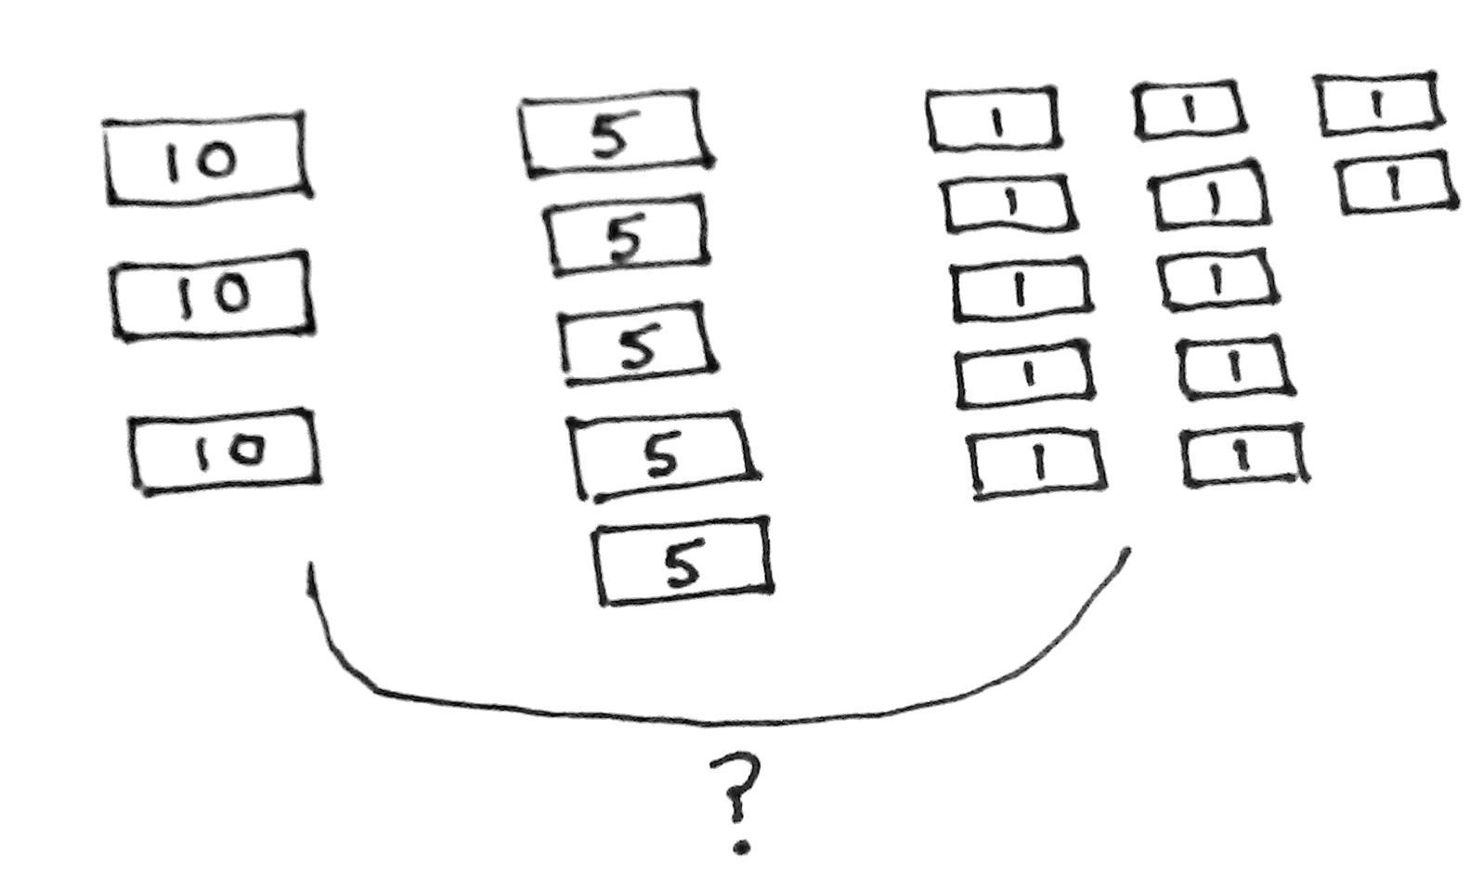
T: Great! I’ll give you about one minute to draw quietly. When I give the signal, talk to your partner about how your drawing (shown on the right) matches the story.
T: Turn and talk: Look at your drawing. What are you trying to find?
S: I need to find out how much money Alyssa has in her wallet. I need to find the total value of the dollar bills. I need to find the total value of the tens, then fives, then ones. Then, add.
T: Go ahead and do that. Write a number sentence and a statement to match your work. (Pause to allow students time to work.) Explain to your partner how you solved the problem and how your number sentence matches your drawing.
S: I put the money in order from greatest to least. Then, I skip-counted by tens first: 10, 20, 30. Then, I added on and skip-counted by fives: 35, 40, 45, 50, 55. Then, I added 12 ones, and I got 67.
I thought, 10 plus 10 is 20, and 20 plus 10 is 30. Then, I counted on each 5, so 35, 40, 45, 50, 55. Then, I added on 12 ones.
T: What’s your number sentence?
S: 30 + 25 + 12 = 67. 10 + 10 + 10 + 5 + 5 + 5 + 5 + 5 + 12 = 67.
T: And the statement of your solution?
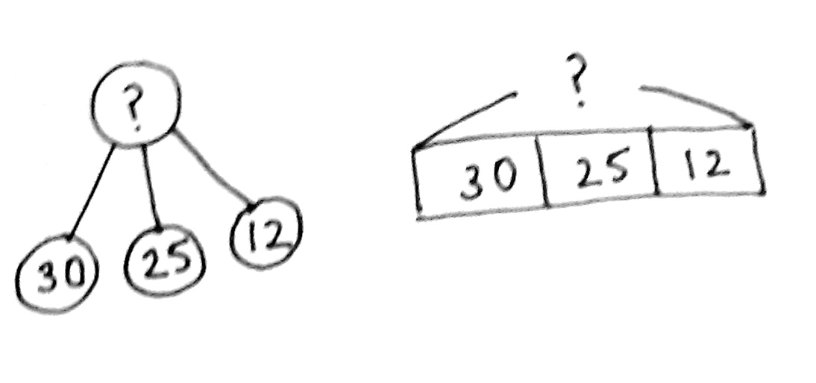
S: Alyssa has 67 dollars in her wallet.
T: Yes! Look how we can also represent this problem with a tape diagram or number bond (see images on the right).
T: Turn and talk. Use part–whole language to describe how your drawing matches mine and how it is different than mine.
S: I combined three parts to find the whole thing. We both have question marks for the whole, since we need to find it. I added three parts, too, the ten dollar bills, five dollar bills, and one dollar bills! My drawing was a lot more work!
T: Do both drawings make sense?
S: Yes!
T: Whose might be more efficient?
S: Yours!
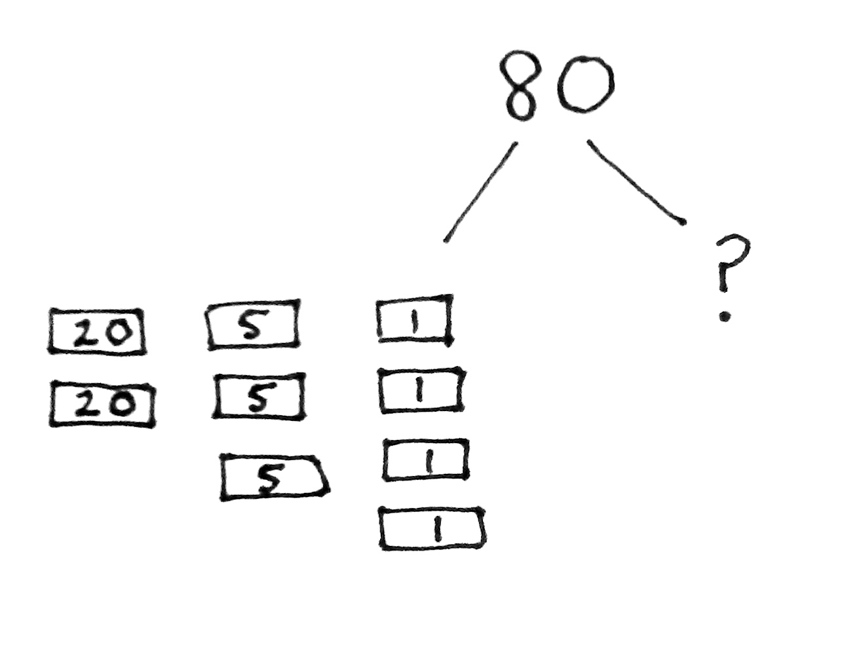
T: The important thing is that a drawing makes sense, but as we solve more problems, sometimes we do see more efficient ways to draw.
Part 2: Solve a take from with result unknown type problem.
Silas uses 2 twenty-dollar bills, 3 five-dollar bills, and 4 one-dollar bills on a gift for his aunt. He is going to save the rest. If Silas started with $80, how much will he save?
T: Let’s read the problem together.
T/S: (Read aloud.)
T: Can you draw something? Just answer yes or no.
S: Yes!
T: I’ll give you a minute to draw quietly. (Circulate to support by rereading and repeating the simple questions, “Can you draw something? What can you draw?”)
T: Talk to your partner. What did you draw?
S: I drew the money Silas spent on the gift and a question mark for the money he saved. I drew 2 twenty-dollar bills, 3 five-dollar bills, and 4 one-dollar bills. I started with 80 and made two arms like a number bond with all the money he spent in one part. (See drawing on previous page.)
T: Turn and talk: Look at your drawing. What are you trying to find?

NOTES ON
MULTIPLE MEANS
OF REPRESENTATION:
Facilitate English language learners’ ability to talk to a partner by providing sentence starters throughout the lesson:
- Silas spent ____ dollars. I know because ___.
- I need to find ___.
- I drew ___ to match the story.
- I used the ____ strategy to find how much money Deste has.
S: First, I am trying to find out how much Silas spent altogether by adding. I need to find the total value of all the bills. Then, I need to subtract from $80 to see how much he’ll save.
T: Good analysis. Now, write a number sentence and a statement to match your work. (Pause while students work.) Explain to your partner how you solved.
S: First, I added 20 plus 20, which is 40. Then, I
skip-counted up by fives, so 45, 50, 55. Then, 4 more is 59 dollars. I wrote 40 + 15 + 4 = ____. Since 15 + 4 is almost 20, I added 40 + 20 to make 60. Then, I subtracted 1 to get 59. After I found the total, $59, I used compensation to subtract. I changed 80 – 59 to 81 – 60, which is $21. To find how much Silas saved, I wrote 59 + ___ = 80. I counted up 21 more using the arrow way.
MP.2
T: I see many of you wrote two number sentences. First, you found the total Silas spent on the gift. From there, you found out how much he saved. Nice work!
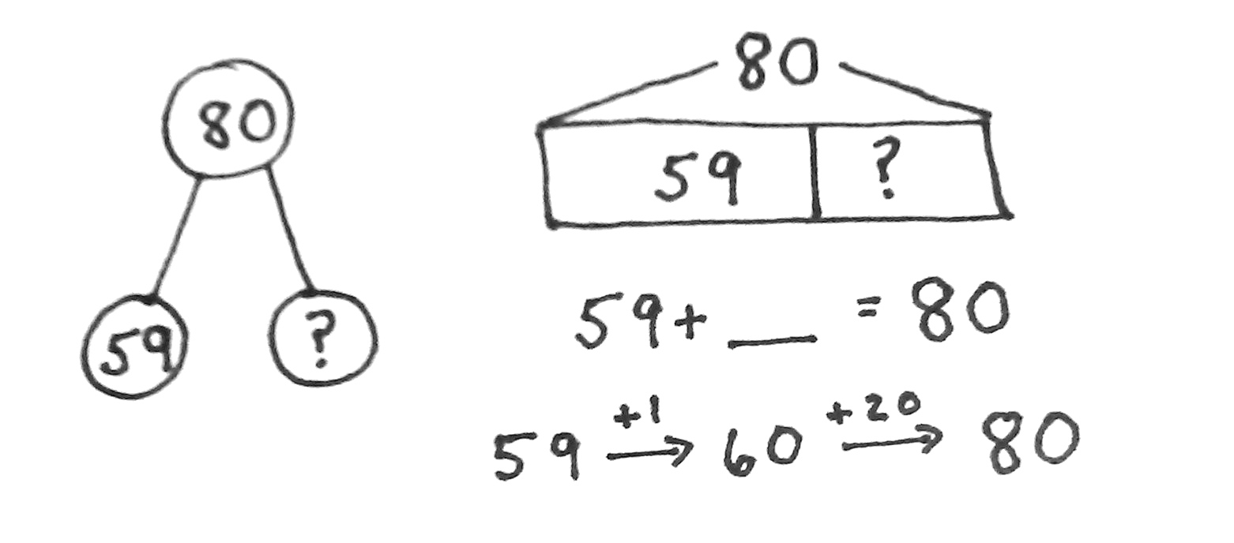
T: How much did Silas save? Tell me in a statement.
S: Silas saved 21 dollars.
T: Some of you also represented this situation with a part–whole model (shown on the right).
T: Use part–whole language to describe how your drawing matches your friend’s.
S: I added up the money in my drawing to get $59, which is one part in your number bond. I drew $80 first, since that was the whole amount Silas started with. I had a question mark for the part he saved.
T: You’ve got it!

Part 3: Solve a compare with smaller unknown type problem.
Deste has 4 ten-dollar bills and 6 five-dollar bills. She has $25 more than Kirsten. How much money does Kirsten have?
T: Let’s read the problem together.
T/S: (Read aloud.)
T: What do we do after we have read?
S: Draw.
T: Great! Get going.
T: Look at your drawing. What are you trying to find? Turn and talk.
S: I’m trying to find out how much money Kirsten has. I’m trying to find out Kirsten’s total money.
I know it is $25 less than Deste’s.
T: Write a number sentence and a statement to match your work. (Pause to allow students time to work.) Explain to your partner how you solved and how your number sentence matches the story.
S: First, I skip-counted in my head by tens and fives to get Deste’s total: 10, 20, 30, 40, 45, 50, …70.
I knew that if Deste has $25 more, then Kirsten has $25 less. I subtracted 70 – 25. Then, I added 5 to both numbers and made it an easier problem. (See image below.) I drew a tape diagram, but I wrote ? + 25 = 70. I counted up 5 to 30 and then added on 40 more, so 45 dollars.
T: How much money does Kirsten have? Tell me in a statement.
S: Kirsten has 45 dollars.
T: The words more and less in a word problem can be tricky. Let’s look back at the problem to be sure our drawing matches the story. (Point while working through the problem.)
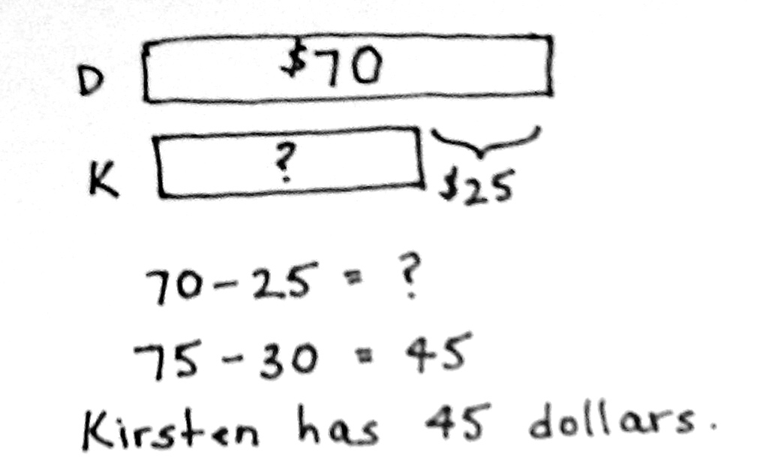
T: How much money does Deste have?
S: 70 dollars.
T: Does our drawing show that?
S: Yes.
T: Who has more money?
S: Deste!
T: Does our drawing show that?
S: Yes!
T: How much more money does Deste have than Kirsten?
S: $25.
T: Does our drawing show that?
S: Yes!
T: Explain to your partner how you know Deste has more than Kirsten.
S: Deste has $70, and that’s $25 more than $45. Kirsten’s total should be $25 less than Deste’s total. $45 is $25 less than $70.
T: The tricky thing for me is that the problem says Deste has more, but we subtract to find the amount of money Kirsten has!
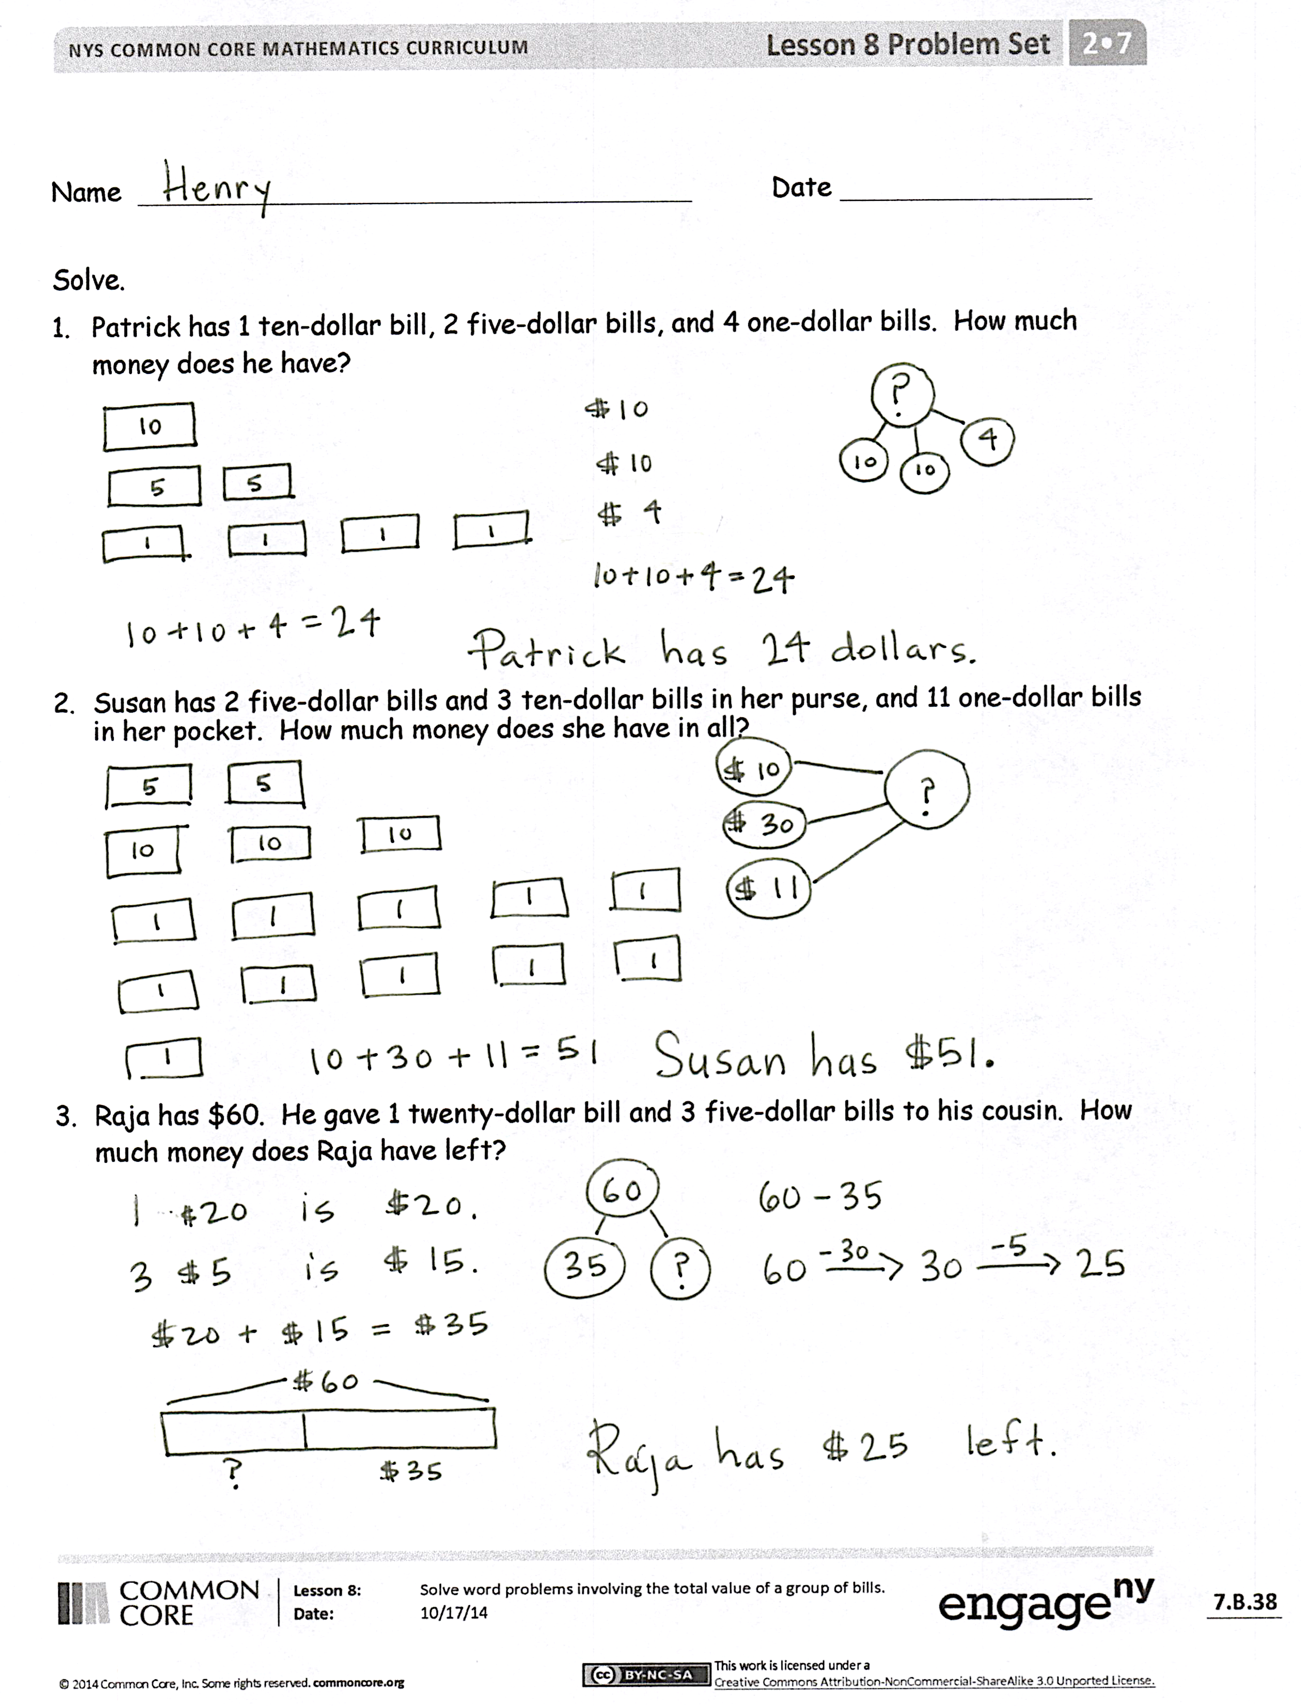
Problem Set (10 minutes)
Students should do their personal best to complete the Problem Set within the allotted 10 minutes. For some classes, it may be appropriate to modify the assignment by specifying which problems they work on first. Some problems do not specify a method for solving. Students should solve these problems using the RDW approach used for Application Problems.
Student Debrief (10 minutes)
Lesson Objective: Solve word problems involving the total value of a group of bills.
The Student Debrief is intended to invite reflection and active processing of the total lesson experience.
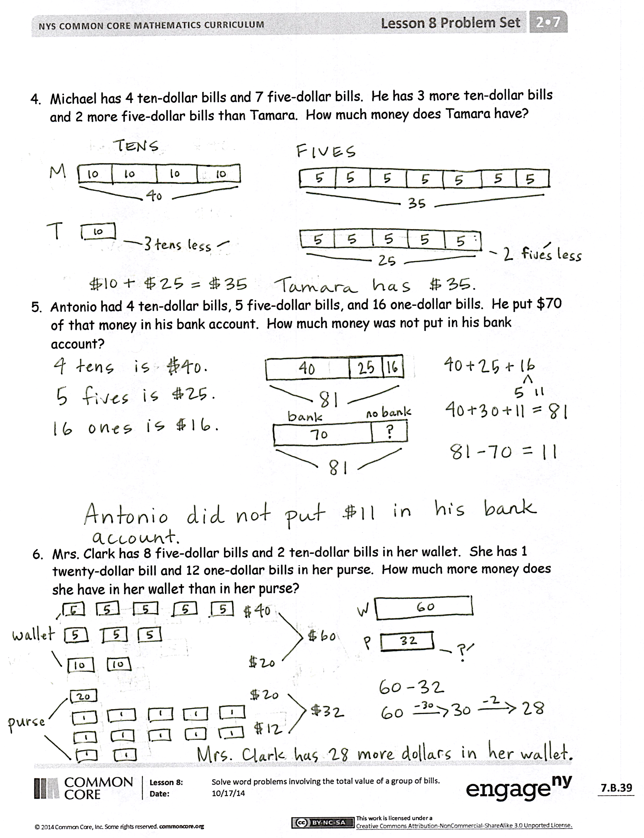
Invite students to review their solutions for the Problem Set. They should check work by comparing answers with a partner before going over answers as a class. Look for misconceptions or misunderstandings that can be addressed in the Debrief. Guide students in a conversation to debrief the Problem Set and process the lesson.
Any combination of the questions below may be used to lead the discussion.
- Look at Problem 2 on your Problem Set. Talk to your partner about how you thought about the one-dollar bills when figuring out how much money Susan had. Did you use what you know about place value to help you?
- What strategy did you use in Problem 4 to compare Michael’s and Tamara’s money? (Number bond, tape diagram, pictures, or equations.)
- Let’s read Problem 6 together. When it asked how much more money is in her wallet than in her purse, did you think add or subtract? Talk to your partner. (Discuss comparison problems and how not to be tricked by the word more.)
- Let’s read Problem 5 together. Talk to your partner. How did your drawing help you know what you were trying to find? (Without a drawing labeled with a question mark for the unknown, students might miss that they are finding what Antonio did not put in his bank account.)
- Explain to your partner a good way to think about dollars when the problem asks you to count many different bills. How do your organize them so they are easier to count?
Exit Ticket (3 minutes)
After the Student Debrief, instruct students to complete the Exit Ticket. A review of their work will help with assessing students’ understanding of the concepts that were presented in today’s lesson and planning more effectively for future lessons. The questions may be read aloud to the students.

Number Correct: _______
A
Adding Across a Ten
 | 9 + 2 = |  |  |  | 4 + 7 =
 | 9 + 3 = |  |  |  | 4 + 8 =
 | 9 + 4 = |  |  |  | 5 + 6 =
 | 9 + 7 = |  |  |  | 5 + 7 =
 | 7 + 9 = |  |  |  | 3 + 8 =
 | 10 + 1 = |  |  |  | 3 + 9 =
 | 10 + 2 = |  |  |  | 2 + 9 =
 | 10 + 3 = |  |  |  | 5 + 10 =
 | 10 + 8 = |  |  |  | 5 + 8 =
 | 8 + 10 = |  |  |  | 9 + 6 =
 | 8 + 3 = |  |  |  | 6 + 9 =
 | 8 + 4 = |  |  |  | 7 + 6 =
 | 8 + 5 = |  |  |  | 6 + 7 =
 | 8 + 9 = |  |  |  | 8 + 6 =
 | 9 + 8 = |  |  |  | 6 + 8 =
 | 7 + 4 = |  |  |  | 8 + 7 =
 | 10 + 5 = |  |  |  | 7 + 8 =
 | 6 + 5 = |  |  |  | 6 + 6 =
 | 7 + 5 = |  |  |  | 7 + 7 =
 | 9 + 5 = |  |  |  | 8 + 8 =
 | 5 + 9 = |  |  |  | 9 + 9 =
 | 10 + 6 = |  |  |  | 4 + 9 =
Number Correct: _______
Improvement: _______
B
[KEY]

Adding Across a Ten
 | 10 + 1 = |  |  |  | 5 + 6 =
 | 10 + 2 = |  |  |  | 5 + 7 =
 | 10 + 3 = |  |  |  | 4 + 7 =
 | 10 + 9 = |  |  |  | 4 + 8 =
 | 9 + 10 = |  |  |  | 4 + 10 =
 | 9 + 2 = |  |  |  | 3 + 8 =
 | 9 + 3 = |  |  |  | 3 + 9 =
 | 9 + 4 = |  |  |  | 2 + 9 =
 | 9 + 8 = |  |  |  | 5 + 8 =
 | 8 + 9 = |  |  |  | 7 + 6 =
 | 8 + 3 = |  |  |  | 6 + 7 =
 | 8 + 4 = |  |  |  | 8 + 6 =
 | 8 + 5 = |  |  |  | 6 + 8 =
 | 8 + 7 = |  |  |  | 9 + 6 =
 | 7 + 8 = |  |  |  | 6 + 9 =
 | 7 + 4 = |  |  |  | 9 + 7 =
 | 10 + 4 = |  |  |  | 7 + 9 =
 | 6 + 5 = |  |  |  | 6 + 6 =
 | 7 + 5 = |  |  |  | 7 + 7 =
 | 9 + 5 = |  |  |  | 8 + 8 =
 | 5 + 9 = |  |  |  | 9 + 9 =
 | 10 + 8 = |  |  |  | 4 + 9 =

Name Date
Solve.
- Patrick has 1 ten-dollar bill, 2 five-dollar bills, and 4 one-dollar bills. How much money does he have?

- Susan has 2 five-dollar bills and 3 ten-dollar bills in her purse and 11 one-dollar bills in her pocket. How much money does she have in all?

- Raja has $60. He gave 1 twenty-dollar bill and 3 five-dollar bills to his cousin. How much money does Raja have left?

- Michael has 4 ten-dollar bills and 7 five-dollar bills. He has 3 more ten-dollar bills and 2 more five-dollar bills than Tamara. How much money does Tamara have?

- Antonio had 4 ten-dollar bills, 5 five-dollar bills, and 16 one-dollar bills. He put $70 of that money in his bank account. How much money was not put in his bank account?

- Mrs. Clark has 8 five-dollar bills and 2 ten-dollar bills in her wallet. She has
1 twenty-dollar bill and 12 one-dollar bills in her purse. How much more money does she have in her wallet than in her purse?

Name Date
Solve.
- Josh had 3 five-dollar bills, 2 ten-dollar bills, and 7 one-dollar bills. He gave Suzy
1 five-dollar bill and 2 one-dollar bills. How much money does Josh have left?

- Jeremy has 3 one-dollar bills and 1 five-dollar bill. Jessica has 2 ten-dollar bills and 2 five-dollar bills. Sam has 2 ten-dollar bills and 4 five-dollar bills. How much money do they have together?

Name Date
Solve.
- Mr. Chang has 4 ten-dollar bills, 3 five-dollar bills, and 6 one-dollar bills. How much money does he have in all?

- At her yard sale, Danielle got 1 twenty-dollar bill and 5 one-dollar bills last week. This week, she got 3 ten-dollar bills and 3 five-dollar bills. What is the total amount she got for both weeks?

- Patrick has 2 fewer ten-dollar bills than Brenna. Patrick has $64. How much money does Brenna have?

- On Saturday, Mary Jo received 5 ten-dollar bills, 4 five-dollar bills, and
17 one-dollar bills. On Sunday, she received 4 ten-dollar bills, 5 five-dollar bills,
and 15 one-dollar bills. How much more money did Mary Jo receive on Saturday than on Sunday?

- Alexis has $95. She has 2 more five-dollar bills, 5 more one-dollar bills, and 2 more ten-dollar bills than Kasai. How much money does Kasai have?

- Kate had 2 ten-dollar bills, 6 five-dollar bills, and 21 one-dollar bills before she spent $45 on a new outfit. How much money was not spent?

