Lesson 7
Objective: Solve word problems involving the total value of a group of coins.

Suggested Lesson Structure
 Fluency Practice (12 minutes)
 Application Problem (5 minutes)
 Concept Development (33 minutes)
 Student Debrief (10 minutes)
Total Time (60 minutes)
Fluency Practice (12 minutes)
- Skip-Count by $5 and $10 Between 85 and 205 2.NBT.2 (3 minutes)
- Sprint: Subtraction Across a Ten 2.OA.2 (9 minutes)
Skip-Count by $5 and $10 Between 85 and 205 (3 minutes)
Materials: (T) 20 ten-dollar bills, 10 five-dollar bills
Note: Bring students to an area where you can lay the bills on the carpet or central location. Students apply their knowledge of skip-counting by fives and tens to counting bills in preparation for solving word problems with bills in the next lesson.
T: (Lay out $85 in bills so that all the students can see.) What is the total value of the bills?
S: $85.
T: Count in your head as I change the value. (Lay down ten dollar bills to make 95, 105, 115.)
T: What is the total value of the bills now?
S: $115.
T: (Remove ten dollar bills to make 105, 95.) What is the total value of the bills now?
S: $95.
T: (Add more ten dollar bills to make 105, 115, 125, 135, 145, 155, 165, 175, 185.) What is the total value of the bills?
S: $185.
T: (Lay down five dollar bills to make 190, 195, 200.) What is the total value of the bills?
S: $200.
Continue to count up and back by 5 and 10, crossing over the hundred and where students struggle.
Sprint: Subtraction Across a Ten (9 minutes)

NOTES ON
MULTIPLE MEANS
OF ACTION AND EXPRESSION:
Challenge students working above grade level by asking them to find other ways to show the same value
(65 cents) as presented in the Application Problem. Students can use manipulatives to show their results or use paper and pencil to show how many different combinations of coins can make 65 cents.
Materials: (S) Subtraction Across a Ten Sprint
Note: This Sprint gives practice with the grade level fluency of subtracting within 20.
Application Problem (5 minutes)
Danny has 2 dimes, 1 quarter, 3 nickels, and 5 pennies.
- What is the total value of Danny’s coins?
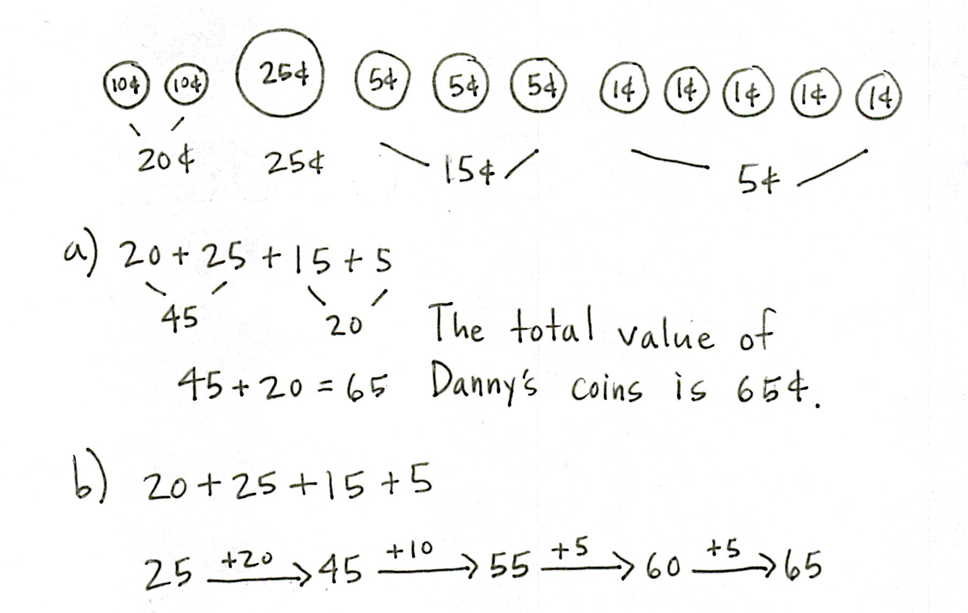
- Show two different ways that Danny might add to find the total.
Note: The problem is designed to encourage students to think flexibly when adding coins. While some may order coins from greatest to least and count on, others may skip-count, and still others may look to make a ten. These strategies will be used to problem-solve during today’s lesson.
Concept Development (33 minutes)
Materials: (T) Play money coins, personal white board
(S) Personal white board
Remind students to use the RDW process when solving word problems with money. Emphasize the importance of rereading and adjusting.

NOTES ON
MULTIPLE MEANS
OF REPRESENTATION:
At the beginning of the lesson, support English language learners by pointing to visuals of the coins while reading Problem 1 out loud to the class. Pictures of quarters, dimes, nickels, and pennies should have the name of the coins printed clearly so that students can learn them more quickly. Post the visuals on the word wall so that students needing extra support can refer to them.
- Read the problem.
- Draw and label.
- Write number sentences.
- Write a statement.
Part 1: Solve a put together with total unknown problem.
Ignacio has 3 dimes and 2 nickels in one pocket and 1 quarter and 7 pennies in another pocket. How much money is in Ignacio’s pockets?
T: What do we do first when we see a word problem?
S: Read it.
T: Yes. Let’s read the problem together. (Read aloud.)
T: What can you draw?
S: Two pockets! One pocket with 3 dimes and 2 nickels and another pocket with 1 quarter and 7 pennies.
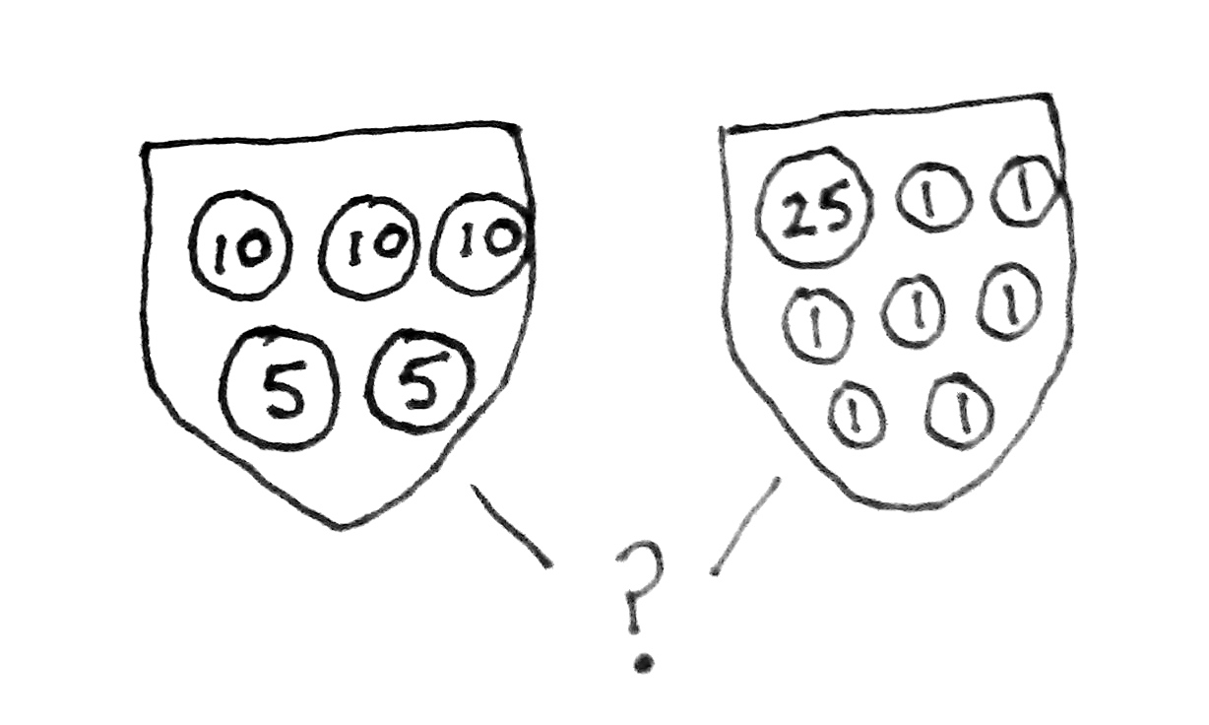
T: Great! Get going. I’ll give you a minute to draw quietly. When I give the signal, talk to your partner about how your drawing matches the story.
T: (Allow students time to draw. Signal.) Turn and talk: Look at your drawing. What are you trying to find? (See example drawings to the right.)
S: We need to find out how much Ignacio has in both pockets.
We need to find the total value of the coins. We need to find the total in Pocket 1 and the total in Pocket 2 and then add them.
MP.2
T: Go ahead and do that. Write a number sentence and statement to match your work. (Pause to allow students time to work.) Explain to your partner how you solved the problem.
S: For the first pocket, I just skip-counted by tens, then fives: 10, 20, 30, 35, 40 cents. For the first pocket, I added the 2 nickels first to make ten. And then, I added on 3 more tens to get 40 cents.
A quarter is 25 cents, and then you can count on 7 cents, so 26, 27, 28, …32 cents in Pocket 2.
In the second pocket, I drew a number bond to make a ten, so 25 + 5 is 30, plus 2 is 32 cents.
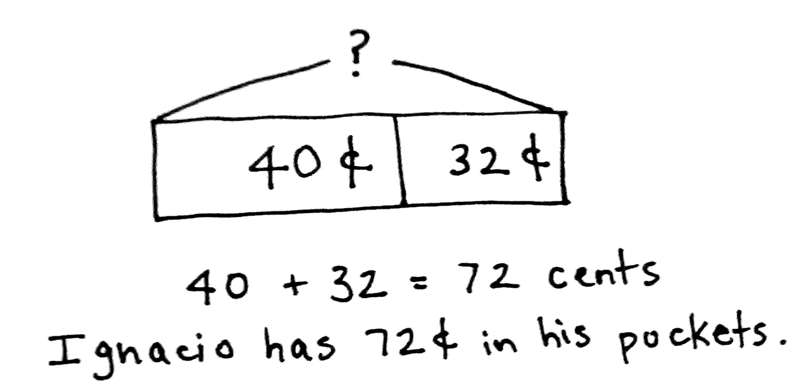
T: What’s your number sentence?
S: 40 + 32 = 72.
T: And the statement of your solution?
S: Ignacio has 72 cents in his pockets.
T: Yes! Look how we can also represent this problem with a tape diagram. (See image to the right.)
T: Turn and talk. Use part–whole language to describe how your drawing matches mine.
S: Your bar has two parts, and I drew two pockets. We both added the two parts to find the total. Our parts have the same amount of money in them.

NOTES ON
MULTIPLE MEANS
OF ENGAGEMENT:
Provide students working below grade level with the chance to continue using coin manipulatives and part–whole templates for their personal white boards. This provides extra scaffolding to help them transition to drawing tape diagrams.
T: Exactly! Let’s try a more challenging problem. You’re ready for it!
Repeat the process with the following put together with result unknown problem, adjusting the level of support as appropriate for the students:
Tamika has 12 pennies and 2 quarters in her new piggy bank. She puts in 4 nickels, 1 dime, and 4 more pennies. How much money does Tamika have in her piggy bank altogether?
Circulate and support students as they use the RDW process to complete the problem independently. Encourage flexible thinking. Check student drawings and problem-solving strategies.
The following questions may be used to check for student understanding:
- What did you draw to show the story?
- What number sentence did you write to match your drawing?
Part 2: Solve a two-step put together with total unknown and take from with result unknown word problem.
On Monday, Reese gives 2 dimes and 3 nickels to her sister. On Tuesday, she gives her sister 1 quarter,
1 dime, and 4 pennies. If Reese started with 94 cents, how much money does she have now?
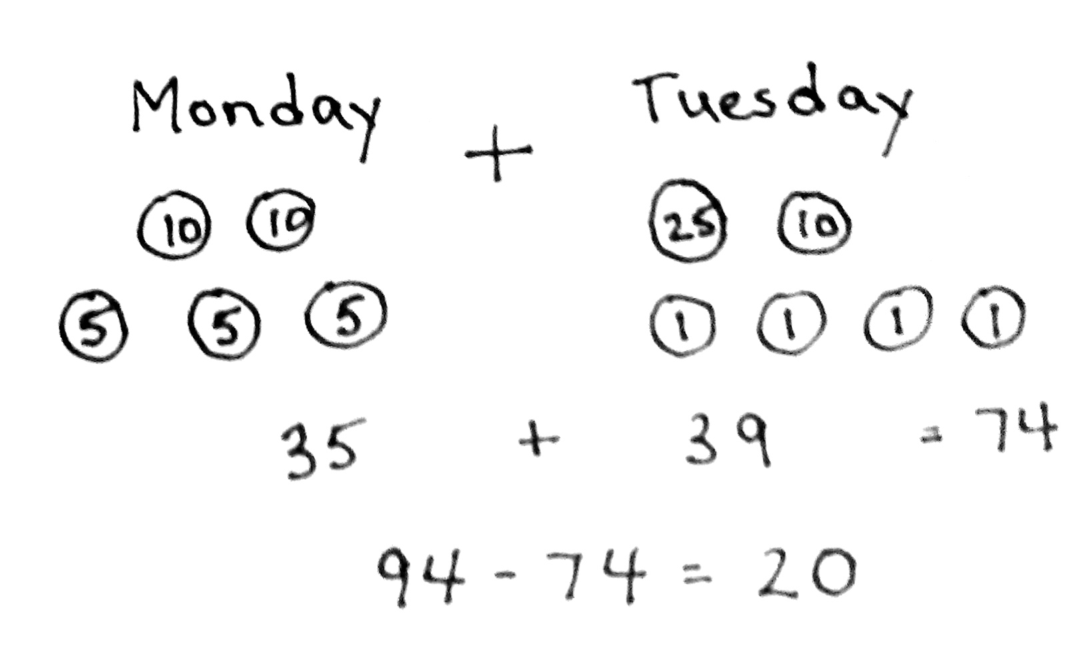
T: Let’s read the problem together.
T/S: (Read aloud.)
T: What can you draw first?
S: Two groups of coins, one for Monday and one for Tuesday.
T: Great! Get to work. I’ll give you a minute to draw quietly. When I give the signal, talk to your partner about how your drawing matches the story. (Allow students time to draw. See examples to the right.)
T: Turn and talk: Look at your drawing. What are you trying to find?
S: We need to find the total value of all the coins Reese gave to her sister. Then, we need to subtract the total from 94 cents. We need to add the two groups of coins first, but then we need to subtract to see how much she has left.
T: Go ahead and do that. Write a number sentence and statement to match your work. (Pause to allow students time to work.) Explain to your partner how you solved the problem.
S: First, I added the money from Monday and Tuesday. Then, I subtracted 74¢ from 94¢ to get 20¢.
I used the make a ten strategy to make it easy. 35 + 39 = 34 + 1 + 39 = 34 + 40 = 74.
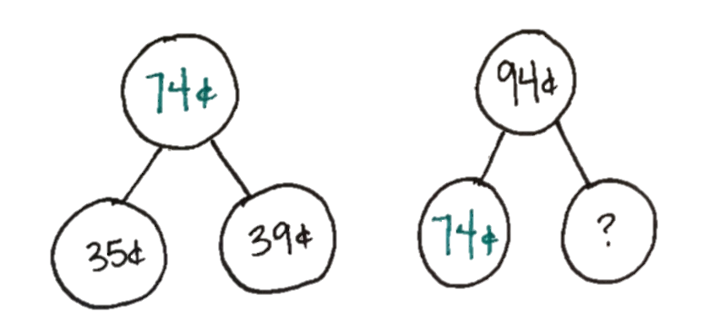
T: (Circulate to provide support and check for understanding.)
T: What were your number sentences?
S: First, I added, so 20 + 15 + 25 + 10 + 4 = 74.
My second one was 94 – 74 = 20.
T: And the statement of your solution?
S: Reese has 20 cents now.
T: Watch how we can also represent this problem with a number bond.
T: Turn and talk. Use part–whole language to describe how your drawing matches mine.
S: Since Reese started with 94 cents, that’s the whole. We know that she gave her sister a total of 74 cents; that’s one part. We know the whole and the part she gave her sister, and we found the part Reese has left.
T: You’re on a roll! Now, it’s your turn to solve.

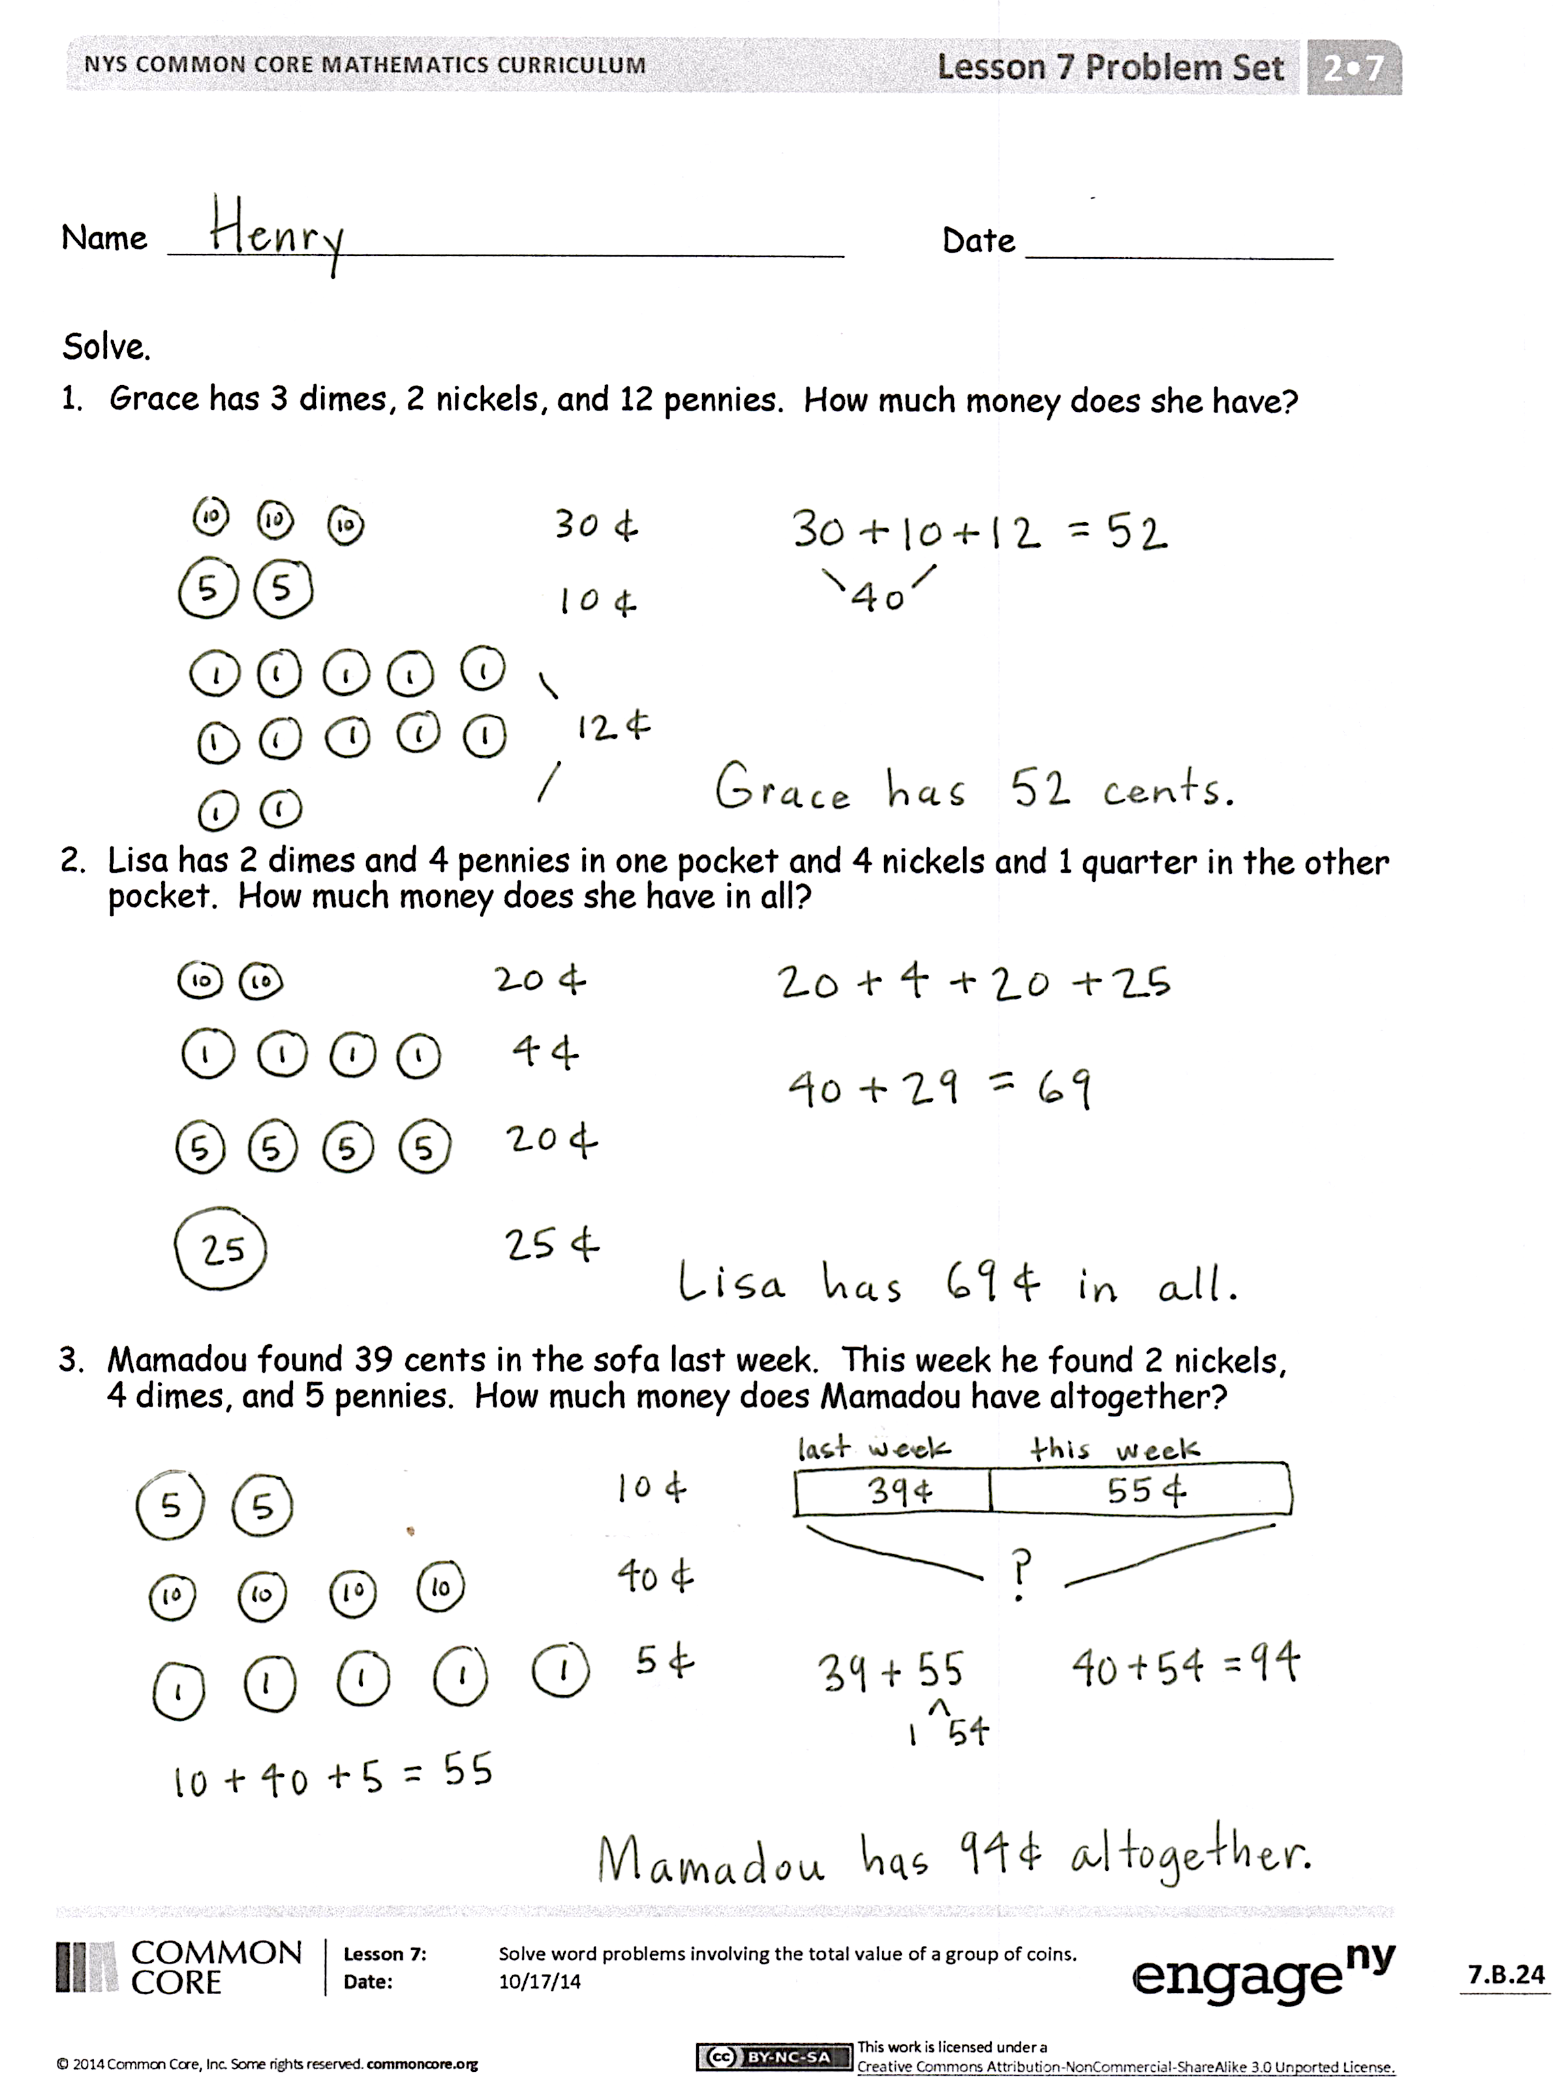
Problem Set (10 minutes)
Students should do their personal best to complete the Problem Set within the allotted 10 minutes. For some classes, it may be appropriate to modify the assignment by specifying which problems they work on first. Some problems do not specify a method for solving. Students should solve these problems using the RDW approach used for Application Problems.
Student Debrief (10 minutes)
Lesson Objective: Solve word problems involving the total value of a group of coins.
The Student Debrief is intended to invite reflection and active processing of the total lesson experience.
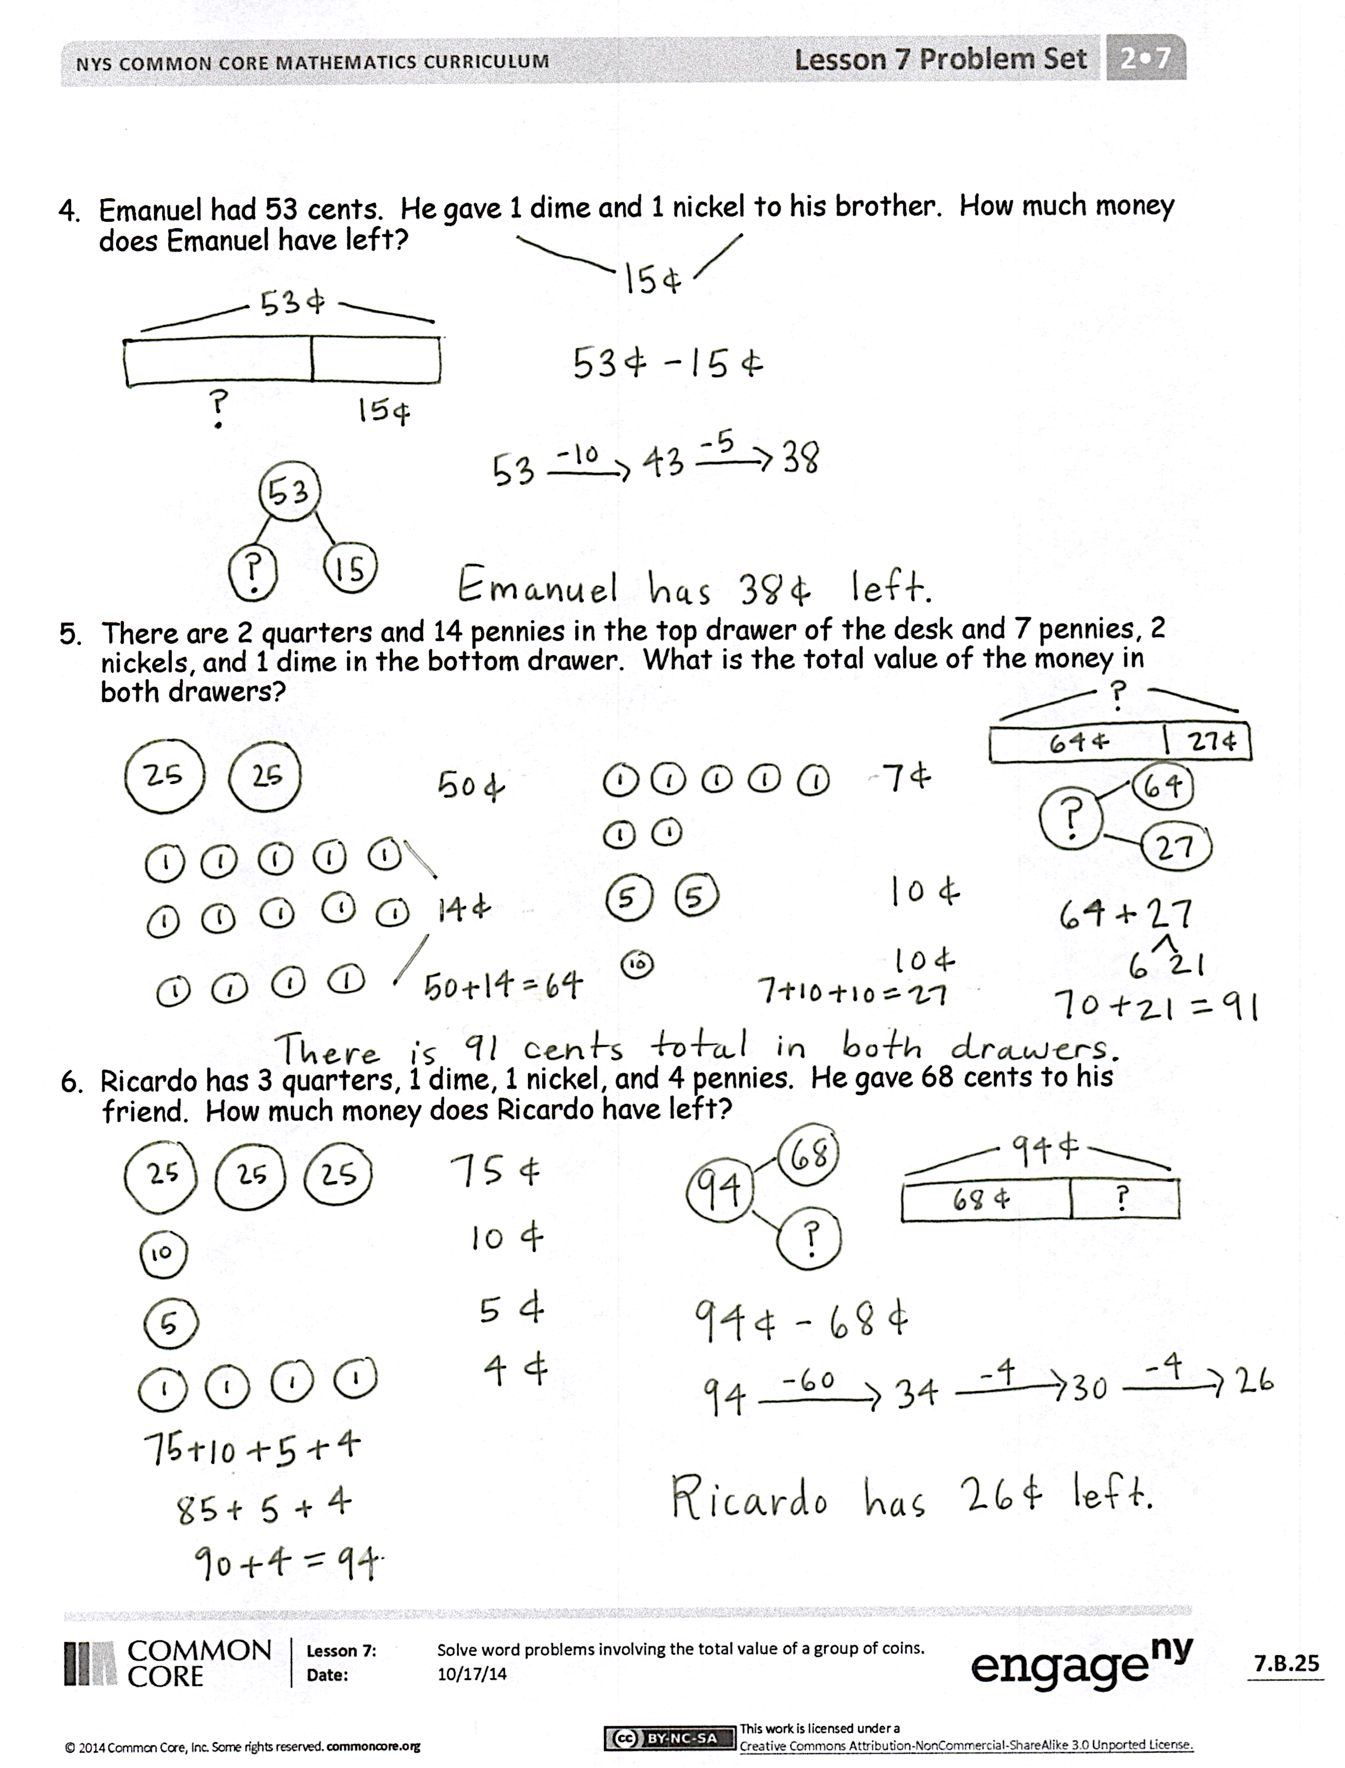
Invite students to review their solutions for the Problem Set. They should check work by comparing answers with a partner before going over answers as a class. Look for misconceptions or misunderstandings that can be addressed in the Debrief. Guide students in a conversation to debrief the Problem Set and process the lesson.
Any combination of the questions below may be used to lead the discussion.
- Look at the first problem in the Problem Set. Talk with your partner about how you thought about and counted the pennies. How could you think about the nickels to make it easier to find their value?
- How does understanding place value help you to find the value of coins?
- Turn and talk. What tool did you use to solve Problem 4: addition, subtraction, or something else?
- Explain to your partner using part–whole language how you figured out how much money Ricardo had left in Problem 6. If you used a model or an equation, show it to your partner.
- How are number bonds and the part–whole tape diagrams the same? How are they different? Are there certain math problems where it is better to use one over the other?
Exit Ticket (3 minutes)
After the Student Debrief, instruct students to complete the Exit Ticket. A review of their work will help with assessing students’ understanding of the concepts that were presented in todays’ lesson and planning more effectively for future lessons. The questions may be read aloud to the students.
Number Correct: _______
A
Subtraction Across a Ten
 | 10 – 3 = |  |  |  | 11 – 9 =
 | 11 – 3 = |  |  |  | 12 – 9 =
 | 12 – 3 = |  |  |  | 17 – 9 =
 | 10 – 2 = |  |  |  | 10 – 8 =
 | 11 – 2 = |  |  |  | 11 – 8 =
 | 10 – 5 = |  |  |  | 12 – 8 =
 | 11 – 5 = |  |  |  | 16 – 8 =
 | 12 – 5 = |  |  |  | 10 – 6 =
 | 14 – 5 = |  |  |  | 13 – 6 =
 | 10 – 4 = |  |  |  | 15 – 6 =
 | 11 – 4 = |  |  |  | 10 – 7 =
 | 12 – 4 = |  |  |  | 13 – 7 =
 | 13 – 4 = |  |  |  | 14 – 7 =
 | 10 – 7 = |  |  |  | 16 – 7 =
 | 11 – 7 = |  |  |  | 10 – 8 =
 | 12 – 7 = |  |  |  | 13 – 8 =
 | 15 – 7 = |  |  |  | 14 – 8 =
 | 10 – 6 = |  |  |  | 17 – 8 =
 | 11 – 6 = |  |  |  | 10 – 9 =
 | 12 – 6 = |  |  |  | 13 – 9 =
 | 14 – 6 = |  |  |  | 14 – 9 =
 | 10 – 9 = |  |  |  | 18 – 9 =
Number Correct: _______
Improvement: _______
B
[KEY]

Subtraction Across a Ten
 | 10 – 2 = |  |  |  | 11 – 7 =
 | 11 – 2 = |  |  |  | 12 – 7 =
 | 10 – 4 = |  |  |  | 16 – 7 =
 | 11 – 4 = |  |  |  | 10 – 9 =
 | 12 – 4 = |  |  |  | 11 – 9 =
 | 13 – 4 = |  |  |  | 12 – 9 =
 | 10 – 3 = |  |  |  | 18 – 9 =
 | 11 – 3 = |  |  |  | 10 – 5 =
 | 12 – 3 = |  |  |  | 13 – 5 =
 | 10 – 6 = |  |  |  | 10 – 6 =
 | 11 – 6 = |  |  |  | 13 – 6 =
 | 12 – 6 = |  |  |  | 14 – 6 =
 | 15 – 6 = |  |  |  | 10 – 7 =
 | 10 – 5 = |  |  |  | 13 – 7 =
 | 11 – 5 = |  |  |  | 15 – 7 =
 | 12 – 5 = |  |  |  | 10 – 8 =
 | 14 – 5 = |  |  |  | 13 – 8 =
 | 10 – 8 = |  |  |  | 14 – 8 =
 | 11 – 8 = |  |  |  | 16 – 8 =
 | 12 – 8 = |  |  |  | 10 – 9 =
 | 17 – 8 = |  |  |  | 16 – 9 =
 | 10 – 7 = |  |  |  | 17 – 9 =

Name Date
Solve.
- Grace has 3 dimes, 2 nickels, and 12 pennies. How much money does she have?

- Lisa has 2 dimes and 4 pennies in one pocket and 4 nickels and 1 quarter in the other pocket. How much money does she have in all?

- Mamadou found 39 cents in the sofa last week. This week, he found 2 nickels,
4 dimes, and 5 pennies. How much money does Mamadou have altogether?

- Emanuel had 53 cents. He gave 1 dime and 1 nickel to his brother. How much money does Emanuel have left?

- There are 2 quarters and 14 pennies in the top drawer of the desk and 7 pennies,
2 nickels, and 1 dime in the bottom drawer. What is the total value of the money in both drawers?

6. Ricardo has 3 quarters, 1 dime, 1 nickel, and 4 pennies. He gave 68 cents to his friend. How much money does Ricardo have left?
Name Date
Solve.
- Greg had 1 quarter, 1 dime, and 3 nickels in his pocket. He found 3 nickels on the sidewalk. How much money does Greg have?

- Robert gave Sandra 1 quarter, 5 nickels, and 2 pennies. Sandra already had
3 pennies and 2 dimes. How much money does Sandra have now?

Name Date
Solve.
- Owen has 4 dimes, 3 nickels, and 16 pennies. How much money does he have?

- Eli found 1 quarter, 1 dime, and 2 pennies in his desk and 16 pennies and 2 dimes in his backpack. How much money does he have in all?

- Carrie had 2 dimes, 1 quarter, and 11 pennies in her pocket. Then, she bought a soft pretzel for 35 cents. How much money does Carrie have left?

- Ethan had 67 cents. He gave 1 quarter and 6 pennies to his sister. How much money does Ethan have left?

- There are 4 dimes and 3 nickels in Susan’s piggy bank. Nevaeh has 17 pennies and
3 nickels in her piggy bank. What is the total value of the money in both piggy banks?

- Tison had 1 quarter, 4 dimes, 4 nickels, and 5 pennies. He gave 57 cents to his cousin. How much money does Tison have left?

