Lesson 5
Objective: Solve word problems using data presented in a bar graph.

Suggested Lesson Structure
 Fluency Practice (10 minutes)
 Application Problem (5 minutes)
 Concept Development (35 minutes)
 Student Debrief (10 minutes)
Total Time (60 minutes)
Fluency Practice (10 minutes)
- Grade 2 Core Fluency Differentiated Practice Sets 2.OA.2 (5 minutes)
- Coin Drop 2.NBT.2, 2.OA.2 (5 minutes)
Grade 2 Core Fluency Differentiated Practice Sets (5 minutes)
Materials: (S) Core Fluency Practice Sets (Lesson 1 Core Fluency Practice Sets)
Note: During Topic A and for the remainder of the year, each day’s Fluency Practice includes an opportunity for review and mastery of the sums and differences with totals through 20 by means of the Core Fluency Practice Sets or Sprints. The process is detailed and Practice Sets are provided in Lesson 1.
Coin Drop (5 minutes)
Materials: (T) 2 quarters, 10 dimes, 10 nickels, can
Note: In this activity, students practice adding and subtracting 25, 10, and 5.
T: (Hold up a quarter.) Name my coin.
S: A quarter.
T: How much is it worth?
S: 25 cents.
T: Watch carefully as I drop the quarter and some nickels in my can. Count along in your minds.
Drop in a quarter and some nickels and ask how much money is in the can. Take out some of the nickels and show them. Ask how much money is still in the can. Continue adding and subtracting nickels for a minute or so. Then, repeat the activity with a quarter and dimes, a quarter with dimes and nickels, and then 2 quarters with dimes and nickels.
Application Problem (5 minutes)
Rita has 19 more pennies than Carlos. Rita has 27 pennies. How many pennies does Carlos have?
Note: In this problem, the context shifts to money. This leads into today’s Concept Development, where students work with money data to solve word problems, and segues into problem solving with coins and bills in Topic B. The problem type is compare with smaller unknown, one of the more difficult problem types because more suggests the wrong operation. Guide students, as needed, to draw a tape diagram to solve.
Concept Development (35 minutes)
Materials: (T) Ruler (optional) (S) Activity Sheets 1, 2, and 3, colored pencils or crayons
Note: In this lesson, students use money data to solve word problems. Depending on the needs of your students, you may choose to have them work independently, with a partner, or in groups.

NOTES ON
MULTIPLE MEANS
OF REPRESENTATION:
Some students may find it visually challenging to fill in and read the graphs. Enlarge the activity sheet, or provide these students with Template 1 (Lesson 2) which leaves space between the bars. Also, have students use different colors to further distinguish the bars.

T: Today, we’re going to use activity sheets for our lesson. Use the information in the table to complete the graphs, and then use the data to answer the questions.
MP.6
Pass out Activity Sheets 1 and 2. Circulate to be sure students are labeling their graphs accurately, paying special attention to the count scale. You may wish to remind them with the visual aid of a ruler that the beginning of the scale is 0 and not 1.
Provide support as students work. Invite them to share how they solved as they complete each problem. This is a good opportunity to work with a small group of students who are struggling with graphing or answering questions based on information presented in a graph. It is also a chance to provide extension for students working above grade level. For those students, a good alternative might be to use Activity Sheet 3 to design their own survey and table and then create a graph and questions to represent and interpret the data.

NOTES ON
MULTIPLE MEANS
OF ENGAGEMENT:
Activate multiple senses by playing music to create a soothing atmosphere.
Allow flexible grouping, and allow students to move around, check their work, and ask questions of those not in their pair or group.

As students successfully complete their work, allow them to move on to the Problem Set.
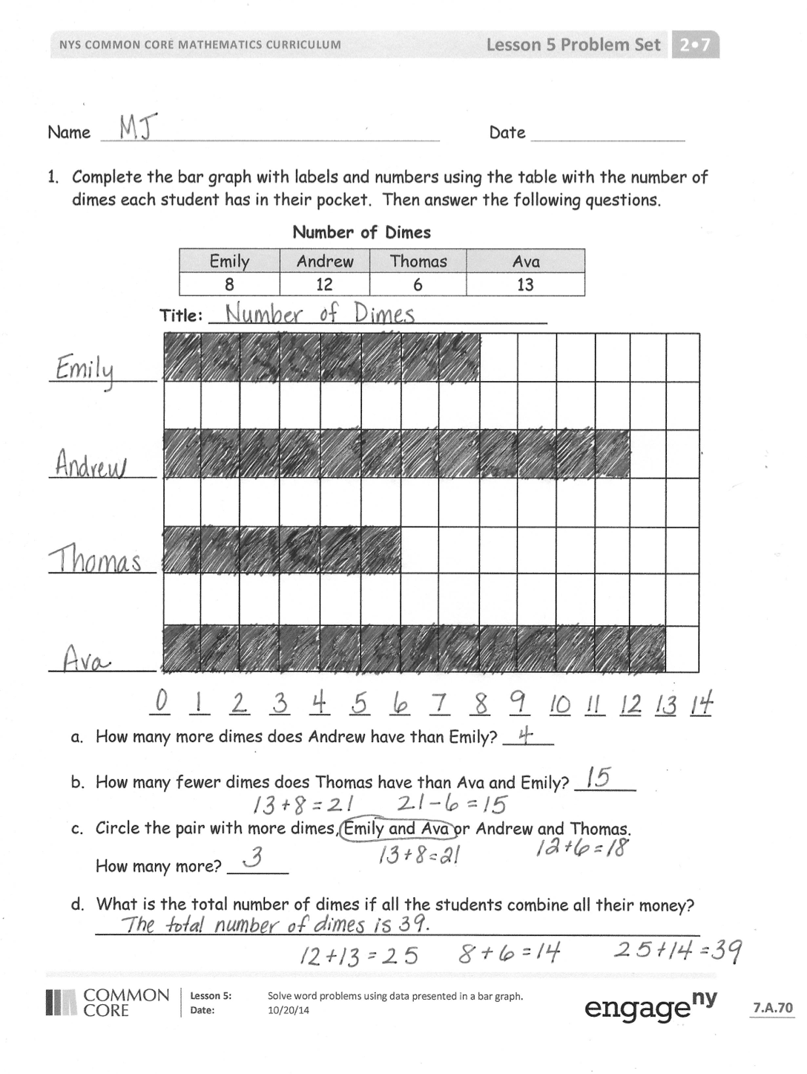
Problem Set (10 minutes)
Students should do their personal best to complete the Problem Set within the allotted 10 minutes. For some classes, it may be appropriate to modify the assignment by specifying which problems they work on first. Some problems do not specify a method for solving. Students should solve these problems using the RDW approach used for Application Problems.
Student Debrief (10 minutes)
Lesson Objective: Solve word problems using data presented in a bar graph.
The Student Debrief is intended to invite reflection and active processing of the total lesson experience.
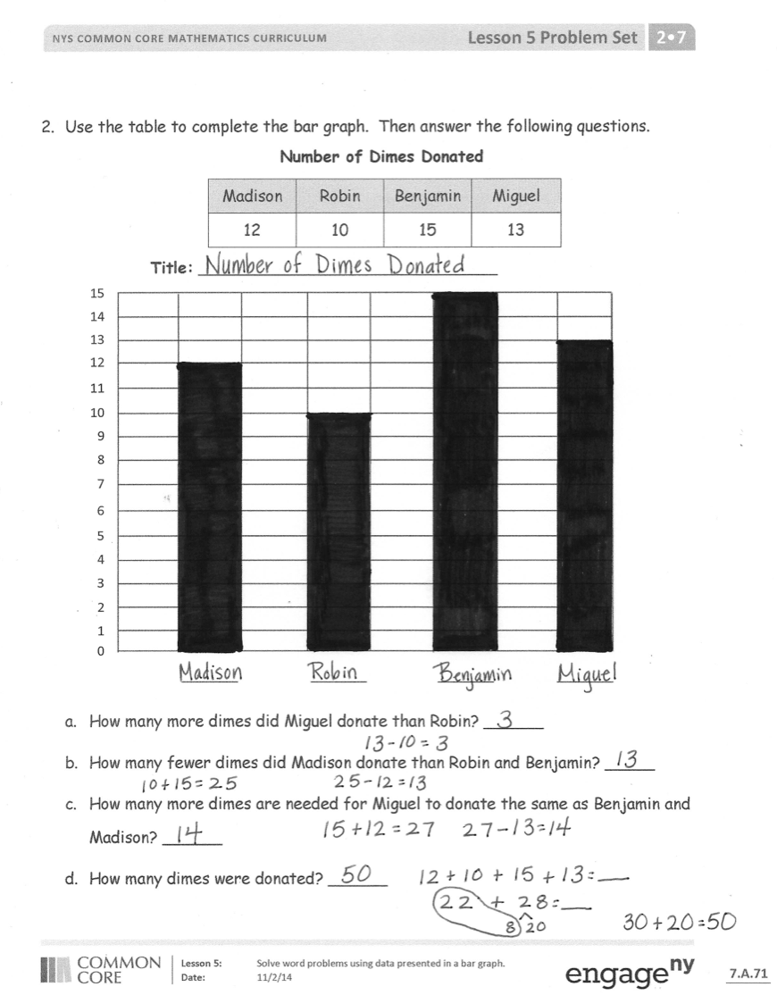
Invite students to review their solutions for the Problem Set. They should check work by comparing answers with a partner before going over answers as a class. Look for misconceptions or misunderstandings that can be addressed in the Debrief. Guide students in a conversation to debrief the Problem Set and process the lesson.
Any combination of the questions below may be used to lead the discussion.
- Look at Emily’s dimes in the Problem Set. How many dimes would Emily have if you doubled her dimes? (16.) How would we record 16 in the graph? (We would have to make more boxes.
Or, we could make each unit box’s value 2 instead of 1.)
- In each graph you completed today, you were asked to find the total amount of coins recorded in the graph. Tell your partner if you figured out the answer in your head or with paper and pencil. Share the calculation strategy you used.
- Think about a question you could ask our class that you could turn into a bar graph. Tell your partner what question you would ask. What would you title your graph? What would the categories be labeled?
Exit Ticket (3 minutes)
After the Student Debrief, instruct students to complete the Exit Ticket. A review of their work will help with assessing students’ understanding of the concepts that were presented in today’s lesson today and planning more effectively for future lessons. The questions may be read aloud to the students.
Name Date
Callista saved pennies. Use the table to complete the bar graph. Then, answer the following questions.
Pennies Saved
Saturday | Sunday | Monday | Tuesday
15 | 10 | 4 | 7

Title: ______________________________
15

14

13

12

11

10

9

8

7

6

5

4

3

2

1

0
- How many pennies did Callista save in all? ___
- Her sister saved 18 fewer pennies. How many pennies did her sister save? ___
- How much more money did Callista save on Saturday than on Monday and Tuesday? ___
- How will the data change if Callista doubles the amount of money she saved on Sunday? ___________________________________________________
- Write a comparison question that can be answered using the data on the bar graph. _____________________________________________________

Name Date
A group of friends counted their nickels. Use the table to complete the bar graph. Then, answer the following questions.
Amount of Nickels
Annie | Scarlett | Remy | LaShay
5 | 11 | 8 | 14

Title: _________________________________

0 __ __ __ __ __ __ __ __ __ __ __ __ __ __
- How many nickels do the children have in all? ___
- What is the total value of Annie and Remy’s coins? ___
- How many fewer nickels does Remy have than LaShay? ___
- Who has less money, Annie and Scarlett or Remy and LaShay? __________
- Write a comparison question that can be answered using the data on the bar graph.
_________________________________________________________

Name Date
- Design a survey and collect the data.
- Label and fill in the table.
- Use the table to label and complete the bar graph.
- Write questions based on the graph, and then let students use your graphs to answer them.
  - _________________________________________________________
  - _________________________________________________________
  - _________________________________________________________
  - _________________________________________________________

Name Date
- Use the table to complete the bar graph. Then, answer the following questions.

Emily | Andrew | Thomas | Ava
8 | 12 | 6 | 13
Number of Dimes

Title: _________________________________

__ __ __ __ __ __ __ __ __ __ __ __ __ __ __
- How many more dimes does Andrew have than Emily? _____
- How many fewer dimes does Thomas have than Ava and Emily? ______
- Circle the pair with more dimes, Emily and Ava or Andrew and Thomas.
How many more? ______
- What is the total number of dimes if all the students combine all their money?
___________________________________________________________
- Use the table to complete the bar graph. Then, answer the following questions.

Number of Dimes Donated
Madison | Robin | Benjamin | Miguel
12 | 10 | 15 | 13

Title: ______________________________
15

14

13

12

11

10

9

8

7

6

5

4

3

2

1

0

- How many more dimes did Miguel donate than Robin? ______
- How many fewer dimes did Madison donate than Robin and Benjamin? _____
- How many more dimes are needed for Miguel to donate the same as Benjamin and Madison? ______
- How many dimes were donated? ______

Name Date
Use the table to complete the bar graph. Then, answer the following questions.

Lacy | Sam | Stefanie | Amber
6 | 11 | 9 | 14
Number of Dimes

Title: _________________________________

__ __ __ __ __ __ __ __ __ __ __ __ __ __ __

- How many more dimes does Amber have than Stefanie? _____
- How many dimes will Sam and Lacy need to save to equal Stefanie and Amber? _________

Name Date
- Use the table to complete the bar graph. Then, answer the following questions.

Justin | Melissa | Meghan | Douglas
13 | 9 | 12 | 7
Number of Nickels

Title: _______________________________

__ __ __ __ __ __ __ __ __ __ __ __ __ __ __

- How many more nickels does Meghan have than Melissa? ______
- How many fewer nickels does Douglas have than Justin? ______
- Circle the pair that has more nickels, Justin and Melissa or Douglas and Meghan.
How many more? ______
- What is the total number of nickels if all the students combine all their money?
___________________________________________________________
- Use the table to complete the bar graph. Then, answer the following questions.

Dimes Donated
Kylie | Tom | John | Shannon
12 | 10 | 15 | 13

Title: ______________________________
15

14

13

12

11

10

9

8

7

6

5

4

3

2

1

0
- How many dimes did Shannon donate? ________
- How many fewer dimes did Kylie donate than John and Shannon? ______
- How many more dimes are needed for Tom to donate the same as Shannon and Kylie? _______
- How many dimes were donated in total? ________

